**Lecture Notes**

**FYS 4260/FYS 9260:**

**Microsystems and electronic packaging and interconnection technologies**

Frode Strisland - Associate Professor II



**Preface**

These lecture notes are intended as a support literature for students following the FYS4260/FYS9260 course *Microsystems and electronic packaging and interconnection technologies* at the University of Oslo. *Electronics packaging* (here used as a short-term covering all the course subject matter) is an essential ingredient in the physical realization of all electronics products, it is the major cost factor in manufacturing of electronics, and it affects all aspects of the physical realization of electronics.

The course has previously been offered using the book "Electronic Components, Packaging and Production" by Halbo and Ohlckers [1]. The scope of this book is still relevant, and I have kept the overall approach and sequence to the various topics. However, more than 20 years of development has made increasing sections of it obsolete. A number of other books have also been published, but either use information from the same time frame (the 1990s) [2] [3] or are sold out [4]. Meanwhile, several changes have happened to the industry, such as a move from hole mounted components to surface montage, and increasing use of environmental friendly electronics (lead solders banned), and microsystems technology is now included in many devices. In addition, there has been a general progression of technology performance. All of this and more will be covered in the course.

Whereas it is a large and active research and industry field, it is challenging to find good teaching material. I have therefore decided to develop lecture notes for topics not suitably covered from other sources. The course will therefore be based on a combination of lecture notes and extracts of chapters form selected text books. Feedback on the text and advices for improvements are therefore appreciated.

Electronics packaging is a challenging since it demands an understanding of many different fields, including materials properties, metallurgy, chemistry, physical and mechanical properties. As well as electronics, obviously! An understanding of how the various basic fields interact is necessary in order to find the optimum mix of solutions for the problem at hand. The course will give a large amount of information. My challenge to you is to try to understandthe broad lines rather than to try to memorize a lot of material constants and other details. I place the same challenge on myself to try to focus on giving you this understanding. The course literature will give you an important foundation for the course, but it is essential to gain operational understanding. This will be done through

* **Exercises** – targeting to train you to see how the text content can be applied in real life
* **Mandatory lab project** – where you will design, produce and test your own printed circuit board
* **Company visits** – to see how electronics are made in large scale – both real life visits and virtual (youtube) visits will be included.

Oslo, January 2020 Frode Strisland

1. **Introduction to microsystems and electronics packaging and interconnection technologies**

**Objectives:**

* Introduce electronics packaging terms and course content
* Design, manufacturing and test process for electronic products
* Give an overview of the electronics packaging hierarchy
  1. **Definition of terms**

Microelectronics is a subfield of electronics devoted to small, highly integrated electronic designs and components. These devices are typically made from semiconductor materials, such as a digital integrated circuit (IC).

Microsystems are microminiaturized and integrated systems based on microelectronics, photonics, RF, micro-electro-mechanical systems (MEMS) and packaging technologies.

Electronic packaging is the physical (hardware) realization of an electronic product or system, starting from a block-/circuit diagram level. It involves choices of technology for implementation, choice of materials, assembly, detailed design in chosen technology, analysis of electrical and thermal properties, reliability and much more. We however limit the scope to the physical realization aspects.

Interconnections are the electrical connections being part of the electronic system. This can be implemented for example by means of soldering, conductive adhesives, welding and other techniques.

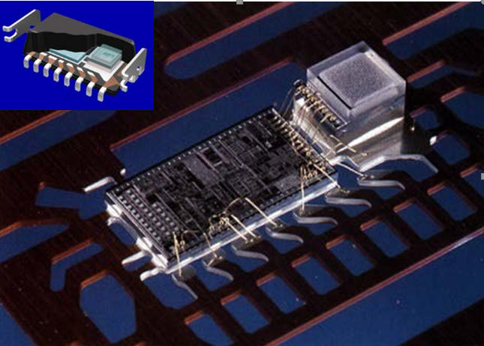EXAMPLE: Figure 1 shows an example of microsystem device during the packaging process. The MEMS sensor element and an application specific integrated circuit (ASIC) is assembled on a metal lead frame. The ASIC drives the sensor element, read out the sensor reading, add the calibration, and gives as output a measurement in a standardized analog or digital format. Electrical connections are implemented by gold wire bonding. In subsequent packaging steps, the unit will be integrated in a housing (an epoxy encapsulation), and lead frame legs will be trimmed and shaped to allow the device to be used on an electronics circuit board, see figure insert. The illustration also exemplifies that packaging and interconnection represent the main source of failures in electronic systems, and in particular within microsystems packaging: being very sensitive, the sensor element was also easily influenced by packaging induced mechanical stresses, thereby causing a NOK 229 million investment loss when the development had to be terminated.

*Figure 1: Interior chip assembly of the SA30 automotive Crash Sensor, a microsystem from SensoNor, Norway. A MEMS sensor element (right) and an application specific integrated circuit (ASIC) (left) mounted on a metal lead frame with electrical interconnections implemented by gold wirebonding. An impression of the final package is shown in the insert.*

The term *micro* in microelectronics and microsystems indicates that typical feature sizes are of the order micro meters (µm). However, chips and ICs are becoming smaller and smaller, thus terms as *nanoelectronics* and *NEMS* (nano-electro-mechanical systems) are becoming more and more popular. Within nanoelectronics, 10 nmprocess dimensions are currently under development, and intense research efforts are made to incorporate nanowires in NEMS devices. However, in the course we will not deal with this technology.

CHALLENGES BROUGHT BY MINIATURIZATION:

* ICs have a large number of input/output (I/O) points that must be connected. With smaller size, the distance between the various connections, and the possibility to electrically insulate the different interconnects from each other becomes more difficult.
* there is less material protecting the delicate, fragile electronic structures from the surrounding environment, making it more prone to corrosion processes.

* 1. **On the need for a structured design and manufacturing process**

Electronics design, manufacturing and testing are the main ingredients in product development. A long period passes between the target specification and achieving testable circuits, (several months to year(s)), and with limited possibility to fix design flaws without severe development delays 🡪 it is crucial that every effort is made to ensure that

1) the right product is made: we must develop a useful product that encounters customer needs 🡪 for this PRECISE TARGET SPECIFICATION IS ESSENTIAL!

2) the product is made right: we want to realize electronic systems that work from an electronic perspective without no short circuits, unintended cross talk or grounded signal paths

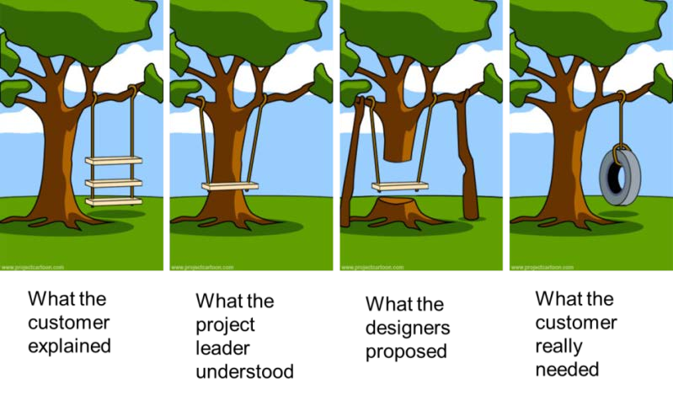

*Figure 2: Defining the right product is often more difficult than to make the product right!*

## **Regulatory requirements and design concerns for specific product groups**

Electronic products need CE marking in Europe2 in order to indicate that they meet all necessary regulatory compliance requirements on safety, health, and environmental protection requirements to be sold legally.

Products have to satisfy:

* Safety testing: the product is safe to use for all users
* electromagnetic compliance: the product is not influenced by other systems (immunity) and electromagnetic emission levels are acceptable

For some electronics systems the manufacturer may state that the applicable standards and procedures are applied, but for others, third party "notified bodies" are required to inspect and verify that requirements are met. The Norwegian institution Nemko is one example of such an organization verifying product regulatory compliance.

Certain product categories need additional safety measures, and are therefore to stricter regulatory requirements: medical devices, machinery, radio/telecommunication equipment and childrens' toys.



* + 1. **Different product groups have different demands on the electronics**

The demands on electronics products vary enormously depending on their use and intended market:

* + - * *Low end consumer electronics:* Very large market volume, high price pressure, the target lifetime is a few years, and failed products are replaced rather than repaired
      * *Automotive and avionics electronics:* Must tolerate very harsh environments, vibration, large temperature variations and lifetimes of at least 10-20 years. High reliability, low weight,

indication that systems are working or have failed. Repair when necessary. A very high development and test cost is acceptable in order to avoid expensive repairs or catastrophic failures

* + - * *Medical devices:* User safety and device effectiveness (that it works reliably as intended) are essential. Relatively high price for extensively tested products. Implanted electronic devices such as pace makers are life critical equipment that are not readily accessible for repairs
      * *Satellite electronics:* One unit, extreme demands on performance, reliability, low weight, small volume. Repair impossible. Very high development and production cost is acceptable.
    1. **The steps of the product development process**

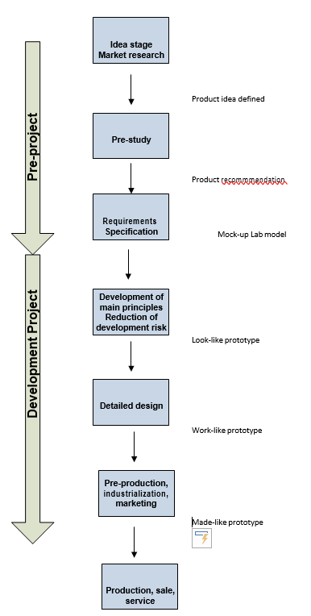

*Figure 3: Typical stages in the development of electronic systems*

It is important to run a systematic and staged product development process: anticipated results can be described and decisions can be made at defined points in time. An example process is shown in Figure 3.

In addition to the technical development aspects, we have to analyse and minimize marketing risks. The pre-project activities may only involve a few % of the overall product development cost, but care in this stage can save a lot of time and money in later stages by avoiding late stage design changes.

“SMART” RULE FOR TARGET SPECIFICATIONS

|  |  |
| --- | --- |
| **S**pecific | All requirements should be written in clear, unambiguous engineering terms |
| **M**easurable | All requirements should be quantified so that it is possible to verify at a later stage that the requirement was met. |
| **A**chievable | All requirements should be realistic to reach within the project constraints |
| **R**elevant | All requirements should be related to the product under development (and not related to factors outside the project) |
| **T**ime-limited | All requirements should be related to the time-frame of the product development |

One way to check that requirements are SMART is to inspect that all requirements can be tested. Testing can for example be done by a

* demonstration (when the on-off button is pressed, the device starts)
* observation (alarm button is red)
* experimental testing, which in particular is of relevance in performance testing.

The main development project starts after a decision is made to move forward towards a product. In this stage: multiple expert developers in multiple fields have to work together. Critical parts are realized and tested first. Often, several iterations of lab prototypes are developed to evaluate technology, lower risk and ensure from end user feedback that the development is indeed on the right track. Test prototypes focusing specifically on appearance (look-like prototype, which may not at all be functional) and function (work-like prototype, which includes all functionalities, but not in the targeted appearance) can be efficient steps on the way until a made-like production prototype can be realized. Here, all functions are integrated in a prototype with the targeted form factor, and where components are made using the same manufacturing technology as the final product.

MARKETING AND TIMING: even if costs increase, it is often better to shorten development time in order to reach the market opportunity at the right time. There are instruments that help in reducing the time consuming: 3-dimensional Computer Assisted Design (3D CAD) tools together with rapid prototyping (RP) technology have made visualization much easier, and allow over-night realization of realistic physical models.

* 1. **Electronics packaging hierarchy**
* 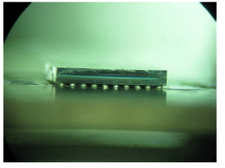level 0 is the interconnection of integrated, single transistors on a silicon (or gallium arsenide) integrated circuit (IC) chip. IMPORTANT: packaging starts on wafer level and not after the wafer is cut into circuits

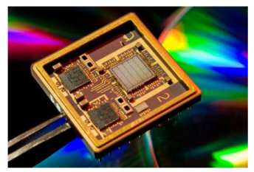

* the chips communicate by interconnection on level 1, which is a hybrid circuit or a module. Alternatively it can be the wiring inside an IC package, between the chip and the external solder joints of the package.

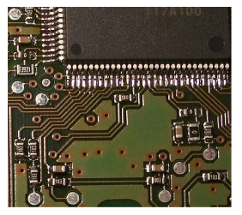

* Level 2 is the wiring on a printed circuit board (PCB) where ICs and discrete components are mounted.

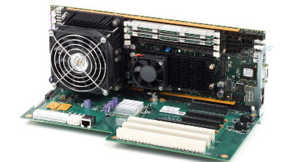

* The circuit boards in a larger system are mounted on to a back plane, interconnection level 3.
* Several back planes may make up a cabinet, with internal cabling, level 4.
* 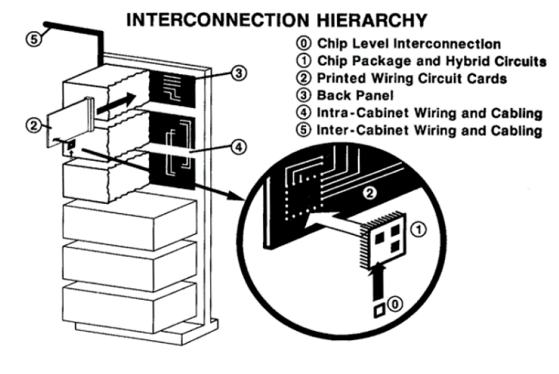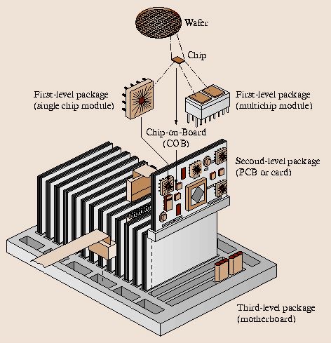Very large systems have several cabinets with cabling between them, interconnection level 5.
  + 1. **Moore’s law**

Technologies in microelectronics have made huge steps in the last decades 🡪 many efforts devoted to increase the number of components per unit area in a IC. This is described by Moore’s law

More transistors 🡪 more contact points on smaller dimensions 🡪 more demanding packaging

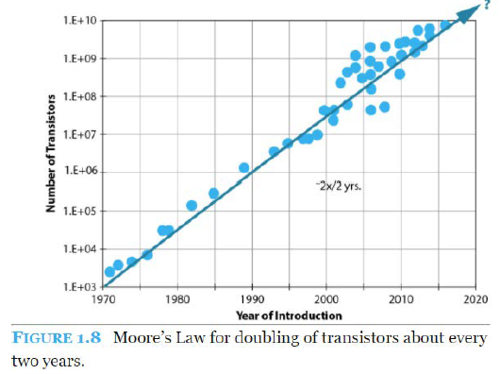Example: More heat is required to be dissipated

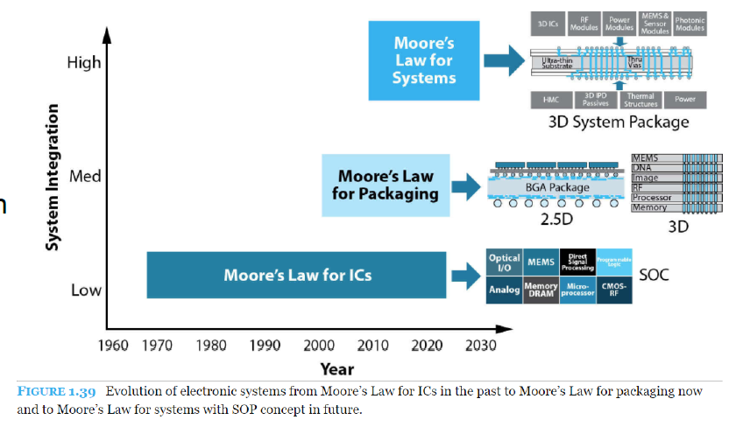

**BEFORE PROCEEDING: A SMALL DIGRESSION ABOUT SOLDERING PROCESSES THAT WILL BE NOMINATED IN THE NEXT SECTION**

* 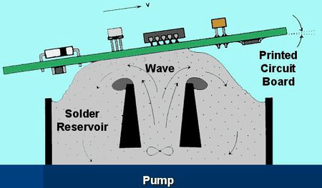**Wave Soldering:** **In this process t**he circuit board is passed over a pan of molten solder in which a pump produces an upwelling of solder that looks like a standing wave. The flux used for wave soldering is usually made up of more solvents than flux used for other applications, and will be sprayed on the board prior to it going through the solder wave. Once in place, the flux will clean the components that are to be soldered to remove any oxide layers that have formed. If the board is using a less corrosive type of flux, then the board will have to go through a pre-cleaning before the flux is applied.
* **Solder Reflow:**  solder reflow is a soldering technique in which surface-mount components are held in position on a circuit board using a paste containing solder which melts to form soldered joints when the circuit board is heated. For boards that are going through the solder reflow*,* a paste composed of a sticky flux and small spheres of metal solder is used. This solder paste holds the parts in place until the heat of the oven causes the solder particles to reflow. Not only are the metal surfaces cleaned by the flux, but the pasty nature of the flux seals out the air preventing further oxidation. The solder paste flux also contains additives to improve the flow characteristics of the solder as it melts.
* **Selective Soldering:** The flux used for selective soldering processes is applied either by spraying it, or by using a more precise drop jet process.

1. **Overview of electronics manufacturing technologies**

**Objectives:**

* Give an overview of the main technologies applied in electronics systems
* Give an understanding of how individual components are integrated into a complete electronics system.

This chapter will give an overview of the main technologies applied in electronics. Electronics packaging starts where the design of integrated circuit ends 🡪 we need to start the physical realization of the product.

## All the techniques presented here will be better illustrated in further chapters.

**BREADBOARDS**: they are a quick solution for simple prototypes, but they fail completely when it comes to realizing complex, long term stable, reliable, and reproducible (mass‐manufacturable) electrical circuits. Many components are also virtually impossible to connect to unless attached to a circuit board.

**STRIPBOARDS/VEROBOARDS**: they are equivalent to breadboards, but here soldering is permitted.

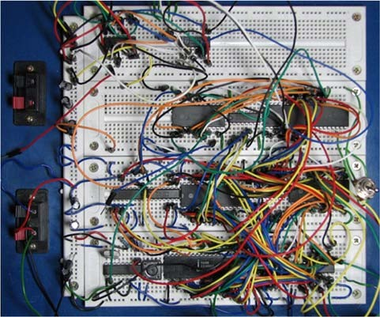

We will start with the most conventional printed wiring board technologies, thick film and thin film hybrid technologies, chip on board and multichip‐modules. We will also introduce briefly MEMS technology concepts. The different technologies have different strengths and weaknesses. The optimal choice of technologies therefore depends on a large number of factors, which must be weighed against each other for the system under development. This includes:

* Performance specifications, such as speed, accuracy, power consumption, physical dimensions
* Operating environments
* Required reliability and lifetime of product
* Production volume
* Service/repair needs
* Cost
* Engineer's approach*: Keep it simple, stupid (KISS).* Good enough is enough! It is an art not to overdo a design!
  1. **Introduction to printed circuit board technology**

The purpose of a Printed Circuit Board (PCB) is to mechanically support and electrically connect electronic components using conductive tracks, pads and other features etched from copper sheets laminated onto a non‐conductive substrate [6].

An illustration of a PCB cross‐section is shown in Figure 6. PCBs can be single sided (one copper layer), double sided (two copper layers), four layer (as in Figure 6) or multi‐layer. Conductors on different layers are connected with plated‐through holes called vias. Advanced PCBs may contain components ‐ capacitors, resistors or active devices ‐ embedded in the substrate.

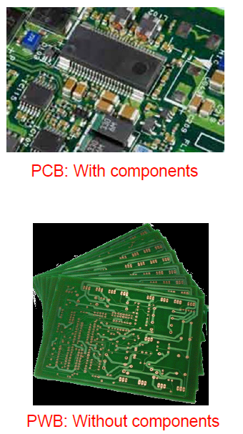We must distinguish between PRINTED CIRCUIT BOARDS AND PRINTED WIRING BOARDS

* PWB: Historically, the term Printed Wiring Board (PWB) has been used to describe the electrical wire pattern of the board before any electrical components have been mounted. (Nowadays also called PCB)
* PCB: the term PCB was reserved for boards *when* components had been assembled (consistent with the definition that an electrical circuit is not established until it is closed – which means that a circuit board without circuit are just a board of wires, and not an electrical circuit). (nowadays also called PCB-A)

The use of PWB is nowadays not consistently used in this way, with the exception of some cases where it is useful to highlight the wiring aspects of the board. We will mainly use the term PCB in this course to cover boards both with and without components.

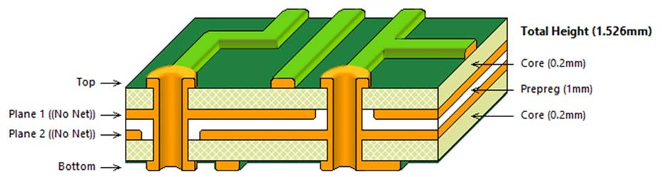

The most common PCB laminate technology 🡪 FR‐4:

* it uses a glass epoxy matrix as the primary insulating substrate.
* One or more thin layers of copper foil are laminated to one or both sides of the FR‐4 panel
* circuitry interconnections are etched into copper layers to produce printed circuit boards

FR‐4 technology is the dominating circuit board technology world‐wide, and its processing technology will be presented in more detail at a later stage of the course. FR‐4 will also be the work horse of the course lab project where you will design, assemble and test a 4‐layer FR‐4 PCB.

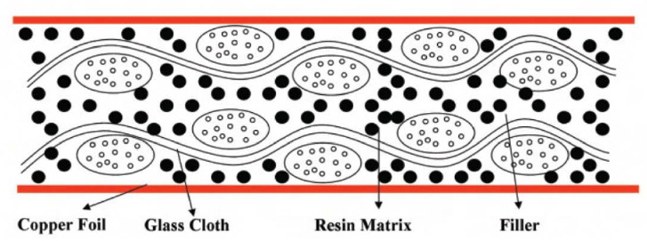

ADVANTAGES WITH FR4: reliable, inexpensive, suitable for mass production

COMPOSITION: it has a woven fiber glass (tessuto in fibra di vetro) cloth with (intrecciato con…) an epoxy resin binder that is flame resistant! This building technique is similar to that used for concrete: steel increases the strength and the elasticity, while concrete is more leading to structural properties.

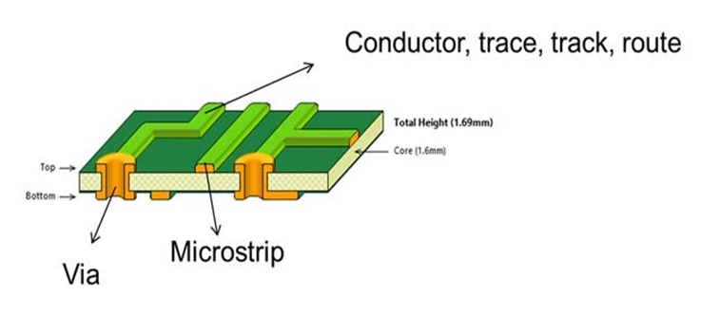**Some common PCB terms**

PCB conductors on the top or bottom layers are known as conductors, trace, track, route and several others.

Conductive holes through the circuit board are called vias.

Vias that only go between layers in a multi‐layer PCB are called micro‐vias.

A microstrip is a thin conductor line separated from ground – often used for RF signals.

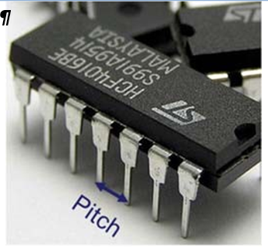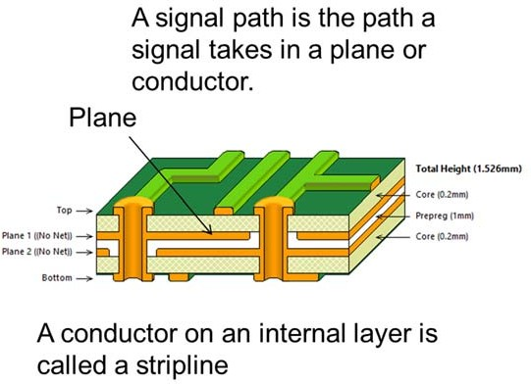PITCH = lead‐to‐lead or pad‐to‐pad dimension.

In multilayer PCBs, internal conductor layers are referred to as planes. It is very common to define a plane as ground and one power plane.

DIMENSIONS:

* For drilled thru‐hole components, the pitch is usually 0.1 inch, corresponding to 100 mil (where 1 US inch = 1000 mil).
* PCB and component dimensions in mil are widely used (and mil is a practical dimension).
* Remember therefore that 1 mil = 25.4 µm!

## **PCB ROUNTING WORKFLOW**

CIRCUIT DESIGN: gives just the idea of the circuit, real values and components are not specified

CIRCUIT SCHEMATICS: this is the actual target implementation, real values and components are specified 🡪 we need to modify this file to add components to the circuit

LAYOUT DESIGN: this is the process in which we transfer elements from schematics to a virtual version of the real pcb 🡪 we can place components, pads, tracks… using PR editor. OUTPUT FILES: each layer is well described and can be used as template for the production phase

PCB PRODUCTION: the board is printed, connections have to be soldered. Generally, different PCB can be obtained from a unique big panel

Electronic components, packages, PCB component montage techniques will be discussed in the further chapters.

* + 1. 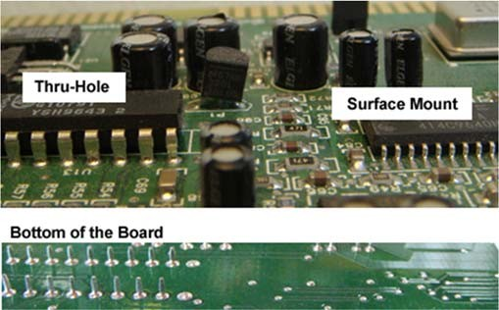**Thru-hole mounting and surface mount technologies**

**THRU-HOLE MONTAGE:** In printed circuit boards (PCBs) with hole mounting, or insertion technology, the components are mounted by insertion through holes in a laminated substrate, the printed wiring board (PWB), and the pins are soldered to the substrate wiring on the backside. This is the traditional way to build electronic circuits.

The components are interconnected on the laminated substrate by conductor lines that are defined in a single layer or multiple layers of copper foil by etching techniques.

The components are discrete devices (resistors, capacitors, transistors, switches, connectors, etc.) or integrated circuits 🡪 The dual-in-line package (DIP) having a center-to-center pin pitch of 0.1" (2.54 mm) is the most used package for integrated circuits.

Laminated glass/epoxy is the most used substrate material. This is made of several layers of woven fibreglass sheets in a matrix of epoxy (see FR4).

Mass soldering is also possible by wave solder bath.

**SURFACE MOUNTED DEVICES**: surface mounted devices (SMDs) are soldered to bonding pads on the surface of the substrate. This technology has been growing very fast since approximately 1980, and is expected to take over the lead from insertion technology as the dominating PCB mount technology.

The most striking advantage 🡪 increased packaging density - the devices are smaller and the conductor pattern of the substrate is routed with a finer pitch.

GLUEING TECHNIQUES: Wave soldering and reflow soldering by infrared (IR) heating, vapour-phase, hot gas, thermode-or laser heating.

Whereas many components are offered in a range of different packages, it might be required to apply a combination of surface mount and thru‐hole montage due to component availability. Especially large and bulky components are predominantly offered for thru‐hole montage since this technology is mechanically more robust.

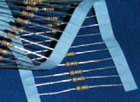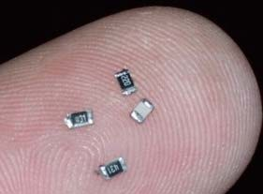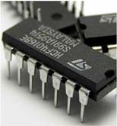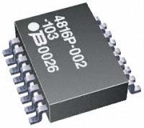

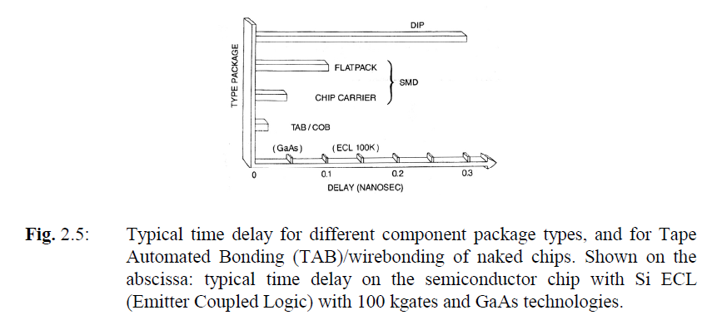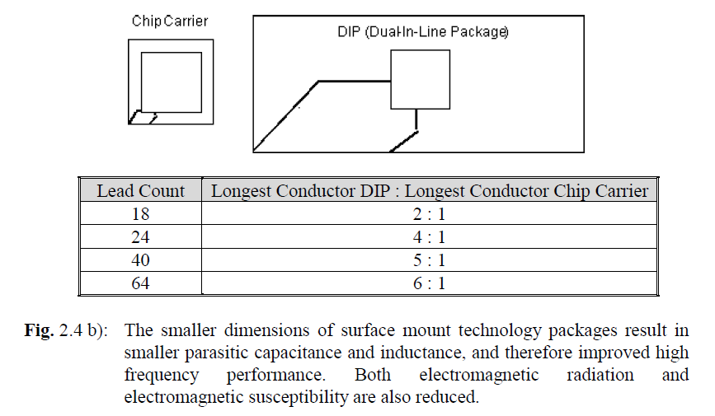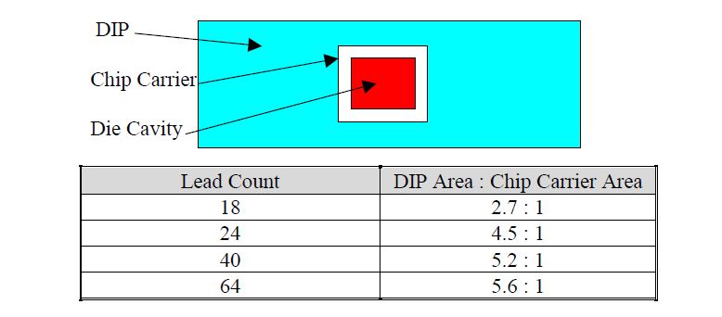

|  |  |  |
| --- | --- | --- |
| Factor | Thru‐hole technology | Surface mount technology |
| Component dimensions (footprint) | Large components.  Board vias occupy space on all layers in multi‐layer boards.  Mainly single side component montage  Standard grid for holes correspond to 100 mil = 2,54 mm pitch | Superior miniaturization potential.  Small sized components possible – often only limited by the size of e.g. the integrated circuit material itself  Double sided component assembly common  Grid for flip chip montage can typically correspond to 150 µm pitch |
| Manufacturing costs | High cost associated with drilling many high accuracy holes. | Cost of package is in many cases negligible compared to the active component material. |
| Manufacturing process | Accurate insertion processes.  Several insertion devices have conductor legs that must be bent before insertion,  and cut after montage | Surface mount components well suited for pick‐and‐place robots.  Many components can be supplied on carrier tapes. |
| Electrical connections | Predominantly component fixing by soldering | Soldering most common, but also conductive adhesives are in widespread use. |
| Serviceability (repair possibilities) | Relatively easy to remove components.  Suitable for testing (fits in breadboards) and "do it yourself" circuits | Repairs often difficult do to small dimensions. Several components are impossible to remove because of connections under the package.  Components attached by adhesives are also difficult to repair |
| Reliability | Very good reliability. Good solder attachment in holes, and metal package pins can compensate mechanical stresses otherwise induced in the package | Good reliability, but problems with thermomechanical stresses – especially for large components.  Large and heavy components such as large capacitors and AC/DC converters are not suited for surface montage, and are only offered as thru‐hole components.  Possibility of overheating components in the soldering processes may give reduced reliability |

## **Direct chip attachment: Chip on board**

Direct chip attachment – chip on board (COB): Bare (naked) silicon or GaAs chips are mounted directly on a wiring board without any packaging.

The three most common electrical connection methods between the chip and the package are shown here.

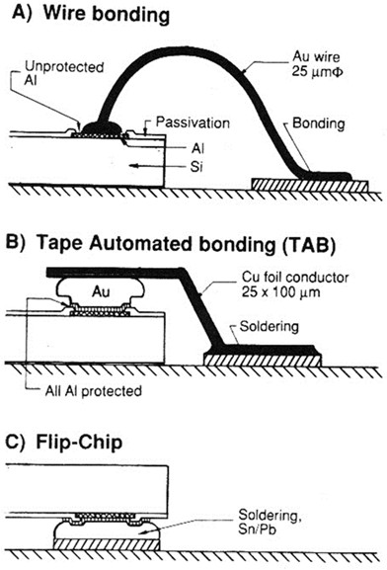

*Figure 13: Summary of the main electrical connection technologies for Chip on Board (from [1]).*

1. *Wire bonding: A thin Au or Al wire is connected from each bonding pad on chip to substrate. Contact by heat, pressure and/or ultrasonic vibration*
2. *Tape automated bonding (TAB): A film with pre‐ fabricated Cu conductor pattern is gang bonded to Au bumps on chip and soldered to substrate.*
3. *Flip chip: Chip is soldered directly, upside down, to substrate by bumps of solder alloy on bonding pads.*

**WIRE BONDING:**

https://www.youtube.com/watch?v=Mi9_ll_Z8mk&list=PLa45mK9hZkZJV6jo1ZoY8gsrlIZtWpNu-

It is done in the same way as for chip packaging 🡪 a silicon chip is attached to the substrate by a die attach material, and electrical connections are made by aluminum or gold wire bonding between connection pads on the chip and connection pads on the subtrate. Wire bonding is described in more detail in Chapter 4.

The thin wire bonds are very fragile 🡪 protected either by inserting the circuit board in a hermetic package, or by adding a droplet of sealing material that protects the fragile interconnects from mechanical and environmental stress (GLOB TOP PROTECTION).

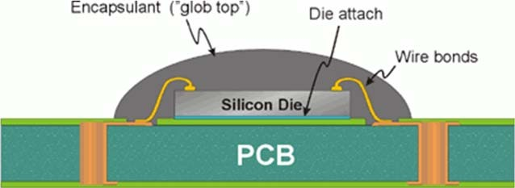

**TAPE AUTOMATED BONDING** (TAB): https://www.youtube.com/watch?v=X104jJNTvuc

has a conductor pattern of copper as interconnections between chip and substrate.

The conductor pattern is pre-processed from a continuous copper tape on a dielectric carrier film. Once that you have this copper tape processed, you connect the copper pads to some gold "bumps" on the silicon chip (see figure above). At this stage, the whole IC + copper package is still separated from the substrate. Mounting of the chip on the substrate is done after cutting off the copper fingers from the tape just outside the chip area.

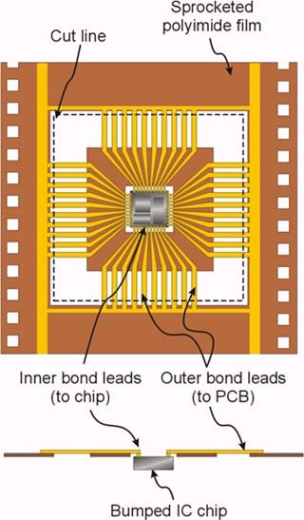The technique 🡪 also called a "tape carrier package" (TCP) because you connect the copper tape to the chip, you mount the whole pack on the substrate, you cut the copper leads and CARRY them to the pads on the substrate.

The leads are soldered to the substrate with a specialized tool employing "impulse soldering".

Following the interconnection process, it is very common to do a glob top process to protect the chip and interconnection.

**FLIP CHIP**: https://www.youtube.com/watch?v=m0K57meeMZ8

It is done by mounting the chip upside down on the substrate, after having deposited solder bumps on all interconnection pads of the chip. The chip is soldered directly onto the substrate, calling for CLOSE THERMAL MATCHING OF THE CHIP AND SUBSTRATE.

* The highest packaging density of the different interconnection methods
* It is common to apply an underfill material that enters into all the voids between the chip and the substrate 🡪 addition strength and environmental protection.
* It is also excellent with respect to electrical characteristics (short signal paths) and is also excellent reliability when properly used.
* it is a very demanding technology both to establish and operate. Initial costs are high, favouring high-volume or high-end applications.

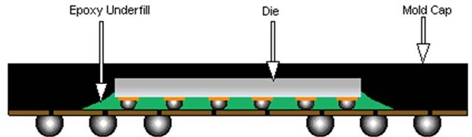

* 1. 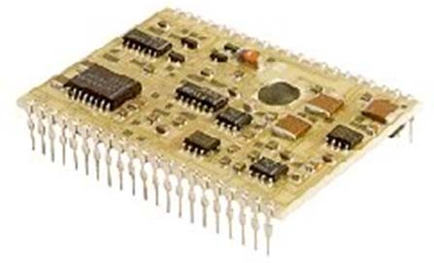**Thick film hybrid technology**

In hybrid technology, chips are interconnected on a substrate, this substrate has the capability of including passive components such as resistors, capacitors and insulators as an integrated part of it.

* Packaging density between integrated circuit technology and printed circuit board technology.
* 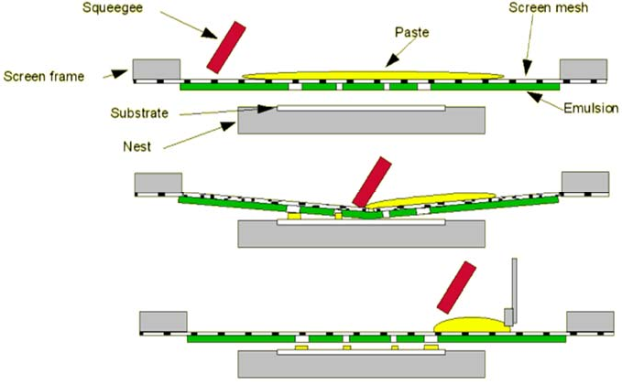sintered 96% aluminium oxide (alumina, ceramic aluminium oxide) as the substrate material. Conductors, resistors and insulators are made as thin layers, deposited by screen printing 🡪 thick film pastes with low resistivity gives conductors, pastes with a higher resistivity give resistors. Insulators are made with dielectric pastes. The layers of conducting, resistive and insulating materials are placed on the alumina substrate by screen printing where pastes are squeezed onto the substrate in predefined patterns defined by the screen mesh
* The thick film pastes for conductors and resistors are made up of conductive particles (metals or metal oxides) in a matrix of glass particles, organic filler materials and solvents. After each printing step, the hybrid substrate is dried and heat treated at a high temperature (700 - 900°C) to remove the solvent and the organic vehicles by evaporation. Meanwhile the glass melts to make up a homogenous mixture of conductive filler in a glass matrix.
* Thick film is an example of an *additive* technology where the wiring and other structures are defined layer‐by‐layer in build‐up process. PCB technologies, in which the copper conductor patterns are defined by etching of a copper layer, are on the other hand referred to as a *subtractive* technology.
* FEATURES: high reliability and stability of both components and interconnections, the packaging density is also high

Usage example: Thick film circuits are widely used in the for example the automotive industry where high reliability is required, combined with demands for extended temperature range operation and massive thermocycling3. Thick film hybrid circuits are therefore found in electronics and sensor applications such as fuel/air mixture sensing, pressure sensing, engine and gearbox controls, sensors for releasing airbags and airbag ignitors.

The drawbacks is a relatively high cost. The ceramic substrates are much more expensive than the typical glass/epoxy laminates used for printed circuit boards. Alumina is a brittle material prone to breakage.

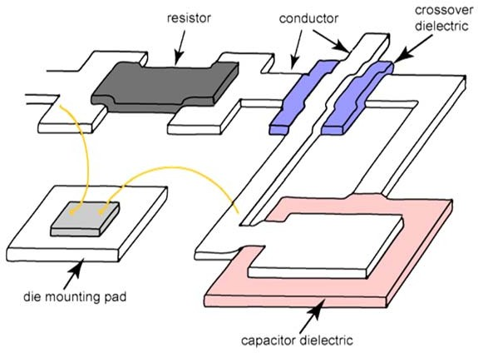

**POLYMER THICK-FILM HYBRID TECHNOLOGY (PTF)**

Thick film hybrid technology high cost 🡪 due to high temperature processing temperature.

Alternative thick film pastes are developed making use of organic, polymer materials instead of glass as matrix material.

* Can be printed on ordinary glass/epoxy laminates and cured at 150-200 °C. PTF can therefore be combined with traditional printed circuit board technology
* The conducting particles in the pastes are silver, copper or carbon.
* PTF has inferior long term reliability compared to traditional hybrid technology and PCB and relatively poor long term stability of the printed resistors
  1. **Thin film hybrid technology**

Alumina ceramics as carrier substrate.

Based on using photolithography in order to obtain very precise conductor patterns, instead of using screen printing. For this reason, polished 99% alumina substrates are used as the process basis.

PHOTOLITOGRAPHY 🡪 based on the deposition of very thin films (≤ 1um) of conducting or resistive materials; in conventional thin film just one conductor layer and one resistor layer is applied.

***Positive photoresist***, the most common type, becomes soluble in the developer when exposed; with ***negative photoresist***, unexposed regions are soluble in the developer

Thin film circuits normally have to be encapsulated in a hermetic metal box or similar in order to protect the thin films of conductor material from environmental exposure causing corrosion.

FEATURES:

* Thin film circuits can be very compact, high performance, and have very high reliability. They do however tend to be expensive.
* Thin film technology is a specialised technology with relatively few suppliers.
* Chips are attached with chip-on-board technique
* 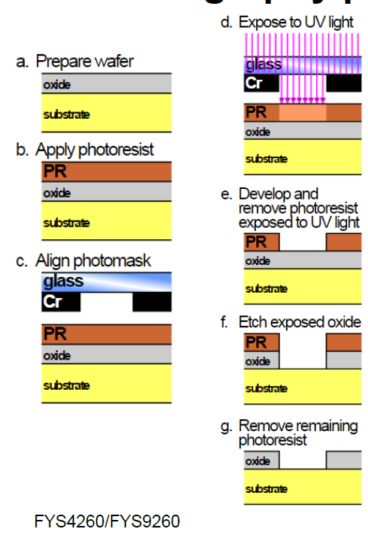Passive components with glued conductive adhesives

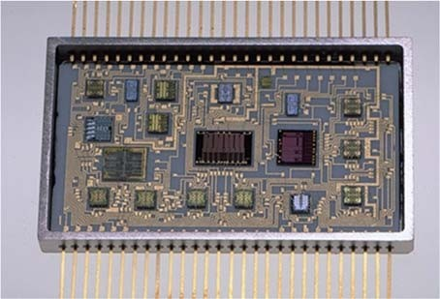

## **Multichip modules**

ICs are required to be more and more performing! Main requirements are:

* Fine-line conductor dimensions with short conductor lengths
* Controlled characteristic impedance
* Low thermal resistance to heat sink
* Matched thermal expansion coefficients

POSSIBLE SOLUTION: advanced multilayer printed circuit boards made of advanced materials with special processing. However, PCB technology has limited performance. Example 🡪 narrow conductors are difficult to make (typical width = 100 μm, compared to less than 1 μm for silicon integrated circuits).

We can define the **maximum achievable interconnection density**: the maximum total line length per unit area when using minimum line width and line spacing times the no. of conductor layers. This parameter can be maximized using Multichip module (MCM) technology 🡪 MCM = a module containing multiple integrated circuits, semiconductor dies and/or integrated discrete components packaged so that they can be as if it was a single component.

4 main groups:

1) MCM-Z (Z for Zero): Modules using no substrates 🡪 we use direct chip-to-chip interconnection and direct chip-to-package connection.

2) MCM-L (L for Laminate): Modules using fine-lined printed wiring board technologies to form the copper conductors on plastic laminate-based dielectrics.

3) MCM -C (C for Ceramic): Modules constructed on co-fired ceramic substrates using thick film (screen printing) technologies to form the conductor patterns (“Cofired” means that the conductors and the ceramic are all heated in an oven at one time). In addition, we include here modules made by thick film printing of conductor pattern on pre-fired bulk ceramic substrates with no previous conductor pattern.

4) MCM-D (D for Deposited) are modules whose interconnections are formed by the thin film deposition of metals on deposited dielectrics, which may be polymers or inorganic dielectrics. Ceramic, glass, silicon or metal are used as base substrate. The denotion MCM-S is sometimes used for MCM-D on silicon substrate.

The main driving forces behind moving towards MCM packages 🡪 the possibility of making very advanced "turn‐key" (chiavi in mano) components that can implement target functionality within a self‐contained package that is straightforward to combine with other electronics.

Examples of MCM packages include DC‐DC converters, motor controllers, and several MEMS packages.

Another alternative: system-in-package (SiP) or system‐in‐a‐package is a more recent term for even more advanced packages where a number of integrated circuits are enclosed in a single module (package). The SiP performs all or most of the functions of an electronic system, and is typically used inside a heavily miniaturized device such as a smartphone. Dies containing integrated circuits may be stacked vertically on a substrate: they are internally connected by fine wires that are bonded to the package, or they are stacked together using flip chip technology.

SiP dies can be stacked vertically or tiled horizontally, unlike slightly less dense multi‐chip modules, which place dies horizontally on a carrier. SiP connects the dies with standard off‐chip wire bonds or solder bumps, unlike slightly denser three‐dimensional integrated circuits, which connect stacked silicon dies with conductors running through the die.

Some examples of Multichip and multilayer modules are contained in the book Electronic components, 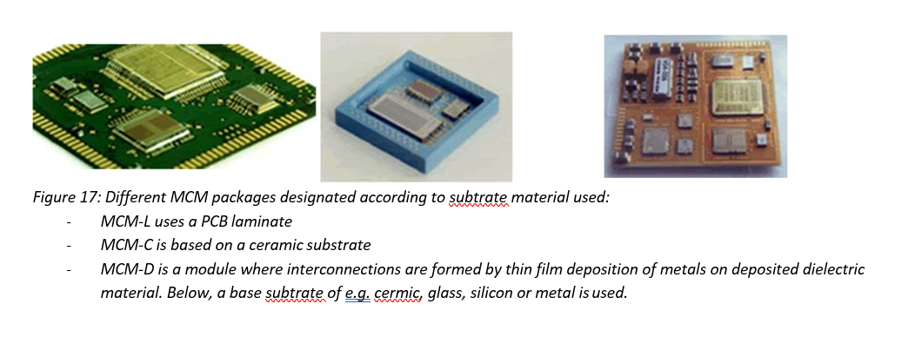packaging and production.

* 1. **Integrated Circuits Application Specific Integrated Circuits (ASICS)**

Design and realization of integrated circuits is not a topic of the present course. Understanding of how standard ICs or custom developed Application Specific Integrated Circuits (ASICs) is however important in order to design optimal electronic systems.

Integrated circuits can be classified into **analog**, **digital** and **mixed signal** (both analog and digital on the same chip). In MEMS applications, it is often necessary to move to a dedicated ASIC front‐end analog or mixed signal electronics realization in order to obtain the accuracy, low noise and configuration capability needed for a highly specialized case. Development expenses are high and development times long (typically around 12 months), but cost in high volume low, making ASICs the alternative for high value or high-volume products.

Standard integrated circuit can range from very simple, such as logic gates and multiplexers to a wide range of configurable processors from small 8‐bit versions and up to very complex state‐of‐art computers processors.

ASICS can be constructed following different procedures:

* GATE ARRAY CUSTOM DESIGN: a gate arrays is made up of a prefabricated layout of transistors and basic logical elements. The customer needs only to design the conductor pattern in the way that meets the specified electrical functions. Fast production, but low flexibility
* STANDARD CELL CUSTOM DESIGN: for standard cell custom design the silicon foundry has available a set of predesigned and characterised electrical building block - the standard cells – that can be combined to give the desired function of the chip
* FULL CUSTOM DESIGN: full custom design is performed by designing the circuits in full detail down to the transistor level. The give the best electrical characteristics and highest packaging density, but it requires a strong design know how, advanced equipment, and it is time consuming.

**Microcontrollers, field programmable gate arrays (FPGA) and digital signal processors (DSP)** can often be used as good alternatives to ASIC or complex electronics realizations 🡪 Figure 18 illustrates the functionalities offered in a microcontroller. In addition, these controllers have a wide range of peripheral systems that can be used in the electronics design, including serial interfaces and I/O, timers and counters, as well as analog modules such as OpAmps, DACs and ADCs. It is therefore possible to avoid substantial electronics hardware realization by selecting and taking advantage of features offered in modern standard 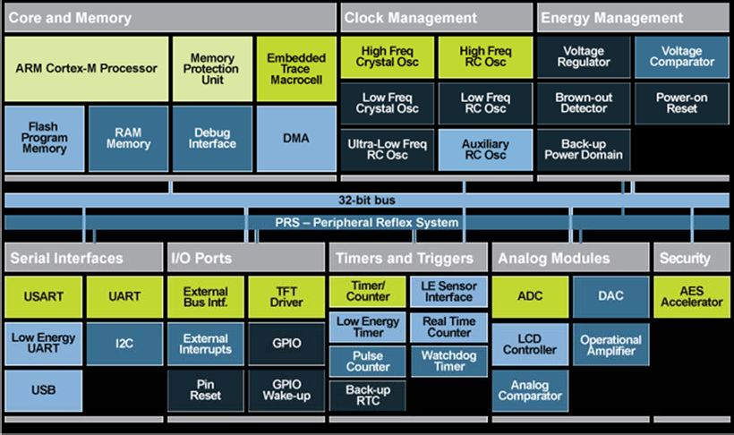ICs.

*Figure 18: Energy Micro 32 bit microcontroller with ARM Cortex core processor.*

## Microsystems technology (MEMS – Micro Electro Mechanical Systems)

Microsystems employs a wide range of existing IC processing technologies such as photolitography, etching techniques, diffusion, implantation, and various deposition techniques and applies them in combination with dedicated technologies to define micro structured features.

Micro Electro Mechanical Systems (MEMS) 🡪 miniaturized mechanical and electro‐mechanical elements (i.e., devices and structures) that are made using the techniques of microfabrication.

MEMS technology is feasible to realize a wide range of miniaturized sensor and actuator elements:

* a sensor element is able to measure a physical quantity
* an actuator is an element that is able to make something happen by means of an electrical signal.

Examples: sensors (pressure, accelerometer, and gyroscope) and actuators (micropumps, valves, digital mirror devices (image component in projectors)).

**TECHINQUES:** Microsystems and IC are mainly distinguished by the techniques used to define 3D structures in silicon. There are three main groups of micromachining technologies that define different types of microsystems elements:

* Bulk micromachining: Wet etching-based approach taking advantage of the full wafer thickness (subtractive process)
* Surface micromachining: Surface micromachining uses layers deposited on the surface of a substrate as the structural materials, rather than using the substrate itself (additive process)
* High aspect ratio (HAR) silicon micromachining, mainly based on Reactive Ion Etching combines surface micromachining approaches with deep reactive ion etching forming deep structures in the wafer

NOTE THAT ALL THESE ETCHING TECHNIQUES WILL BE COVERED IN NEXT CHAPTERS.

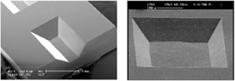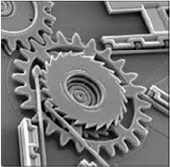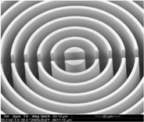

Bulk micromachining Surface micromachining High aspect ratio (HAR) silicon

micromachining

In addition to the microstructuring, MEMS technology employs a wide range of creative techniques to functionalize parts of the elements, for example by adding functional materials.

From a packaging perspective, all the challenges of conventional IC packaging apply, but there are also additional challenges: MEMS devices are usually sensor or actuator components with a window to the environment, thereby adding considerable packaging constraints. Moreover, thermally induced stresses from the packaging can for example give rise to drift in a MEMS sensor.

MEMS will be described in more detail in later stages of the course.

* 1. **The packaging research frontline: Smart Systems Integration**

The present section will give a brief perspective on some current research activities within electronics packaging.

Two main aspects: further miniaturization in IC's and the need for an increasing number of I/Os (input/output) pads from the limited circuit are. These are further driven by the ambition to integrate more functions in small areas or volumes.

Current technology trends include wearable devices and Internet‐of‐things. In both cases, there is a drive towards realizing small, self‐contained units that can sense, process, communicate with other systems while consuming a minimum of power – or harvesting own power from the environment. This research field is often referred to as Smart System Integration in Europe today.

Flip chip bonding and Chip Scale Packages (CSP) are widely used in industry today. CSP is an application of flip chip: ICs are placed on an IC‐sized circuit board by flip chip, connectors are then re‐routed to the other side of the circuit board (often using larger contact pads), thus allowing the use of small (chip size) packages in conventional electronics.

There is also a push for moving from two dimensional to three‐dimensional packaging: In 3D, several ICs (and/or) MEMS devices are stacked on top of each other in a single package. Packaging of memory circuits has been a prime example of where the third dimension has been used to progress miniaturization. Interconnection has been a challenge in 3D packaging since metallization and IC processing generally has been a single side processing technology. During the past decade, techniques for realizing "Through Silicon Vias" (TSV), in which electrical connections are possible from one side to the other side of a wafer, has more common, thereby enabling new constructions. An example of a packaging technology roadmap is shown in Figure 20.

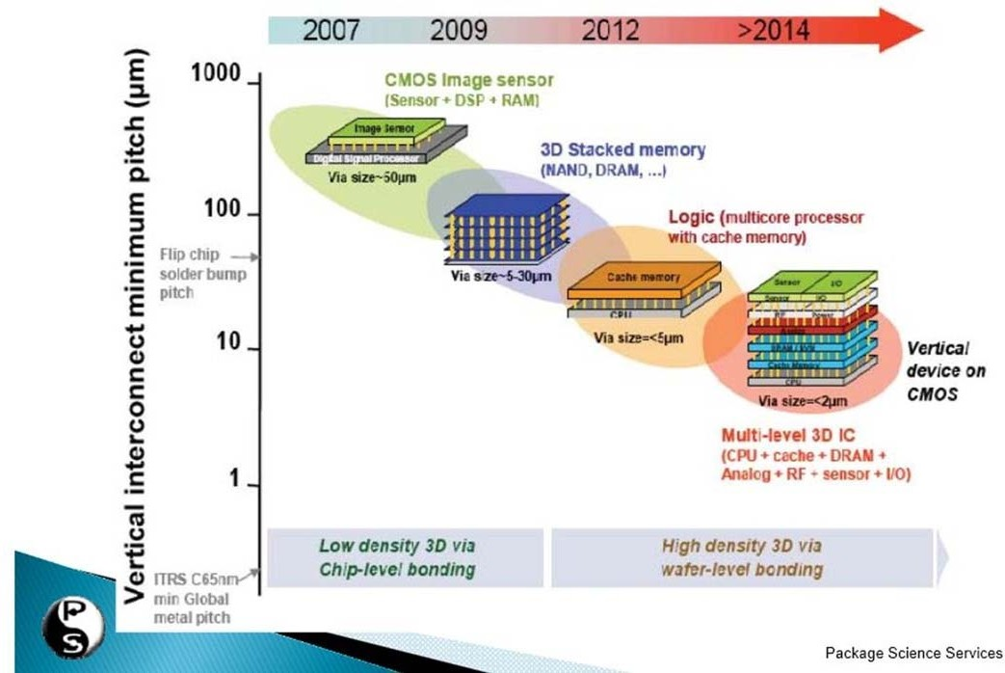

At the research front, there is also very active research on how to develop new functional sensors and concepts. One example is the incorporation of nanostructured parts (nanowires) in electronic devices to establish new logical devices or sensors. Another example is the mixing of electronics with biochemistry to develop ways to sense or manipulate tissue or biofluids.

* 1. **Sustainable electronics**

Electronics has a high impact on the environment, but it can also help in reducing many dangerous effects.

ELECTRONICS 🡪 both part of the problem and the solution!

BAD: poisoning, batteries, Cadmium

GOOD: solar panels, light, information

Many regulations, but not every country has adopted them:

* **RoHS**(The Restriction of Hazardous Substances Directive 2002/95/EC, (RoHS 1) EU
* **Waste Electrical and Electronic Equipment Directive** (WEEE) 2002/96/EC sets collection, recycling and recovery targets for electrical goods

CHALLENGES:

* IoT: sensors and devices are quite difficult to be recycled
* Battery revolution: we need more efficient batteries, with non-azardous compositions
* Trace element shortages (carenza), e.g. rare earth materials used in displays
* Dissolvable electronics and packaging: Truly sustainable electronics should just dissolve itself and leave no footprint for future generations
* Energy consumption associated with production, distribution and destruction

1. **Materials**
   1. 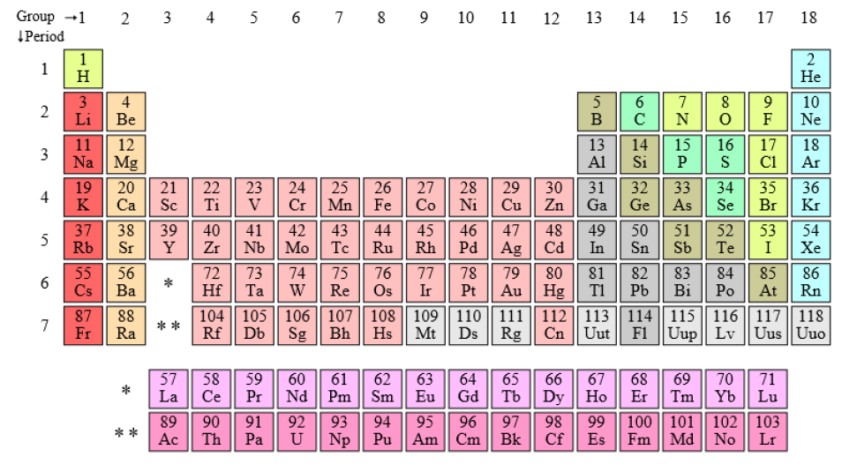**General features**

Periodic table of elements 🡪 elements are stored depending on their electronic structure

* On the eight: elements have completely filled-out shells 🡪 noble gasses
* On the left: Alkaline metals and alkaline earth metals 🡪 the 1st group elements are more reactive
* In between: metals + semiconductors + non-metals

Metals:

* Copper 🡪 most used in electronics
* Ag 🡪 best heat conductor and also good electricity conductor
* Au 🡪 good conductor
* In general, Cu, Au, Ag, Ni, Pd, Pt 🡪 all good conductors

Semiconductors: Si, Ge, Se, As 🡪 building blocks for SC

Fe + C 🡪 steel

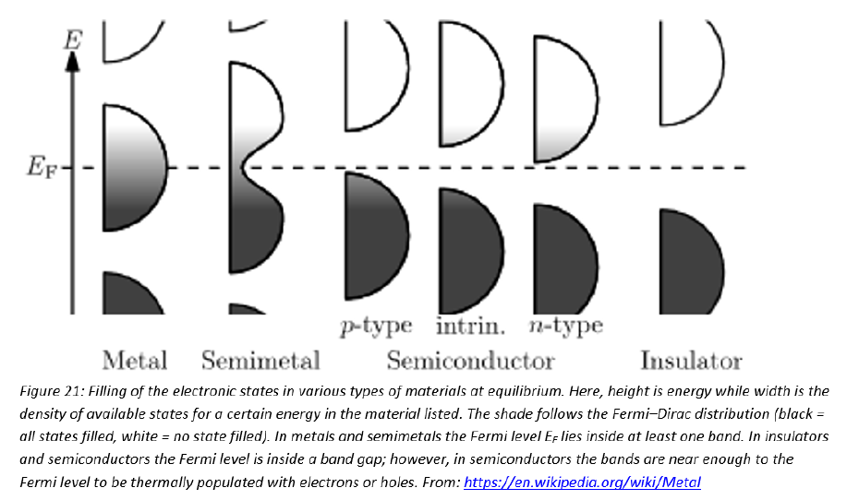How can we distinguish metals, semiconductors and insulators? **THEORY OF SOLIDS**

The innermost electron energy levels are typically completely ﬁlled and tightly bound to the nucleus. However, the outer shells are inﬂuenced by the ﬁelds of other nuclei. From quantum mechanical considerations, the energy levels that are inﬂuenced by a very large number of nuclei form a quasi-continuous band. **The outermost energy band or valence band provides the basis for the prediction of the properties of a solid**

* If the band is partially filled, the electrons can pick up enough energy from an electric ﬁeld to be able to “jump" to a nearby higher energy level in that band, where they can easily be available for conduction. This is the typical situation for metals. The electrons in the conduction band are referred to as **free electrons** and can be considered a classic gas of conduction electrons moving freely thorugh a fixed lattice of ion cores.
* substances which have completely ﬁlled shells in the form of single atoms, but have overlapping bands in the lattice are called semimelals 🡪 In some elements the band above the valence band overlaps with the valence band itself. The overlap between 3s and 3p in Magnesium bands creates available energy states in these lattices, but this overlap does not occur if we consider an isolated atom.
* For insulators, the valence and conduction hands are separated by a large energy gap. The electrons cannot jump easily to the conduction band. They stay in the valence bang where they are tightly bound to are nearby nucleus and hence immobile for conduction. For insulators valence band is completely filled and there are no electrons in the next band (at null temperature). The energy gap is too large to let the electrons be promoted in the conduction band.

Example: polymers and ceramics, quartz (silica) being known as the best insulator

* For semiconductors the forbidden gap is much smaller. This means that some of the electrons have enough energy to jump into the conduction band. The number of excited electrons in an intrinsic semiconductor is exponentially dependent on the absolute temperature. Semiconductors are doped with other elements to improve their conductivity and control their current carriers.
  + When pentavalent atoms are added to a pure semiconductor, there is an excess electron that is not covalent bonded to any atom. These are called **N-type** semiconductors, where electrons are the majority charge-carriers.
  + when a trivalent atom is added to form a **P-type** semiconductor, there is a deﬁciency of electrons, creating a vacancy or hole. The movement of holes from one atom to another consumes charge motion.

Materials can be classified depending on the following properties:

* electrical properties
* mechanical properties
* chemical properties
* metallurgical properties
* low flammability
* corrosion resistance
* stability
* compatibility with other materials used
* weight
* price
* ease of processing
* low absorption of moisture

Let’s now analyze the different features:

* 1. **Metals**

A metal is a material that when freshly prepared, polished, or fractured, shows a lustrous/shiny appearance, and conducts electricity and heat relatively well. Metals are typically malleable (they can be hammered into thin sheets) or ductile (can be drawn into wires). Most metals are either a chemical element such as iron or an alloy (composition of several chemical elements) such as stainless steel.

In physics, a metal is generally regarded as any substance capable of conducting electricity at a temperature of absolute zero.

* good electrical and thermal conductivity
* they are used as mechanical construction materials.
* Copper is a particularly important element in electronics: very high electrical and thermal conductivity, used in foil conductors, lead frames in component packages, thick film conductor materials, heat sinks in power electronic modules, etc.
* Aluminum has similar advantages + low weight and price. Commonly used for mechanical carrying structures, heat sinks, cooling towers. In semiconductor components it is used for bonding wires and circuit metallisation, etc.
* Pure metals TCE = 15 - 30 ppm per degree centigrade, much higher than the semiconductors and most ceramics
* Chemical reactivity varies from very low (Noble metals like gold and platinum), to highly reactive.
* Mechanical properties also vary widely: pure gold, silver and indium are soft, while some of the others are very hard. Mechanical properties may depend on the processing (heat treatment, rolling, etc.), and change with small amounts of additives from other elements.

**ALLOYS**

* have poorer conductivity, both electrical and thermal
* used to achieve better mechanical properties, or often to custom-tailor a desired thermal expansion coefficient: Invar TCE = 1.5 ppm/°C, Kovar = 5.3 ppm/°C, matched to glass, "Alloy 42" = 4.9 ppm/°C, close to that of silicon
* lower melting point than the elements in them and they are used as soldering metals.

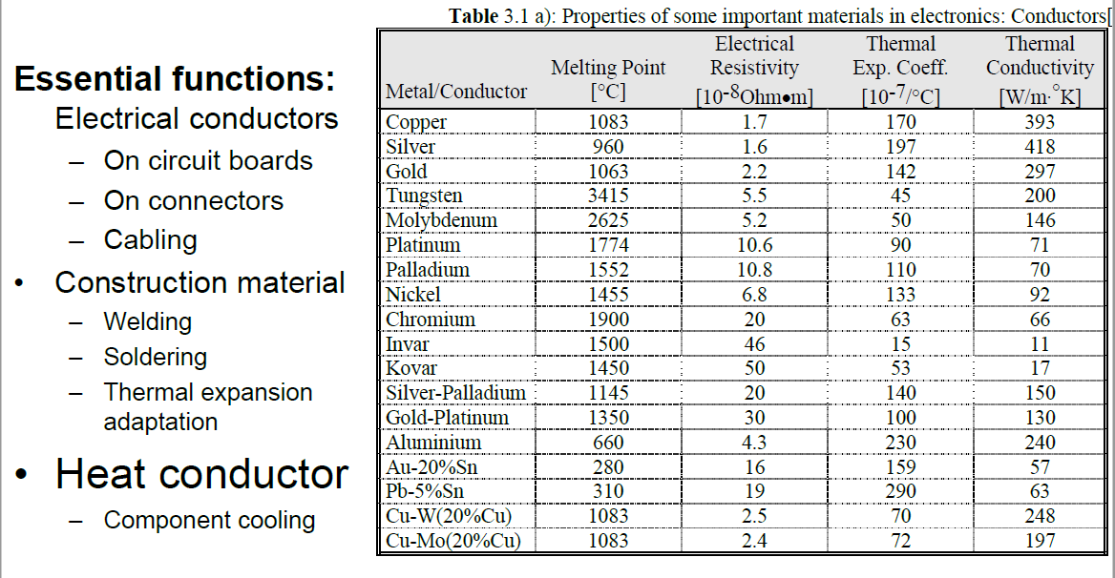

Important features in the table:

* Melting point:
  + Copper - Silver – Gold it is around 1000°C
  + Aluminum: much lower, around 600°C, 🡪 it cannot be used in ceramic circuits because ceramic substrates are exposed to high temperatures
  + Au – 20% Sn / Pb – 5% Sn 🡪 they have a low melting temperature: the message is that we can reduce the T of melting by adding few Sn to Au for example. This is very useful!
* Resistivity:
  + Metals: very low
  + In alloys it increases
* Thermal conductivity: silver is the best
* Thermal expansion coefficient:
  + Invar/Kovar 🡪 designed to have low TEC
  1. **Semiconductors**

Most common 🡪 Si and GaAs

* Crystalline structure
* high thermal conductivity, around 150 W/m
* have very low TCE, around 2.5 ppm/K (Remember Si = 2.6 ppm/K).
* electrical conductivity may be changed over many orders of magnitude by controlled doping.
* Silicon can be "machined" in very interesting ways by anisotropic etching. It has many exciting possibilities as a "mechanical" material. The material keeps its elastic properties practically until it breaks. It is also important for Si that it makes an oxide with very good properties 🡪 SiO2
  1. **Ceramics**

Ceramics: inorganic and non-metallic materials that are artificially manufactured, by high temperature reactions (>600 °C)

* Most interesting for electronics are alumina (Al2O3), aluminium nitride (AlN), beryllia (BeO), silicon carbide (SiC), and glass ceramics.
* Ceramics are made by the **powder method**:
  + the material is made into a powder, mixed with glass particles, organic binders and solvents in two ways:
    - pressing them together in a plate, for example
    - tape casting: this process is used for manufacturing of thin layers of ceramic. From a slurry of for example alumina powder, glass, solvents and binders a thin soft layer is made in the desired width as the material moves through an opening in the bottom of the slurry container, down on a moveable transport band. The distance between the bottom of the opening in the container and the band is controlled with great precision, and it determines the thickness of the layer of ceramic. The consistency is soft and pliable, and the ceramic in this form is called "green tape". After being cut to desired lengths, the material is further processed, by metallisation, punching of holes, etc. Often many layers are laminated on top of each other under pressure

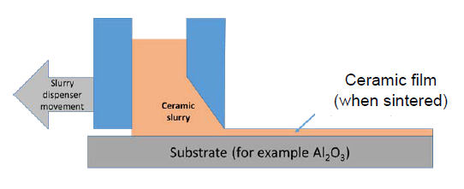

* + Afterwards the material is sintered (heat treated) at temperatures 800 - 1600 °C. During the sintering the binder and solvents are evaporated and the powder particles are bound together. During the process the material typically shrinks 15 - 20 % linearly.

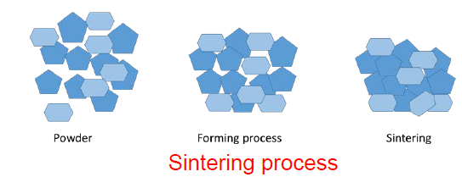

* Ceramics are brittle and crack easily. They are chemically stable and have a good stability in their mechanical properties up to high temperatures. However, they are often difficult to machine after sintering, and they tolerate little mechanical shock.
* Used as substrates in hybrid technology, for component packages, base material in surface mounted resistors, dielectric in capacitors, piezoelectric components, magnet cores (ferrites), etc. Alumina (Al2O3, 90 - 99 %) is the most used ceramics.
* We can see that ceramics have a very wide range of TCE values: from negative to 20 ppm/K. In general it is lower than for metals

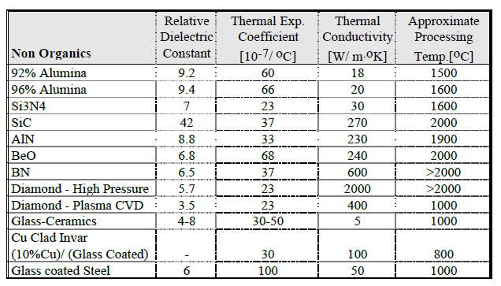

* 1. **Glasses**

A glass is an amorphous, supercooled liquid 🡪 it normally has no regular crystalline structure, and it becomes fluid when re-heated.

EXCEPTION: some materials called **devitrifying glasses**, or glass ceramics, convert to a crystalline state after heating, but do not reflow upon reheating.

* Uses:
  + matrix in thick film pastes
  + Insulator layer and binder material on ceramic circuit boards
  + Isolation on electrical feedthroughs
* Glasses can be available with a wide range of properties

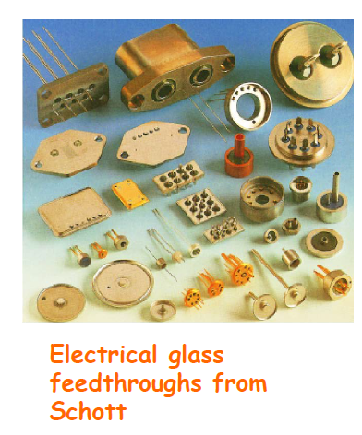

* 1. **Plastics**

Plastic is a large group of organic materials that harden and keep their shape after a moulding or forming process with heat and pressure.

They use polymers as a main ingredient. Most commonly, the continuously linked backbone of a polymer used for the preparation of plastics consists mainly of carbon atoms.

POLYMERS: A **polymer** is a substance or material consisting of very large molecules, or macromolecules, composed of many repeating subunits.

* Usages in electronics:
  + structural materials (boxes, component substrates, connectors, etc.),
  + for thin dielectric layers on circuit boards
  + encapsulation of components
  + electrically conducting or insulating glues, as process materials in production processes (photoresist, etch resist, etc.)
  + as binder for printing pastes in hybrid technology
  + photoresistors in circuit board productions
* BASIC GENERAL FEATURES FOR ELECTRONICS APPLICATIONS:
  + High electrical resistivity, high breakdown field, low dielectric losses, low dielectric constant
  + Thermal and mechanical stability up to the working temperature of the electronics (in general plastics are stable up to 100-200°C)
  + Thermal expansion: 30 – 300 ppm/K 🡪 In general it is higher than in metals and ceramics. This can cause high material stress and possibly cracking. It can also be modified by additives.
  + High mechanical strength for certain applications, softness and flexibility for other applications.
  + Low weight density 🡪 1.0 – 1.5 g/cm3
  + Low thermal conductivity: 0.2 – 0.4 W/K*m this can be a disadvantage when they are used as substrates. This can be increased by adding other particles (ceramics, metals…) to the mixture,
  + Chemical resistance to solvents, etc.
  + Good adhesion to other materials
  + Ease of processing
  + Low water absorption and small change of the properties during the effect of moisture
* ONE OF THE MOST IMPORTANT FEATURE: THEY ARE VERY CHEAP!

**COMPOSITION**

Plastics are synthetic **polymers** 🡪 They consist of very long and complex organic molecules.

Basic building block 🡪 normally is the benzene molecule. We can add other components to the benzenic ring and create **monomers.** When such monomers are bound together in a periodic structure, in a "polymerisation process", we get the analogous polymer composition.

By addition of smaller amounts of other elements or compositions, selected properties can be changed and improved considerably.

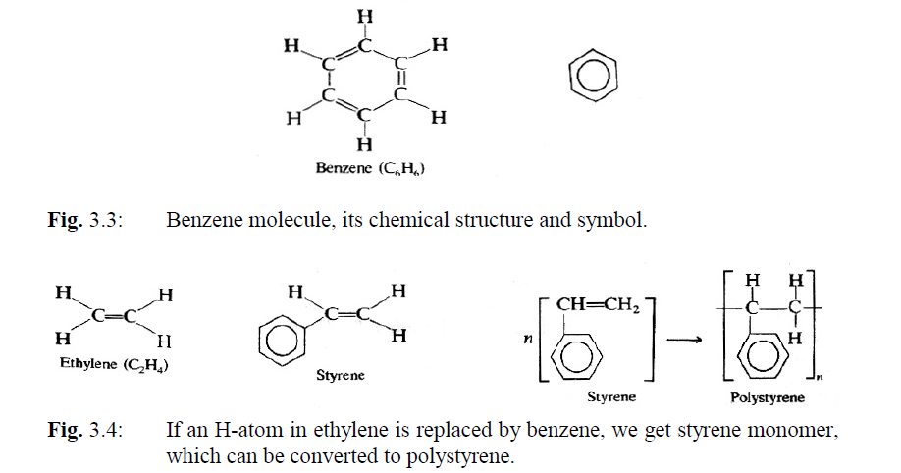

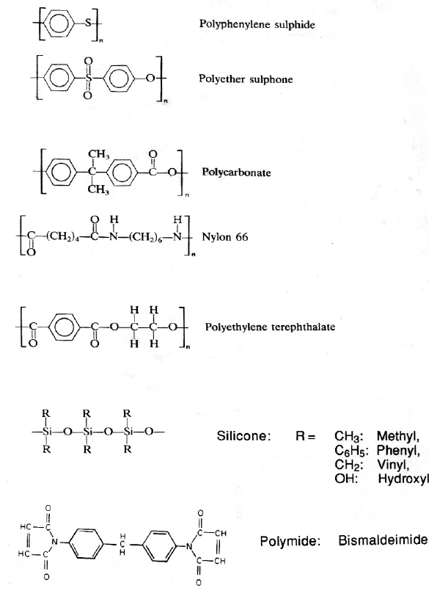

The polymers may be linear, branched, or cross-linked. The cross-linking gives the best chemical stability.

Two important groups of plastics are the:

* **Thermoplastic materials:** melts when it is heated in a reversible process
* **Thermosetting materials**: they are irreversibly cross bound during the polymerisation process, and they cannot be brought back to their original state.

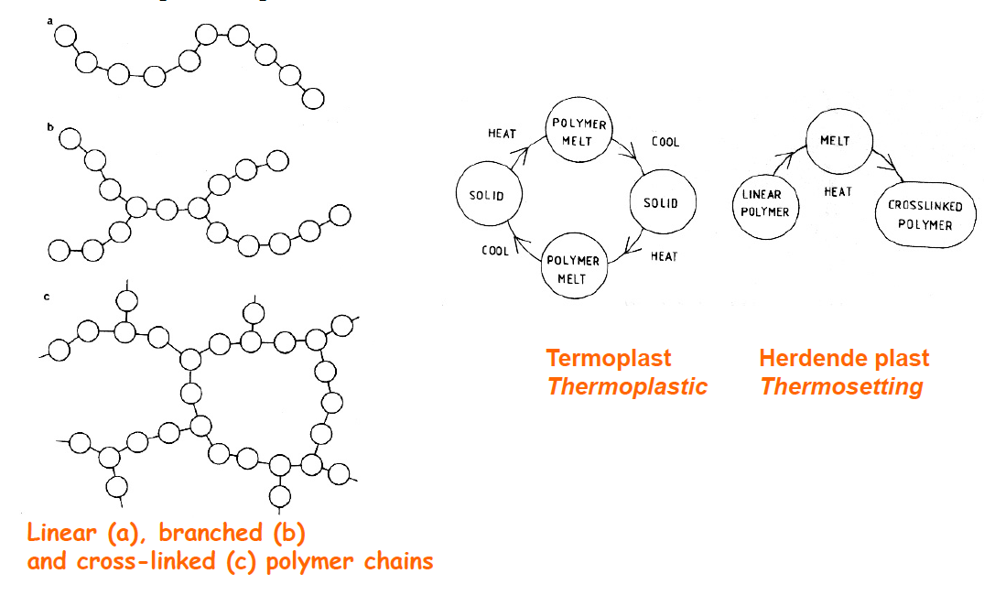

**POLYMERISATION**: it can take place

* by heating
* through pressure, for example with epoxy.
* By exposure exposure to UV-radiation
* two components are stored separately, and the curing starts immediately when they are mixed, even at room temperature (two component system).

**GLASS TRANSITION TEMPERATURE**

The glass transition temperature characterizes the transition of an amorphous material from a brittle state to a rubbery state. Crystalline materials do not show this transition.

Glass transition is manifested by drastic changes in many of the material’s physical properties, such as volume and modulus. The thermal expansion coefficient increases above Tg.

Polymers are subjected to severe thermomechanical stresses and dimension instabilities, related to warpage (the extent or result of being bent or twisted out of shape, typically as a result of the effects of heat or damp) above the glass transition temperature. For many applications, it is important to keep the material above Tg for the shortest time possible. A prolonged permanence in that region could cause an irreversible transition.

Molecular motion is the most important factor in determining Tg 🡪 Molecular chains tend to ﬂuctuate because of thermal energy. The ﬂuctuations are characterized by a distribution of relaxation times that are temperature dependent:

* Below Tg the molecular motion is hampered (ostacolato, relaxation times are very high).
* Above Tg the molecular chains possess sufﬁcient thermal energy to ﬂuctuate between different conformations (rotation of side groups, etc).

Some materials show two distinct relaxation times, one corresponding to the main chain and the other to the side chains. Hence these materials show two glass transition temperatures.

In general:

* Linear polymers and long flexible have very low Tg
* Bulky side groups decrease the mobility of the chain, thus raising Tg.
* Highest Tg 🡪 polymide = 350°C
* Lowest Tg 🡪 silicone
* Range of epoxies: 120 – 200 °C
* (the second graph is referred to epoxy)

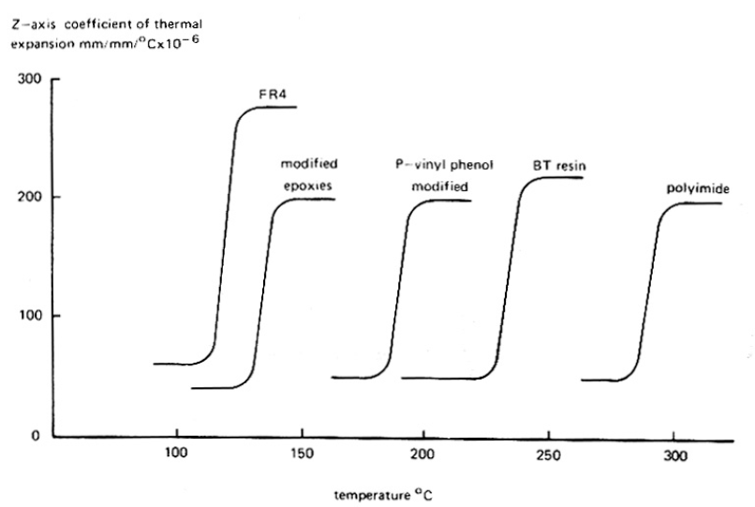

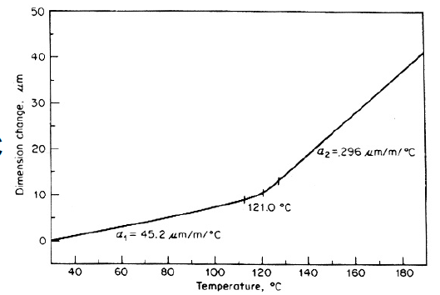

* 1. **Physics behind the materials**

Up to now we discussed many materials and their properties. But which are the general parameters which characterize each of the previously cited categories?

* + 1. **Thermal conductivity**

Main equation 🡪 Fourier’s law: the amount of heat Q transferred per unit time (which is the flux of heat) through a surface with area A is proportional to the temperature gradient. The proportionality coefficient is the thermal conductivity.

$$\frac{dQ}{dt}= -λA∇T$$

Notice the minus sign: heat goes from high temperature region to low temperature region, thus it is opposite to the gradient of temperature. Inserting a minus sign makes the thermal conductivity a positive number.

* Thermal conductivity 🡪 tensor with 9 components.
* Measures the ease with which heat can flow through a surface.
* It is extremely important in IC when they produce a lot of heat 🡪 dissipation is essential! Temperature can be controlled through high-thermal coefficient materials.
* Generally speaking: increasing the average temperature of a component by 10°C reduces its life time to half of its value!

Heat conduction comes from 2 contributions:

* PHONONS:
  + They are quanta of lattice vibrations or oscillations. Their number is not conserved: they are created with high temperature and destroyed with low temperature.
  + Main process responsible for heat conduction in non-metallic materials
  + Scattering of phonons reduced the capability of the material in conducting heat: regular crystals with low impurities are good conductors since they guarantee a low scattering probability for phonons. Impurities or different dimensions for the atoms in the crystal increase the probability. Polymers and plastics 🡪 amorphous structure and thus low thermal conductivity.
* ELECTRONIC MOVEMENT:
  + The flow of current and of heat in metals is based on the same principle: electrons move inside the material! 🡪 intimate link between electrical conduction and heat conduction. This is expressed by Wiedemann-Franz law: the ratio of electrical conductivity and thermal conductivity is proportional to the temperature

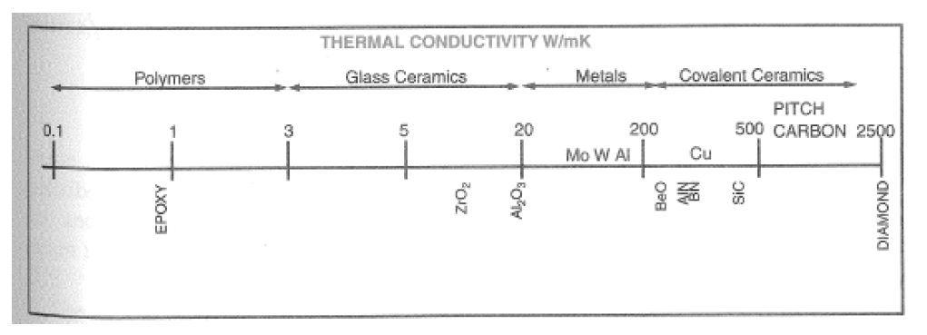

* + 1. **Electrical permittivity**

Consider an electric field applied across a dielectric or an insulator 🡪 positive charges tend to go towards the negative end of the electric field and viceversa for the negative charges 🡪 polarization is induced 🡪 electric flux density inside the material increases (we have additional field lines for every dipole that is created inside the material, thus the density becomes higher).

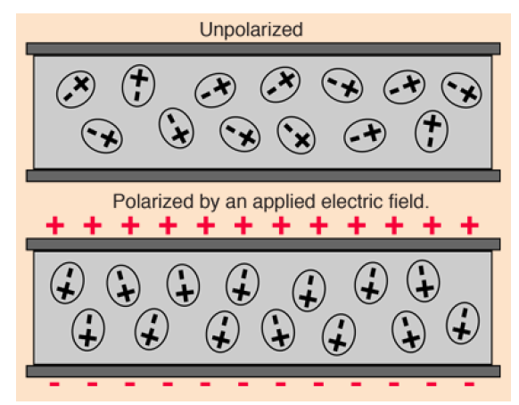

**Electric flux:**  Mathematically, electric flux is the integral of the normal component of the electric field over a given area.

$$ϕ=\int{\vec{E} ⋅d\vec{A}}$$

Conceptually the electric flux can be thought of as "the number of field lines" passing through a given area.

**Electric flux density:** Electric flux density is the electric flux per unit area, and is a measure of strength of the normal component of the electric field averaged over the area of integration.

Define **electrical permittivity** ε as the ratio of the flux density in the material to that in vacuum.

Alternative definition: based on capacity of the dielectric 🡪 the increased flux density manifests through an increased capability in charge storage, which is nothing else that an increased capacity.

Define **electrical permittivity** ε as the ratio of the capacity for a capacitor measured with the material inside and with vacuum.

$$ϵ_{r}=\frac{C_{material}}{C_{vacuum}}$$

Important parameter for packaging: it enters in the formula for the propagation velocity of a signal through the cables and connections 🡪 causes delays.

$$v=\frac{c}{ϵ_{r}}$$

Electric permittivity shows also a dependence on the frequency of the signal traversing the material 🡪 we did not discuss this.

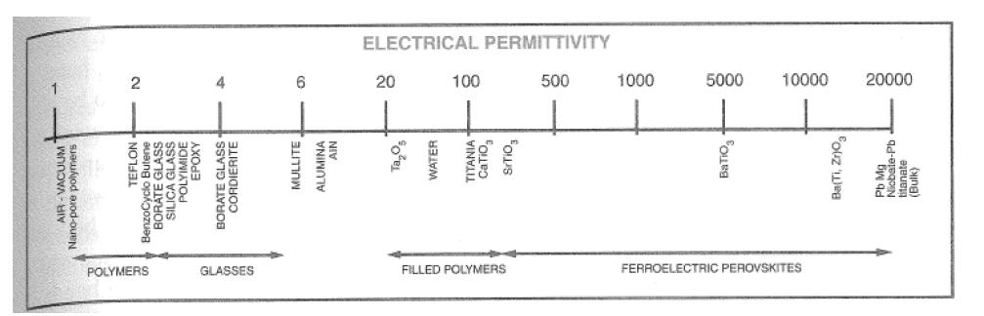

Materials:

* Polymers and glasses have the poorest permittivity values
* Some materials show polarization even in the absence of a ﬁeld (spontaneous polarization) 🡪 ferroelectric materials.

ε = 1k -20k

The polarization results from the asymmetric crystal structure in these ionic compounds, where certain ions are slightly displaced from their electrically neutral positions. Ferroelectric behavior is seen below a certain temperature, referred to as the Curie temperature. Above it the material becomes paraelectric.

Domains: regions spontaneously polarized in ferroelectric materials.

For electronic applications we distinguish:

* Low-K: Materials that form the medium separating transmission lines should have low dielectric constant 🡪 polymers and low—K ceramics are favoured
* High-K: devices for decoupling capacitors, ﬁlters, etc, need high-K materials.

**DELAY:** When a sinusoidal electromotive forte (EMF) is applied at low frequencies the polarization inside a dielectric material develop completely before the ﬁeld reverses. The time-variant polarization is equivalent to an alternating current, which has a phase delay with respect to the EMF exactly by 90 degrees.

Think about this: the voltage becomes positive, the polarization starts to build up. The frequency of the voltage is sufficiently high that the peak in the voltage is reached before the complete build up of the polarization. The polarization however continues even when the voltage is descending, but still positive. Then the polarizability reaches its maximum when the voltage has become null and subsequently it starts descreasing. There is a phase shift of 90 degrees between polarization and voltage!

MAX POLARIZABILITY: when the dipoles can oscillate in resonance to the ﬁeld.

At higher frequencies, when the polarization can no longer keep up with the EMF, the current has a phase delay with the voltage of 90 - d. 🡪 the current has a component that is in-phase with the voltage, hence resulting in a dissipation of energy.

The energy loss can be viewed as resulting from the molecular friction that opposes the molecular motion, leading to an energy loss during polarization.

**Dielectric loss:** measures the energy dissipated per cycle.

How do we model them 🡪 by including a resistive element in series with the capacitor (we’ll see this aspect when treating these components).

Losses are quantified by representing the permittivity as complex: ε = ε(k’ + jk’’). The imaginary part accounts for losses and it can be parametrized by inserting an equivalent series resistance in the circuit.

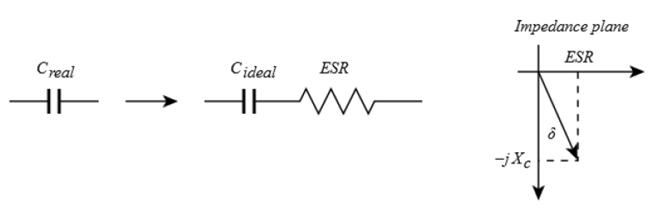

Loss tangent 🡪 parametrizes the dielectric loss. It is defined as the angle between the capacitor's impedance vector and the negative reactive axis.

$$\tan\left(δ\right)= \frac{ESR}{1/ωC}=\frac{1}{Q}$$

Where Q is the quality factor.

* + 1. **Coefficient of thermal expansion**

CTE = dimensional change that occurs per unit rise in temperature per unit length

$$CTE= \frac{1}{l}\frac{dl}{dT}$$

Main concern: when we connect two materials with different CTE (for example, a resistor on a substrate), when temperature changes they can undergo strain and deformations because they do not expand in the same way! 🡪 lifetime is reduced.

Typical values: from -1*10^-6 to 200*10^-6 🡪 units = 1/°C or ppm/°C

Stronger bonds between components in a material 🡪 lower CTE:

* Covalent bonds and loosely (blandamente) packed structures lead to low CTE
* Polymers have weaker bonds 🡪 high CTE
* Above glass transition temperature, CTE increases!
* A special glass ceramic has been developed to match the CTE of Si 🡪 reduces stresses and strains!

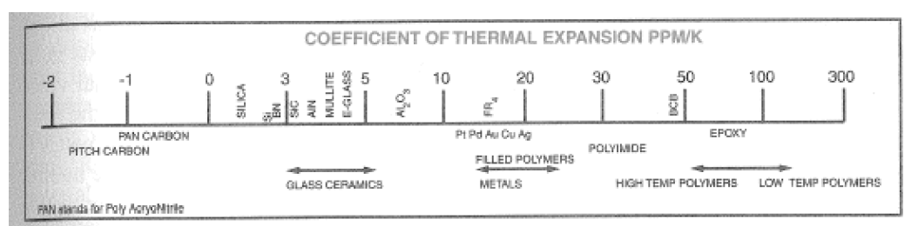**CTE(Si) = 2.6 ppm/°C**

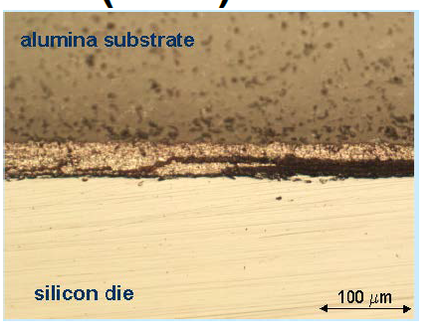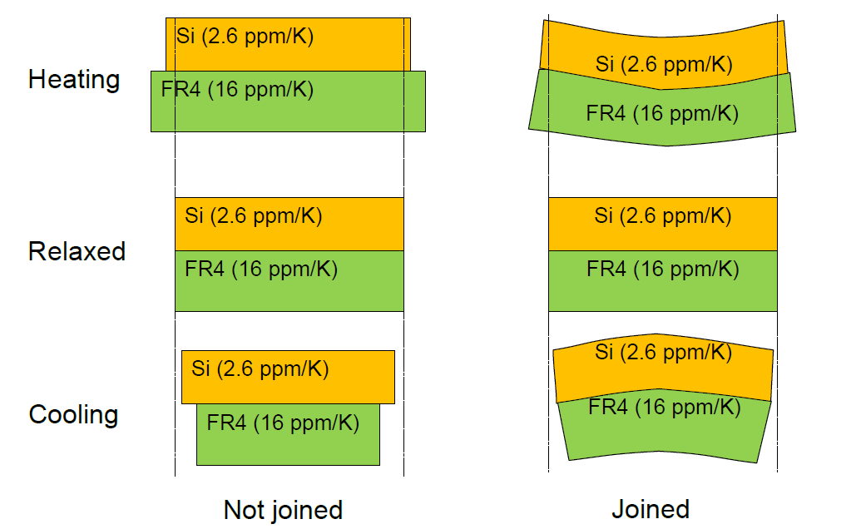

* + 1. **Young’s Modulus**

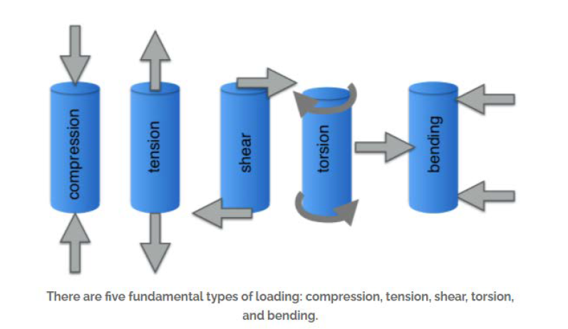Materials can be subjected to forces 🡪 there are different kind of actions that we can perform on a sample

In general, relation between force and deformation is expressed by two 9-components tensors

* Stress: force per unit area applied to the body
* Strain: deformation per unit length produced as a consequence of an applied stress

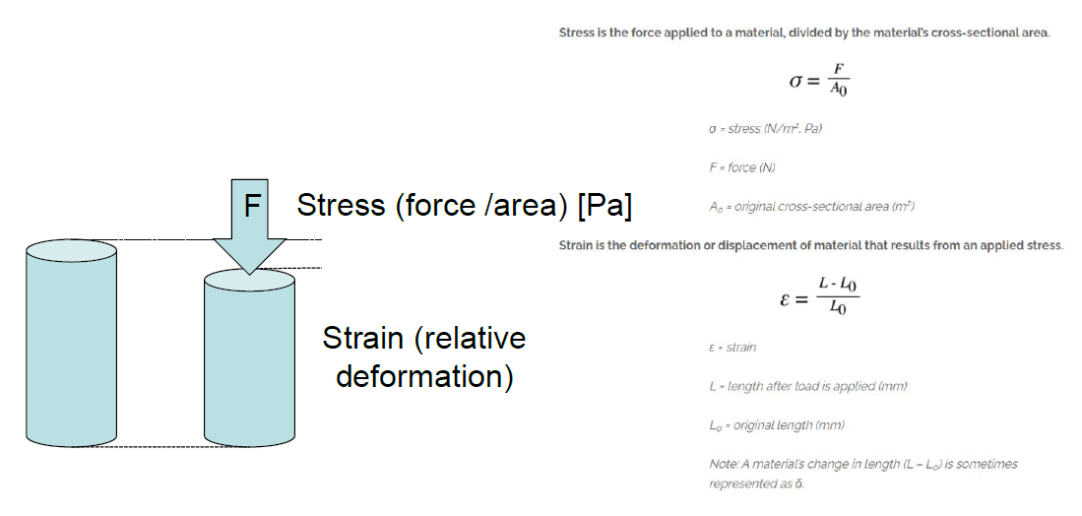

In general:

* for low stresses 🡪 linear relation between stress and strain.
* For high stresses 🡪 plastic behaviour begins and the material irreversibly breaks/fails.

**Young modulus:** stress needed to generate a unitary strain inside a material. It is evaluated as the angular coefficient for the linear dependence between stress and strain in the elastic regime.

**Stiffness:** ability of a material to resist elastic deformation or deflection upon loading 🡪 it is given by both the Young modulus of the material and the geometrical shape of the material.

Materials: the Young modulus is given by several contributions, but in general we can say that stronger bonds between molecules in a material 🡪 higher Young modulus!

In detail:

* Ceramics fails within the elastic regime, they do not have a plastic deformation
* Polymers: considerable plastic and non-recoverable deformations. Contributions: nature of secondary bondings, presence of bulky side groups, cross-linkings
* Metals: considerable plastic and non-recoverable deformations.
* Combinations of materials can be used to enforce structures: when putting materials together always try to match the CTE!
* Fractures are one of the most common causes of failures for the ICs 🡪 we’ll see this aspect when talking about reliability!

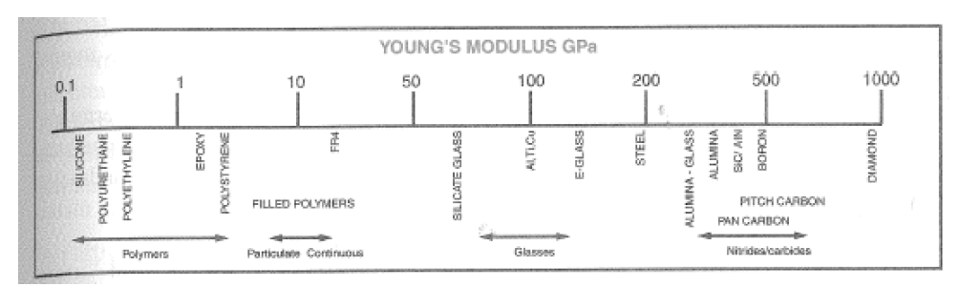

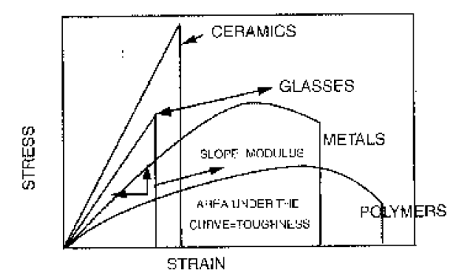

1. **Processes**

Link for video explaining some of the processes: https://youtu.be/8-WGaAmpfOU

In this section we are going to analyse the most important processes for ICs and PCB production. They are:

* Stencil printing
* Photolithography
* Etching
* Plating
* Deposition–Vacuum evaporation
  + RF and DC sputtering
* Methods for electrical and mechanical contact:
  + Soldering
  + Gluing
  + Connections
    - Wire-bonding
    - Flip-chip
  1. **Screen printing and stencil printing**

**Screen printing (or silk printing)**: technique for the transfer of patterns and deposition of materials. One proceeds by in pressing material in paste form through the openings in a printing screen.

Originally screens were made by silk (seta), nowadays from polyester filaments or metal wires.

* The screen is stretched and tensioned on a metal frame
* Preparation of the printing screen: one deposits a photo sensitive film (emulsion) with desirable thickness on the screen.
  + The emulsion: polyvinyl alcohol or -acetate, made light sensitive by additives, e.g. sodium bicarbonate. It softens in water and penetrates into the woven structure (struttura intrecciata).
  + After drying it is exposed through a photomask with the desired pattern, dried, developed and cured (polimerizzato) like the resist in photolithography.
  + Screen/stencil is complete now
* The paste that is to be printed is forced over the screen by a squeegee which is made of polyurethane rubber or similar material. Normally there is a distance of a few millimetres between screen and substrate ("snapoff"), and the screen is forced into contact with the substrate by the pressure of the squeegee.
* CORE: Where there are openings in the resist on the screen, the paste is pressed down onto the substrate.
* After each printing step, everything is dried
* Screen printing is a craftmanship that requires experience and knowledge to give good and reproducible results.

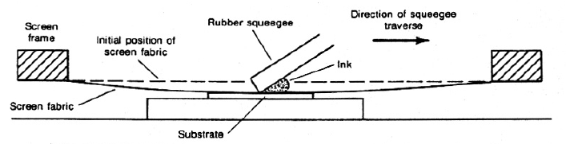

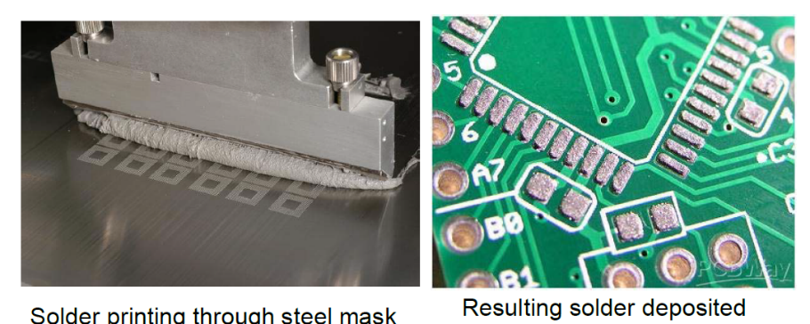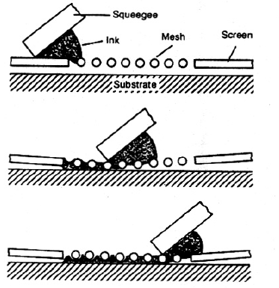

Important factors for good definition, accurate pattern placement and correct amounts of paste are, among others:

* Fineness of the screen and the wire (the number of wires per unit length, "mesh", and the wire diameter)
* Thickness of the resist
* Squeegee hardness, angle and speed of motion
* Tension in the screen and snap-off
* Viscosity and printing properties ("rheology") of the paste 🡪 Certain materials are added to the paste to give high "thixotropy": the paste will flow easily under the pressure of the squeegee, but it has high viscosity when it is not compressed. With high thixotropy narrow printing patterns will get steep walls after printing, since when the pressure from the squeegee is removed the paste returns viscous and does not wet other pieces of surface. This makes it possible to print patterns down toward 0.1 mm widths.

USAGE: Screen printing is used

* in the production of printed wiring boards
* thick film hybrid circuit 🡪 generally alumina (Al2O3) is used as substrate. Components are placed on the substrate by screen printing 🡪 generally based on ceramic pastes = glass particles (mechanical structure) + some materials to define the properties:
  + conductors: pastes containing metals (Ag-Pd) are used
  + Ru2O3 for resistors
  + Insulators made with dielectric pastes
  + Capacitors: 3 steps 🡪 conductive layer, dielectric, conductive layer
* sprinting of solder paste for surface mounting 🡪 For printing of solder paste to high precision, the printing screen is replaced with a thin plate of metal or plastic 🡪 **stencils**. The openings are etched in a photolithography process, or they are punched. Such printing stencils have better dimensional stability and better wear properties than woven screens, BUT one cannot make enclosed patterns or long patterns with short widths, and printing stencils are not suitable for printing of conductor patterns.

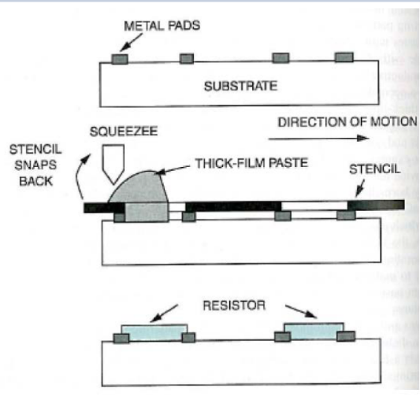

Typical screen parameters

* for thick film:
  + 80 - 400 mesh (number of wires per inch)
  + wire diameter 20 - 100 μm.
* For solder paste printing
  + 40 - 120 mesh typically used
  + wires 60 - 120 μm diameter

High mesh count, thin wire and thin emulsion 🡪 high resolution

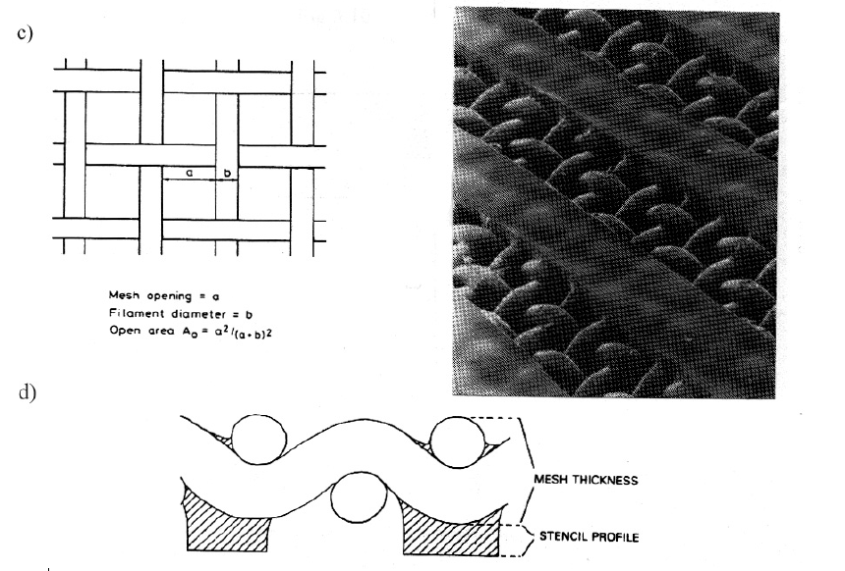BUT with thin emulsion 🡪 more fragile screen that is easily damaged.

* 1. **Spin coating**
* We place a substrate (Si waver) spinning at high speed
* A drop is put on the surface and spreads on the waver 🡪 uniform covering
* Empirical thickness:
$$thickness= \frac{constant}{\sqrt{angular velocity}}$$

* Process optimized for round wavers
* Thickness around 2-20 um

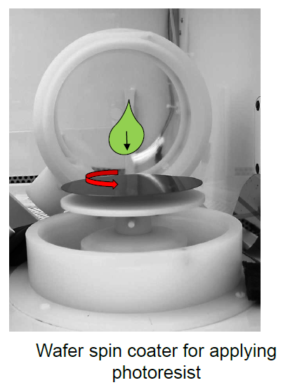

* 1. **Photolithography**

**Photolithography**:

* used for transfer and definition of patterns
* Accuracy and resolution down to 0.2 μm can be achieved, but industries are working for improvements.

PRODUCTION:

* Starting point is a pattern generated from a CAD on a photographic film (photomask)
* The film substrate is a plastic foil, or a glass plate when high precision is required
* The pattern on this film is made by exposure with laser or electron beam (more precise)
* Now the photomask is ready
* A thin layer of photosensitive material (photoresist) may be deposited on the object surface by spinning or spraying or screen printing or laminating on the resist in the form of a dry film 🡪 the photoresist is put on the whole surface, the photomask will cover part of it
* The surface is illuminated through the photo mask. Afterwards the resist is developed and cured by heating
* Two classes of photoresist behave differently:
  + Positively acting: illuminated parts become easily solvable after treating
  + Negatively acting: illuminated partis are difficult to solve

USAGES: Photolithography is used

* for printed wiring boards
* in hybrid technology
* on semiconductor wafers

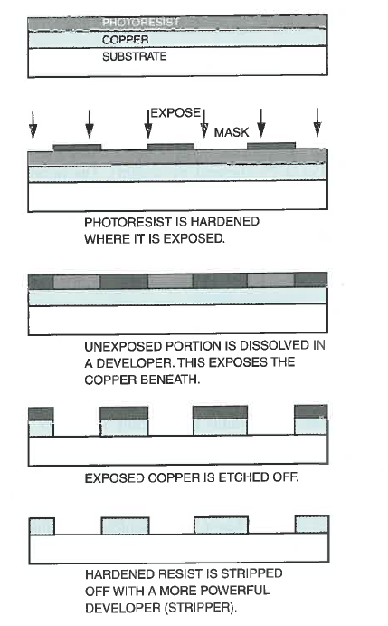

* 1. **Etching**

Subtractive process: we remove the metal that we do not need!

**Wet etching:**

* cover the whole board area with conductor metal
* masking by screen printing or photolithography
* removing the metal where it is not desired by dipping the sample in a chemical bath that dissolves the material, with the other parts of the surface being covered with an etch resist that is not attacked by the etchants
* Etchants: aqueous acidic or alkaline solutions. They can also be sprayed on to the surface.
* The speed of etching depends on the temperature, the composition and concentration of the etchant, how long the etching bath has been in use, circulation, etc
* Regeneration of the etchant is difficult, and the bath has to be discarded when its composition gets out of the specified range 🡪 pollution problem

Example of reactions

Etching of copper through iron chloride, with the following reactions:

FeCl3 + Cu -> FeCl2 + CuCl

In addition the following reaction takes place:

FeCl3 + CuCl -> FeCl2 + CuCl2

In this case: tin/lead is etched and is therefore not usable as "masking". But iron chloride does not attack organic films, which can be used as protection.

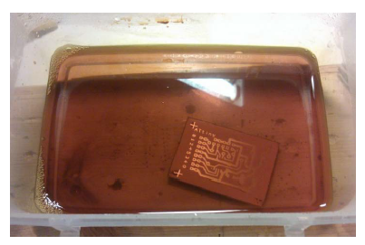

**Dry plasma/ reactive ion etching:**

**Reactive-ion etching** (**RIE**) is an etching technology used in microfabrication.

RIE uses chemically reactive plasma to remove material deposited on wafers. The plasma is generated under low pressure (vacuum) by an electromagnetic field. High-energy ions from the plasma attack the wafer surface and react with it.

PROCESS:

* Plasma is initiated in the system by applying a strong RF (radio frequency) electromagnetic field to two plates on the top and bottom plates inside the vacuum chamber. The bottom plane is above the wafer, but this one is electrically insulated with respect to the system (see figure).
* The oscillating electric field ionizes the gas molecules by stripping them of electrons, creating a plasma. (consider a plasma as a low pressure ionized gas).
* In each cycle of the field, the electrons are electrically accelerated up and down in the chamber, sometimes striking both the upper wall of the chamber and the wafer platter. At the same time, the much more massive ions move relatively little in response to the RF electric field.
* Electrons deposited on the wafer platter cause the platter to build up charge due to its DC isolation 🡪 large negative voltage on the platter, typically around a few hundred volts.The plasma itself develops a slightly positive charge due to the higher concentration of positive ions compared to free electrons.
* Because of the large voltage difference, the positive ions tend to drift toward the wafer platter, where they collide with the samples to be etched. The ions react chemically with the materials on the surface of the samples, but can also knock off (sputter) some material by transferring some of their kinetic energy.
* 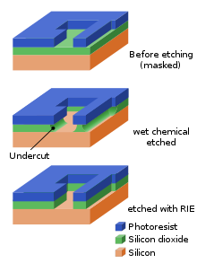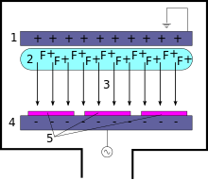Due to the mostly vertical delivery of reactive ions, reactive-ion etching can produce very anisotropic etch profiles, which contrast with the typically isotropic profiles of wet chemical etching.
  1. **Plating**

In general, plating processes are cheap and low-temperature processes 🡪 very used in thin-film applications

* + 1. **Electroplating**

This is a process in which the plating occurs on a conductive inserted in a electrolytic bath composed of a solution of the salt of the metal to be plated.

* A panel to plate is put inside a solution with containing Cu2+ ions 🡪 the panel is the negative electrode of an electrolytic cell, while the anode is constituted by a copper plane
* At the anode: Cu -> Cu2+ + 2e-
* At the cathode: Cu2+ + 2e- -> Cu
* 25-30 um of copper are usually plated
* A voltage is required
* The process works only for etching on conductive plates, not suitable for polymers for example
* Electrolytic plating normally is a simple process. It can give a high rate of deposition (tens of μm per hour). The structure in the deposited material depends of the speed of deposition (current density), temperature and type of plating bath.

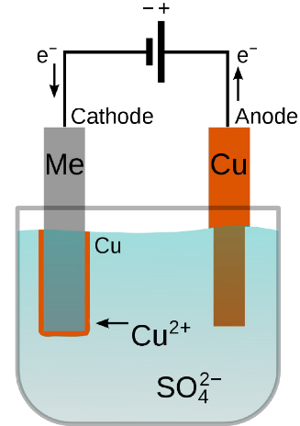

* + 1. **Electroless plating**

This mechanism for plating is an alternative to electroplating.

We describe the activation process:

* Put the panel into a solution rich of Sn2+ ions 🡪 they are absorbed by the material and will act as sensitizers
* We insert an acid solution containing Pd (or Cu, Ag, Au, Pt) 🡪 the acid solution releases the metal in ionic form. The reaction occurs on the surface of the plate: Sn2+ + Pd2+ -> Sn4+ + Pd
* In the plating process, Pd will catalyse the deposition of copper

Then the proper electroless plating:

* The plate rich with Pd is inserted in a bath containing Cu2+ (coming for example from a CuSO4 salt)
* Formaldehyde is a common reducing agent: in this bath Cu2+ is reduced into Cu that covers the whole surface of the plate
* Thickness around 0.5 um
* This is used as precursor process for the electroplating 🡪 an insulating plate becomes conductive and undergo electroplating
  1. **Vacuum deposition**

Thin metal films on hybrid substrates and semiconductor wafers are normally deposited by vacuum evaporation or by sputtering

* takes place in a chamber which is evacuated to 10-6 Torr.
  + Removes impurities that may compromise the deposition
  + Increases mean free path of particles to deposit
  + Reduced the vapour pressure and the temperature that we need to achieve a given deposition rate
* The metal that is to be deposited is placed in a plate of high temperature melting metal (e.g. W) 🡪 the "boat".
* The boat is heated:
  + by passing a high current through it
  + bombard it with an electron beam that is accelerated in an electric field with the boat as anode
* the metal evaporates and its molecules spread out upwards in all directions in the vacuum chamber. The molecules hit the substrate that is located on the substrate holder above.
* Layers under few um 🡪 used for corrosion protection

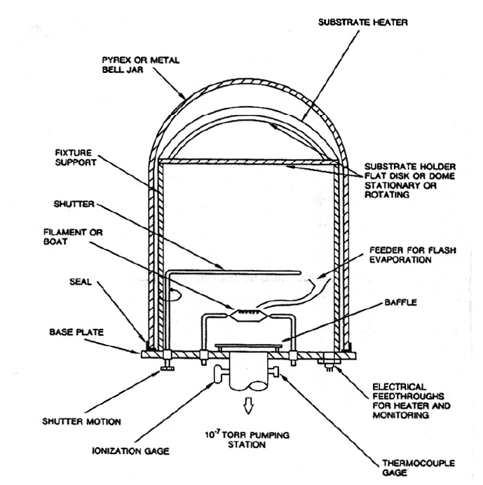

* 1. **Sputtering**
     1. **DC sputtering**

Sputtering is a process under low pressure where a "target" is bombarded by energetic positive ions.

TARGET = material which is hit by the accelerated particles

SUBSTRATE = material that is reached by particles emitted from the target

PROCESS:

* The plasma may be a noble gas, for example argon, at pressure 10^-3 – 10^-3 Torr. The gas is ionised in the strong electrical field, obtained by having 1000 - 2000 V between the target and the anode. A glow discharge is created in the argon gas, which is decomposed into positive ions and free electrons
* The ions are accelerated toward the cathode (target), they give off their charge by receiving electrons and are again neutral. Target material is torn off by the energy released. Energetic secondary electrons interact with neutral Ar atoms that are again ionised.
* The "sputtered" particles hit the substrate that is to be covered

FEATURES:

* Mostly used to deposit metals
* The simplest version is DC sputtering
* Typical deposition rates: 100 - 1000 Å per min
* Film thickness by sputtering is limited to a few μm
* **RF sputtering:** Electrically insulating target materials are not suitable for DC-sputtering, because they will be electrically charged and then disturb the glow discharge 🡪 Then AC radio frequency is used on the target holder electrode.
* **Magnetron sputtering**: uses permanent magnets to provide a field parallel to the target surface 🡪 electrons emitted by the target are captured here
  + Substrate will be cooler because only few electrons will bombard it
  + Deposition rate is enhanced due to electron-atom collision near the target

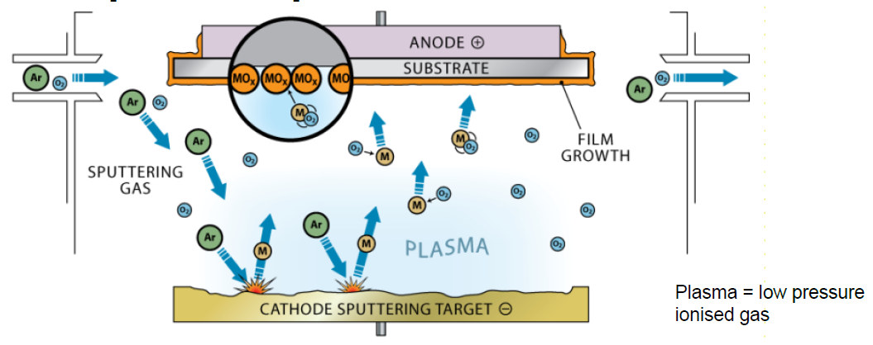

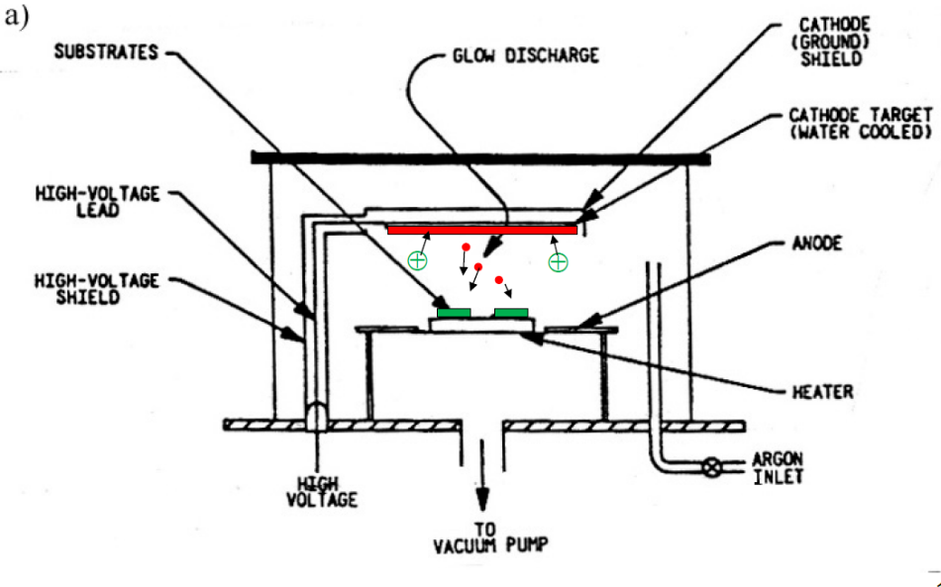

* 1. **Additive manufacturing: rapid prototyping techniques**

Rapid prototyping is a group of techniques used to quickly fabricate a threedimensional model of a physical part or assembly based on 3D CAD design.

For 3D printing we have 2 main techniques:

* **Fused filament fabrication:** a plastic filament is heated up and extruded on a platform layer by layer, creating the final structure. At each new level the platform is lowered
* **Stereolithography:** we use light to get part solidified. A laser illuminated the transparent bottom of a tank filled with a photosentitive resin which polymerizes when it gets in contact with the laser. At each new level the platform is lifted.

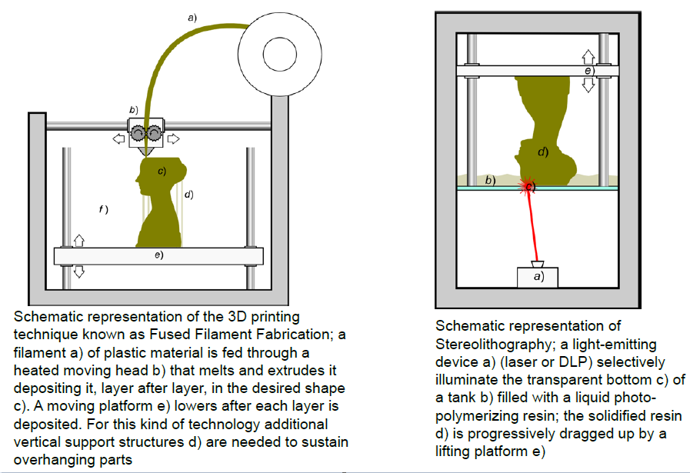

**Methods to establish electrical and mechanical contacts**

* 1. **Soldering**

Soldering is the dominating method for electrical connection of electronic components. It is also important for mechanically assembling and to establish good thermal contact.

SOLDERING: establishment of a metallic bond between two metallic surfaces by use of a different liquid (solder-) metal.

Soldering consists in wetting the surfaces that are to be joined by the molten solder metal and cooling until it solidifies.

**Hard soldering: s**oldering with alloys that melts at high temperatures 🡪 it is used mainly for connecting structural mechanical parts

**Soft soldering:** In electronics, soft soldering with tin/lead alloys, with melting point around 180 °C, dominates. The materials are cheap, the process can easily be automated, and the parts may easily be taken apart for repair.

Yet soldering is the source of a large fraction of the faults in the electronics, during production as well as during the field life of the product afterwards. Some factors that determine solder quality:

* Metallurgical and mechanical properties of the solder metal and compatibility with the metal on the surfaces to be joined
* Wetting
* Surface properties
* Grain structure in the solder metal.
  + 1. **Wetting**

Wetting is the ability of liquids to form interfaces with solid surfaces. To determine the degree of wetting, the contact angle that is formed between the liquid and the solid surface is measured. The smaller the contact angle and the smaller the surface tension, the greater the degree of wetting.

* Poor wetting: the solder metal will tend to contract into a spherical shape seeking the minimum surface area because of surface tension in the solder metal.
* Good wetting: the surface tension between the liquid and the base material dominates and stretches the drop out.

The drop and the base material will minimise the free energy that also includes the surface tension in the base material. This can be described by Young's equation

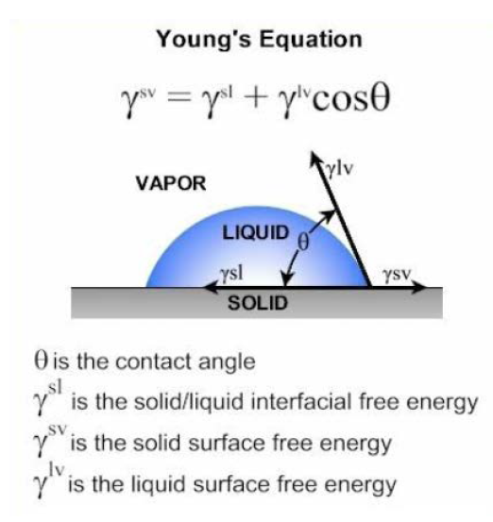

On the book we have that gamma is the surface tension, not the free energy.

Surface properties that determine the wetting depend on many parameters:

* The combination of materials
* purity is important: oxide layer on top of copper or solder metal for example, may ruin the wetting
* The surface structure and the roughness
* In a good solder joint the atoms diffuse from the solder metal into the surface of the base material down to 0.1 - 1 μm. In order to improve the wetting fluxes are used 🡪 we’ll see this.

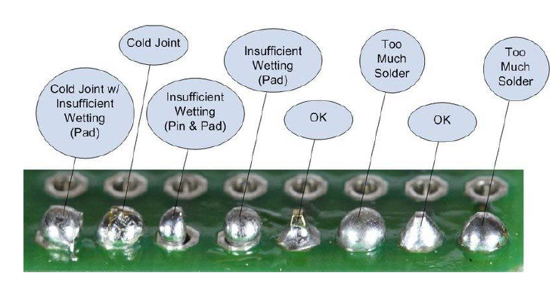

* + 1. **Alloys**

Take home the message: different composition for the soldiering alloys give different properties!

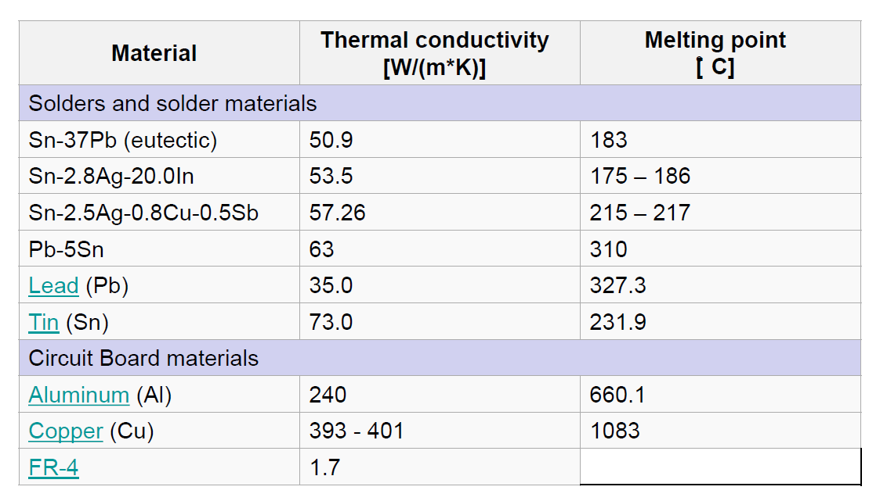We can see that starting with the same two materials (Sn and Pb), just by varying their percentage of a small amount we get completely different melting temperatures and shear strength!

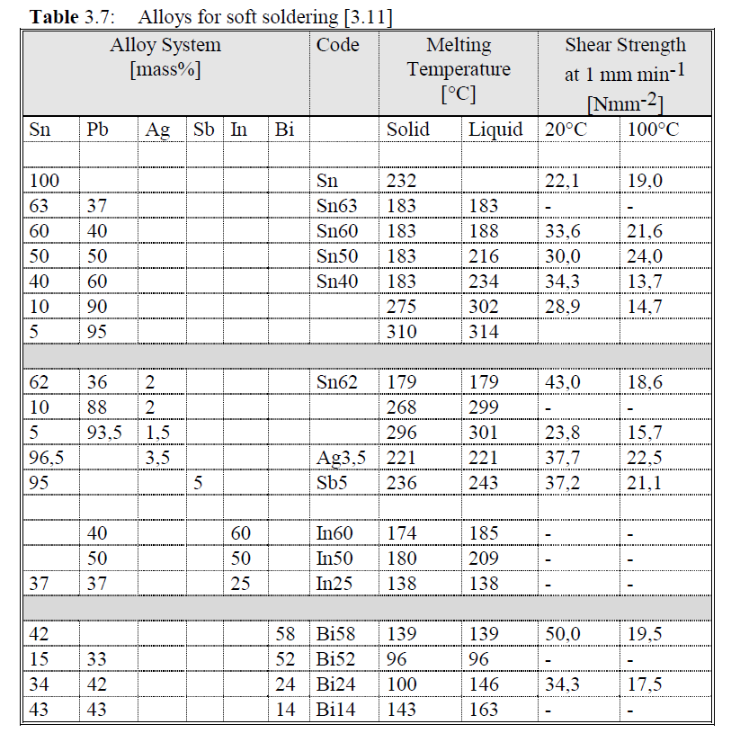

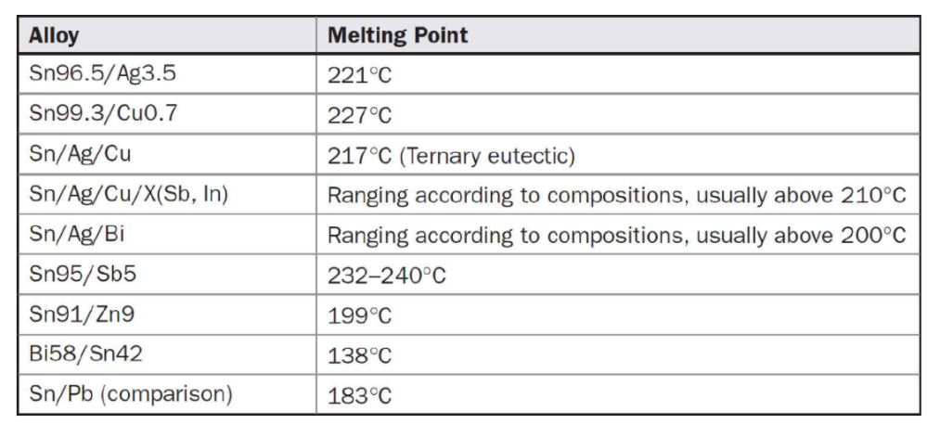

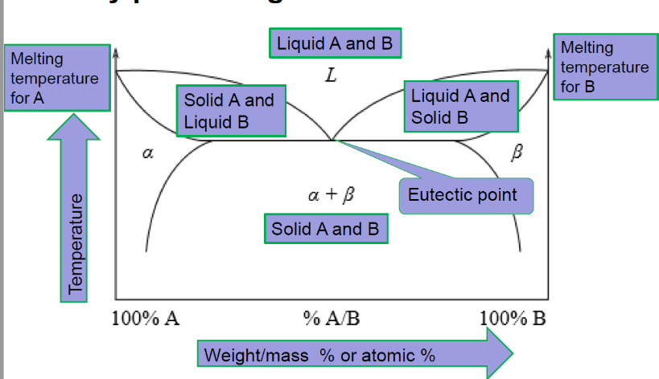**BINARY PHASE DIAGRAM**

We plot the temperature against the relative concentrations of 2 substances in a binary mixture.

On one side of the plot 🡪 we have 100% component A

On the other side 🡪 we have 100% component B

Eutectic system: it is a homogeneous mixture of substances that melts of solidifies at a single temperature that is lower than the melting point of any of the two constituents.

EXAMPLE 🡪 63Sn37Pb

Historically a very common soldering material 🡪 melting temperature 183°C

As we can see, this system is eutectic since the temperature for the components pass from a solid to a liquid state is lower than the melting point of the single pure substances.

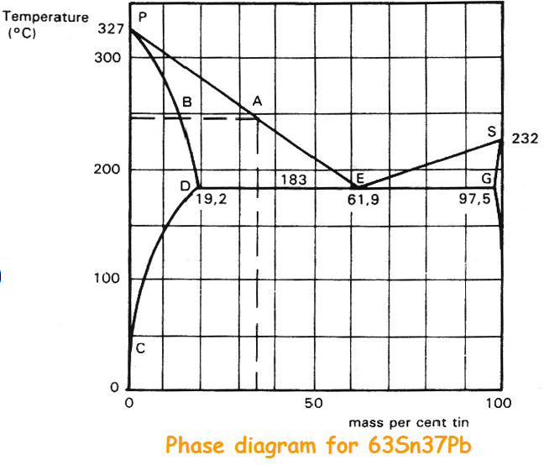Keep in mind that the sentence “Phase diagram for 63Sn37Pb” can lead to errors, since in the phase diagram the composition of the mixture is not fixed!

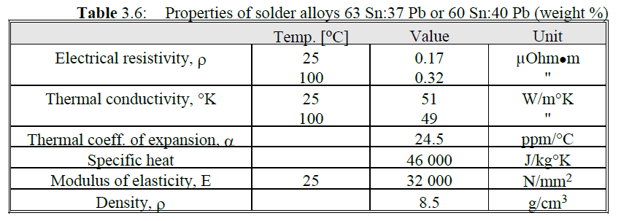

* + 1. **Soldering process step-by-step**
* Put in contact the solder and the materials being joined
* Slow application of heat to warm the parts to be soldered
* Oxide removal from the joining surfaces and solder metallurgies
* Application of heat sufficient to melt the solder
* Solder wetting to join surfaces and intermetallic formation
* Quenching for the solder liquid (raffreddamento)

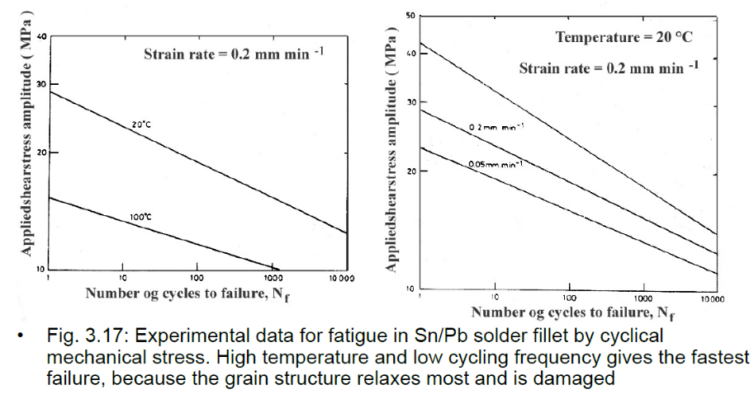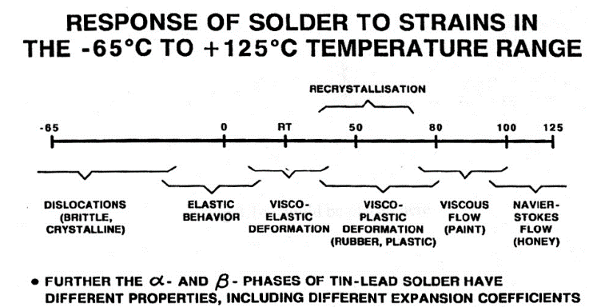REMEMBER: a solder is never just a solder! The material has different properties and features depending on the temperature. Since the solder will become an actual component of the PCB, we have to select it accurately, depending on which will be the usage and the working conditions of our final product.

About soldering you should remember also the Coffin-Manson formula, which describes the reliability of a solder point.

$$N^{0.5}*γ_{p}=constant$$

Where N = number of cycles before the failure and gamma is the relative deformation amplitude.

We’ll see this more in detail in the reliability chapter!

* + 1. **Fluxes and cleanings**

Flux is a chemical cleaning agent used before and during the soldering process of electronic components onto circuit boards. Flux is used in both manual hand soldering as well as the different automated processes used by PCB contract manufacturers. The main purpose of the flux is to prepare the metal surfaces for soldering by cleaning and removing any oxides and impurities. Oxides are formed when metal is exposed to air and may prevent the formation of good solder joints. The flux also protects the metal surfaces from re-oxidation during soldering and helps the soldering process by altering the surface tension of the molten solder.

Flux is made up of a base material and an activator which is the chemical that promotes better wetting of the solder by removing oxides from the metal. It also contains other solvents and additives to help with the soldering process as well as inhibiting corrosion. Flux may be solid, pasty, or liquid in form depending on how and where it will be used. For hand soldering, flux can be applied by a flux pen or is usually in the core of the solder wire that most technicians use.

Fluxes are used to improve the soldering and have several functions:

* Dissolve and remove harmful surface layers (oxide, etc.)
* Protect the surface against new oxidation
* Improve the wetting

Many types of flux are used. They consist of active ingredients dissolved in a liquid. They are of two main categories:

* Soluble in organic liquids
* Water soluble

The category determines how one will be able to clean the flux residues. The common fluxes are also characterised as:

**Organic resin fluxes ("rosin"):**

* most used
* they contain natural resin from (pine-) trees, dissolved in alcohol, etc.
* have a certain effect without additives, but it is normally they are activated by adding an organic chlorine compound 🡪 without activation, wetting of copper takes 6s, with 1% Cl content time is reduced to less than 1s.
* The following symbols/designations characterise the fluxes:
  + R (Rosin, non-activated): Resin flux without chlorine added. It actsbec ause of weak acids in the resin
  + RMA (Rosin mildly activated): Up to 0.5 % Cl content
  + RA (Rosin, activated): Higher content of chlorine

**Organic non resin-based fluxes**

**Inorganic fluxes**

Chlorine is strongly corrosive, and if it remains on the surface after the solder process is completed it may give reliability problems later 🡪 cleaning is required after application.

Popular organic cleaning agents:

* have been trichloro-trifluoro-ethane (Cl3CCF3, also designated TCTFE) mixed with an alcohol 🡪 properties: efficient, does not burn, it is not poisonous and is chemically inert to most materials in electronics, TCTFE is very stable. However, due to its low boiling point the vapour will spread in the atmosphere and the chlorine combinations will over long time break down the ozone layer 🡪 TCTFE and similar combinations are now prohibited from use in most countries
* Cleaning agents based on alcohol are replacements
* cleaning with soap are replacements
* extensive development work is taking place in fluxes that do not need to be removed
  + 1. **Adhesives & gluing**

Gluing is used in electronics to:

* Assemble mechanical parts and keep electronic components in place
* Give electrical connection, as a replacement for soldering
* Give good thermal contact

The types of adhesives used:

* polymers, that generally are electrically and thermally insulating
* often epoxy (or acrylic, phenolic, polyimide, etc.)
  + Adding silver 🡪 better electrical conductivity (we reach 1-10 x 10^-6 Ohm*m) and better thermal conductivity. Thermal conductivity for epoxy without additives typically is 0.2 W/°C * m, and silver filled epoxy has up to 10 x higher value (see figure).
  + 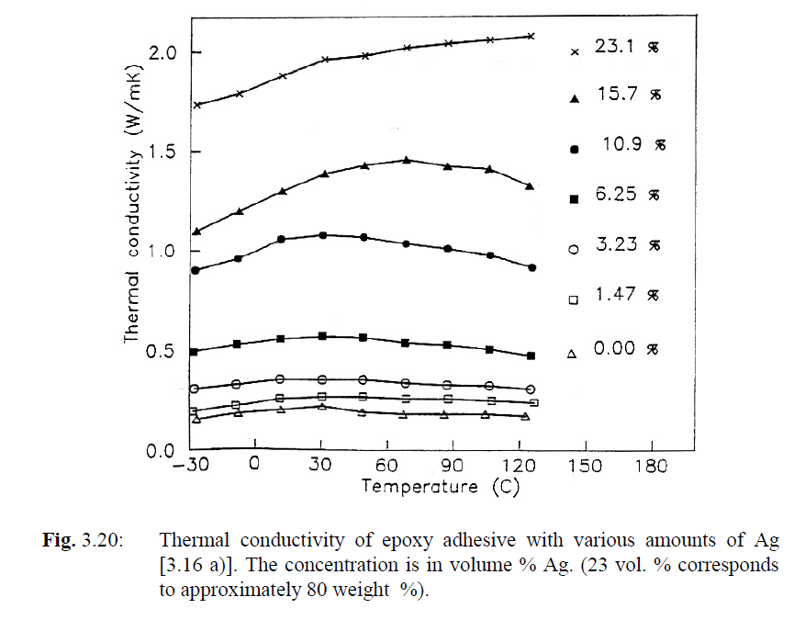Adding Al2O3 or AlN 🡪 Improved thermal contact

The adhesive is deposited by

* screen printing
* dispensing (distribuzione)
* in the form of a partly cured dry film cut to the right size, "preform" (imagine this as scotch). The curing takes place with heat, or by UV-radiation for certain types.

Replacement of component soldering by use of electrically conductive adhesives is an active topic of research.

ADVANTAGES:

* requires lower process temperature with less stress on the components and substrate
* avoid the use of flux, cleaning and poisonous lead
* better long term reliability can be achieved because the adhesive is more elastic and deforms less than the solder metal.

DISADVANTAGES:

* the absorption of moisture in the adhesive polymer may reduce its strength as well as cause migration of the silver 🡪 in the presence of an electric field this migration of silver molecules can give rise to thin wires that can short circuit conductors in the neighbourhood
* you have to be very precise with alignment of components and adhesives: with solders, wetting properties can help you because you get contact between pins and substrates even without a perfect alignment.

REMEMBER: adhesive may shrink a bit while they are drying 🡪 can be good since it helps in keeping close contact between pins and substrate for example

NEW TRENDS:

* **Anisotropically conductive adhesive**: used with components with many pins.
  + It is screen printed over the whole area under the component.
  + It is designed to lead the current just in one way.
  + We can use small conductive balls (as in the figure): they can be metallic or made with polymers covered with metals. The principle is that in the adhesive paste we have a density of these spheres such that for sure there will be some of them between the conductive pins of IC and substrate, but the density is too low to have a continuous chain of these speres between two adjacent pins.
  + In the 1st figure below, refer to c) and d)
  + In the 2nd figure below, refer to a)
* **Isotropically conducting adhesive**: composition is similar in all directions, thus it is also conductive in all directions in the same way. As shown in the figure, we have to prevent the adhesives to join between each other because we would create a short circuit. The working principle is similar to the one discussed above for anisotropically conducting adhesives.

In the 1st figure below, refer to a) and b)

* **insulating instead of conductive adhesive** 🡪 By use of mechanical pressure during the curing, the adhesive is pushed away, and we get direct physical contact between terminal and substrate at points on the slightly non-uniform surfaces. The polymer shrinks during the curing and causes a permanent force that holds the materials together with good reliability. These methods are particularly suitable for components with low current (such as LCD-displays).

In the 2nd figure below, refer to b)

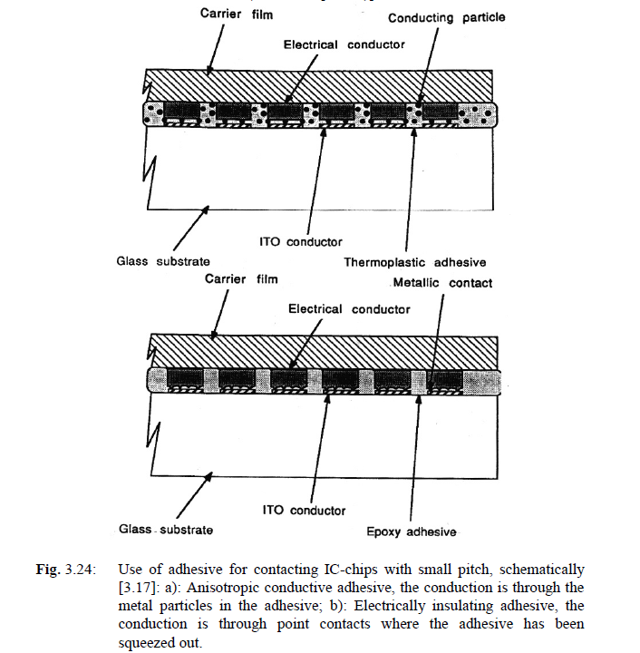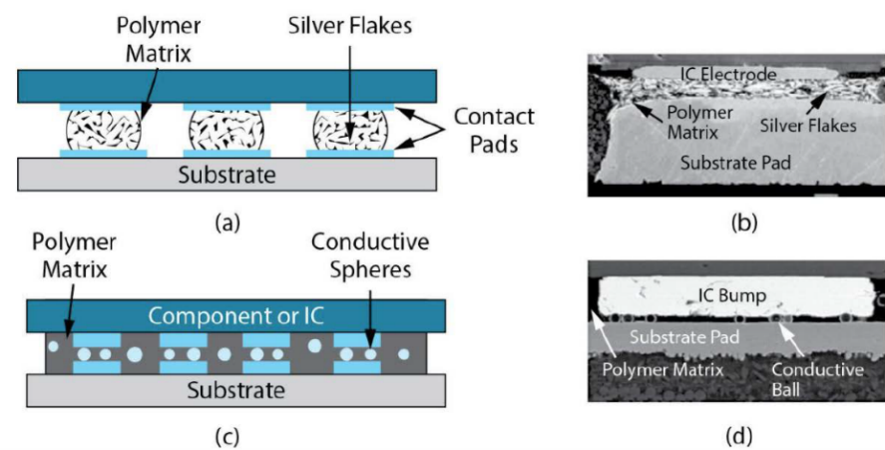

* 1. **Mounting of the semiconductor chips: die bonding**

**Die bonding** (often referred to as die attach) is the process of attaching a die/chip to a substrate or package.

Before electrical connections are made to the chip, the chip must be mounted on the base by "die bonding". That takes place by

* eutectic bonding
* soft soldering
* gluing

Important points with the die bonding are:

* High electrical conductivity if current runs from the chip to the substrate
* good thermal conductivity if the chip dissipates much heat
* mechanical strength and reliability
  + 1. **Eutectic die bonding**

Eutectic bonding takes place when an eutectic alloy is created between silicon and a metal system deposited underneath.

The melting point for the eutectic composition is much below that of the pure elements.

* Au/Si alloy is often used 🡪 melting point 363 °C at 96.7 Au:3.3 Si

while Au melts at 1063 °C

Si at 1412 °C)

* 80 Au:20 Sn 🡪 melting point 280 °C

FEATURES:

* very good electrical and thermal contact
* high mechanical strength
* it is very brittle and when the chips are large the thermal mismatch may cause the chip to crack during the bonding process or during thermal cycling laterUse of gold-rich alloys also makes it costly.
  + 1. **Soft soldering**

Soft soldering 🡪 the classic soldering for circuits:

* used for large chips, particularly in power electronics, where good thermal and electrical conductivity is important
* PbSn, AgPb, SnAgIn and other alloys are used.
  + They are softer than the SiAu eutectic
  + the temperature in the process is lower
  + they can take up thermal mismatch by plastic deformation
  + They are more robust against fatigue than the common SnPb eutectic, but after many thermal cycles the soldering still may fracture due to fatigue.
* The soldering of chips is made by screen printing of solder paste or by use of a solder preform 🡪 It takes place in inert or reducing atmospheres, without flux, to avoid gas pockets or flux residues that may corrode during long term use or which may cause hot spots in high power chips.
  + 1. **Gluing**

Gluing is the dominating method of mounting.

* Made with electrically and thermally conductive epoxy
* Cracks and damage due to thermal mismatch may be a problem with epoxy, but one can obtain soft types that are suited for large chips.
* One limiting factor for high power chips 🡪 poor thermal conductivity of the glue. During thermal cycling (see figure) the adhesive will crack or lose its adhesion to the substrate and the Si chip. The severity depends on chip size, temperature excursion and thermal mismatch between chip and substrate material, as well as the elastic modules and other properties of the adhesive.
* A different kind of chip gluing is done with silver filled low melting glass.

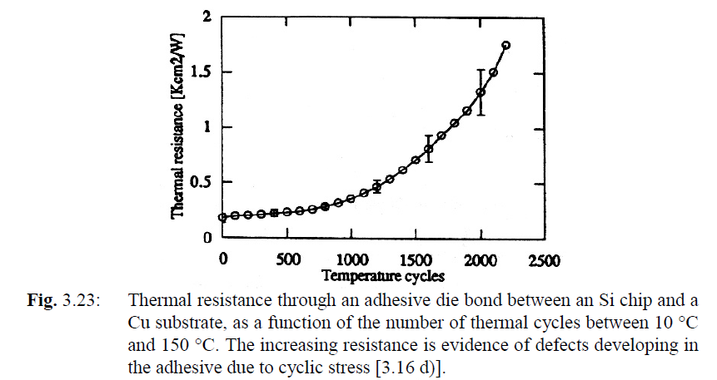

* 1. 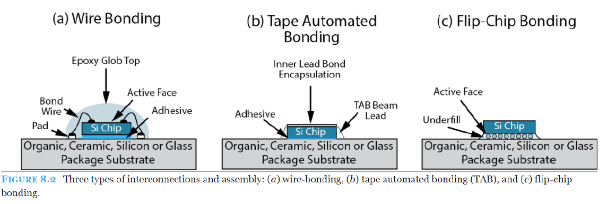**Chip connection techniques**
     1. **Wire bonding**

Wire bonding is the dominating, well established method 🡪 Thin metal wires are connected one by one between the contact points on the semiconductor chip and the corresponding contact point on the substrate outside the chip.

The wires 🡪 made of gold or aluminium, 0.025 - 0.5 mm diameter. Al bond wire with rectangular cross section is also used

The process 🡪

* points where pins are connected on surface of the substrate are normally covered by soft (high purity) gold, deposited by plating or screen printing.
* Then the bonding wire is stretched out through the hole in a capillary tube
* The connection to the chip is made by pressing the wire down onto the Al metallisation on the bonding area of the chip, against the edge of the capillary. There are several processes:
  + Ultrasonic bonding: the capillary vibrates with high frequency during the bonding, and the wire is cold-welded to the base by a combination of pressure and vibration. In addition to the softening of the gold, the vibrations also break up surface oxide layers. The technique is used most for aluminium wire with flat ends on both sides ("wedge -wedge" bonding)
  + Thermocompression bonding: The substrate and chip are heated to about 150 °C during the bonding process. This process is mainly used for gold wire, forming a gold ball at one side and a flat compressed wire end at the other side ("ball - wedge" bonding).
  + Thermosonic bonding is a combination of the two previous methods.
* The end of the gold wire that sticks out of the capillary is brought to melting with a hydrogen flame and it creates a small spherical ball. The capillary is moved down onto the aluminium bonding area on the Si chip, and it is pressed down, making the soft gold flat and sticking to the Al surface. The capillary is pulled up and it is moved over to the substrate bonding area, where it is pressed down and the bonding wire is squeezed flat. Then the capillary is pulled up, while the wire is held firmly inside the capillary and is torn off. The capillary is moved to the next terminal and the cycle is repeated.

With a typical maximum chip size of today (over 20 mm side), there is an upper limit of approximately 1000 terminals for wire bonding.

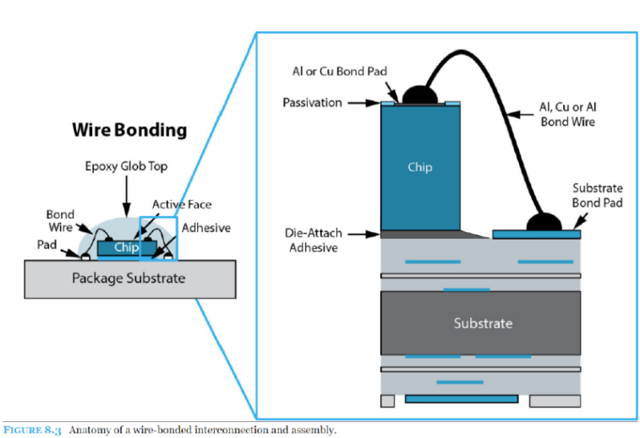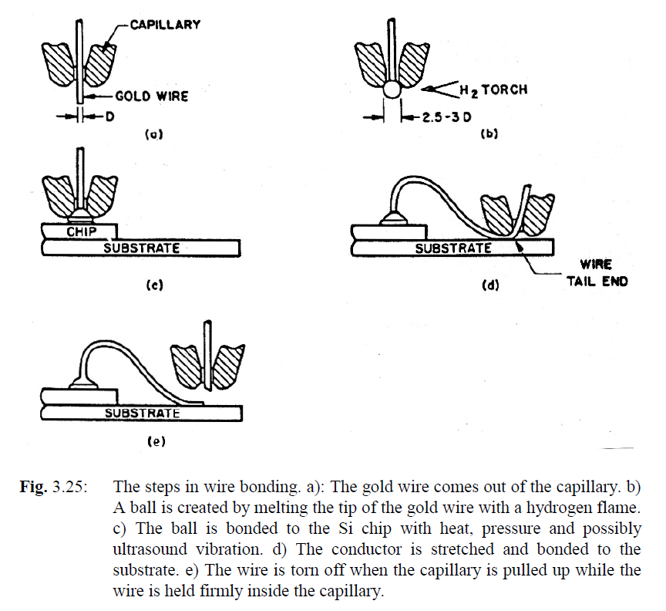

* + 1. **TAB – tape automated bonding**

A conductor pattern has been made in advance, fitting the semiconductor chip and the substrate bonding pad patterns. The conductor foil is on a carrier of polyimide film. The conductors are bonded to Au bumps on the chip.

We will see:

* Fabrication of gold bumps on the chip
* Fabrication of connectors in TAB
* Inner lead bonding 🡪 connection process

In the following picture 🡪 in the outer leads the polymer is placed on top of the conductive copper, while later we’ll see that is placed below 🡪 not so important.

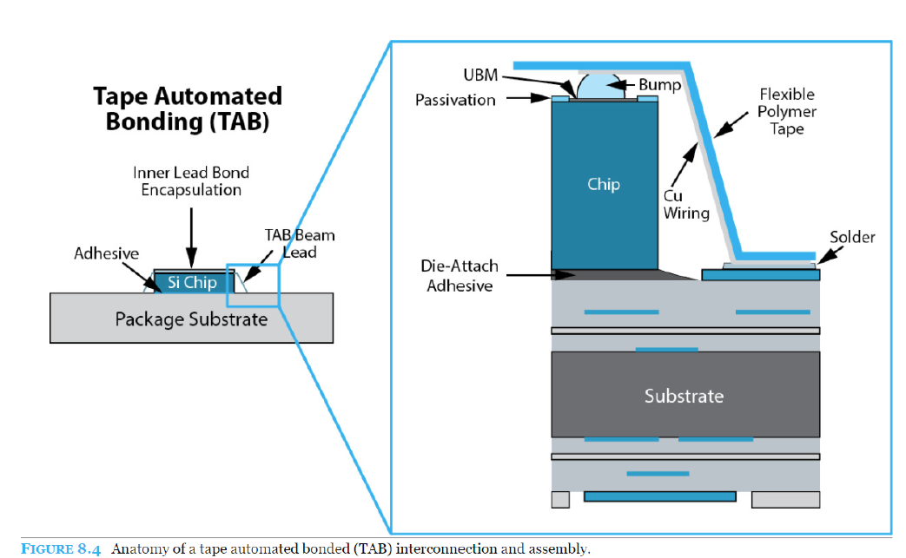

**Frabrication of gold bumps (on the chip)**

**Gold bumps are the pads on the chip. These pads will be connected to the TAB routes with ILB and then the whole package will be placed on the substrate.**

Gold bumps are formed on processed Si wafers.

* First a metal system is deposited on the waver, having the following functions:
  + Covers the Si surface with a conducting layer, such that electrolytic plating can be used
  + Prevents gold from diffusing into Al and Si (diffusion barrier)
  + Gives better adhesion for the gold
* Afterwards a layer of thick photoresist is deposited 🡪 by photolithography we produce holes where Au will be deposited
* Au is electroplated where we produced the holes: the rest of the wafer is protected by the photoresist as plating mask.
* Then the photoresist is stripped, and the barrier metal system is etched off outside the gold bumps.
* Then the wafers are cut into individual chips. The chips are now ready for inner lead bonding (ILB).

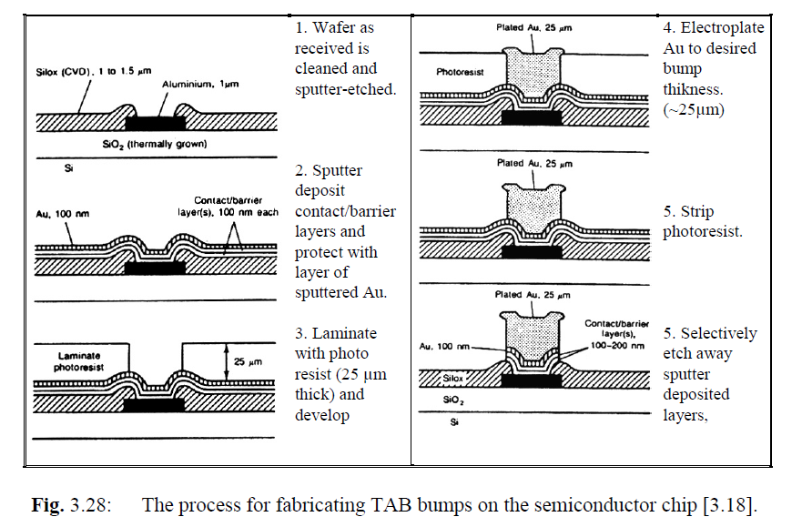

**Fabrication of TAB films**

Starting material: polyimide (it is under the brown part in the picture, the brown color is given by copper)

Holes for handling (analogous to those on camera film) along the edges of the film

Also windows for the Si chip is opened

Copper foil is laminated onto the polyimide, with an adhesive layer in between 🡪 the copper gives the brown color in the picture🡪 conductor pattern in the Cu foil is defined by photoresist that is illuminated through a photo mask with the pattern on it

Then developing follows and etching of the foil 🡪 The conductor pattern is tinned or gold plated. (not mandatory)

So the conductor pattern is gold in the picture!

RESUME:

* Polymide as substrate
* Copper on it
* Gold on copper to create the conductor lines

35 mm wide film is the most common

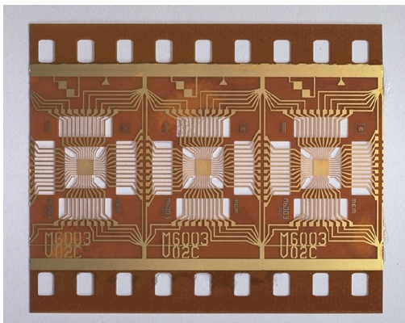

**Inner lead bonding (ILB)**

Inner lead bonding 🡪 mounting of the semi-conductor chip onto the TAB film.

We have to connect the chip to the conductive pattern on TAB 🡪 we can remove a bit of polymer (as in figure) or we can keep the polymer on top (as in the figure presented at the beginning of the section).

Performed by thermocompression bonding.

The bonding tool: thermode 🡪 made by hard metal or diamond. It is pressing all Cu ends against the soft gold bumps simultaneously for approximately 1 sec at a temperature of 300-400 °C. A drop of epoxy is applied on to the chip for mechanical protection and environmental protection encapsulation.

The film with Si chips is rolled on to a reel (bobina) 🡪 ready for selling.

So up to now we have the structure in polymide + copper + gold placed “above” the chip as shown in the figure 🡪 now we have to place the whole package on the substrate, connecting the TAB to the gold bumps on the substrate.

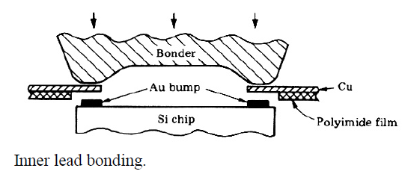

**Mounting, outer lead bonding (OLB)**

Three steps:

* We cut the conductor patterns in excess, creating the leads that will be used to connect the chip to the substrate
* Bending of the leads, so that the outer ends are in the plane of the underside of the Si chip ("lead bending")
* Placement of the chip on the printed circuit board (attached with adhesives in general) and soldering the outer ends of the Cu leads with the gold bumps previously created on the substrate

The connections on the printed circuit board 🡪 made by pressing the copper lead ends down into solder paste or reflowed solder metal on the board. Soldering tool: thermode 🡪 The tool solders TAB chips individually by pressing the Cu leads down into the solder metal and supplies heat by a pulse that lasts a few seconds. The OLB thermode is cooled below the melting point before it

is lifted up. The complete cycle takes 10 - 20 seconds.

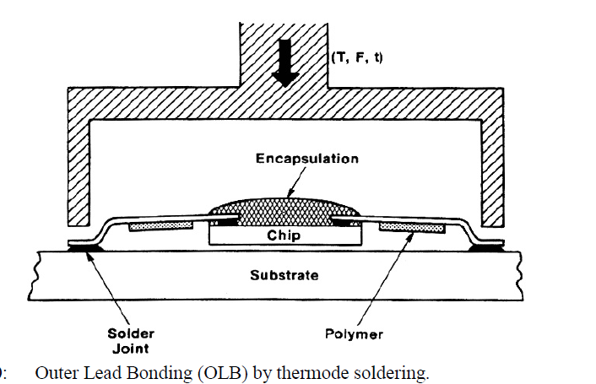

**Advantages and disadvantages with TAB**

* It requires less bonding area for each contact on the chip, and smaller distances between the terminals than wire bonding 🡪 saves chip area at the same time as it makes it possible to interconnect chips with a larger number of terminals (up to approximately 1000).
* The outer lead bonding requires less space on the printed circuit board than the same chip in a regular package. The mounting is simpler and more robust than wire bonding.
* The gold bump on each bonding area gives a hermetic enclosure of the Al metallisation underneath 🡪 reduced possibility of corrosion, and the reliability is improved 🡪 TAB is suitable for use without additional encapsulation
* Soldering all the connections at one time is a more efficient process than wire bonding that is made one bond at a time, and has a higher production yield
* TAB film can also be used as a separate, flexible little printed circuit board, on which it is possible to mount other components as well.
* It requires non-standard process of the Si chips (deposition of the gold bumps).
* It requires special fabrication of carrier film and conductor pattern that is costly and takes time.
* The mounting on the PCB requires special mounting equipment, and a separate tool for each individual component geometry. Individual mounting/soldering of each component is time consuming and costly.
* Repair (replacement of a defect component) on the PCB is demanding.
* Few standard circuits are available in TAB form.
* There is little standardisation of dimensions and tooling, which increases the costs.
  + 1. **Flip chip**

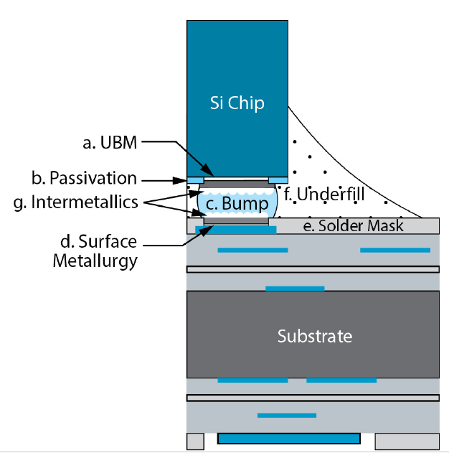Consists in direct soldering between the electrical contact points on the semi-conductor chip and points on the substrate 🡪 the chip is turned upside down.

We start from the Si chip🡪 A bump of solder metal is formed on each bonding area on the silicon chip.

The fabrication of the bumps: start from Si wafer.

* First a metal barrier layer is deposited, for example thin films of Cr/Cu/Au 🡪 they help the soldering process and give reliability and good properties to the connection
* The solder metal: 95 % Pb/5 % Sn (melting point approximately 305 °C) or In alloy 🡪 the solder is deposited on the chip:
  + by sputtering through a metal mask with an opening for each bump
  + vacuum deposition through a metal mask with an opening for each bump
  + by photolithography and electroplating
* After deposition the solder metal is reflowed in a hydrogen atmosphere 🡪 done to:
  + homogenise the composition of the alloy
  + let the surface tension generate a spherical shape of the bumps
  + remove oxides, which will otherwise ruin the solder ability.
* The bumps 🡪 diameter 100 μm
* The Si wafer is cut, and the chips are ready for mounting.

The shape of the drop of solder metal may be strange, so the chip is heated to reflow the solder metal.

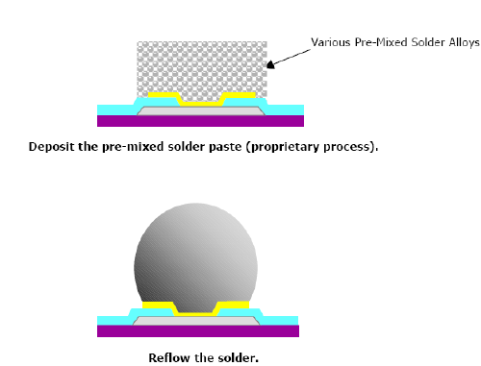

Then each chip is turned upside down and placed very accurately in position on the corresponding solder areas on the substrate.

Before final soldering of the chip on the substrate 🡪 Water- or resin-based flux is used and the subsequent cleaning is very critical.

A certain amount of self-alignment is achieved 🡪 there are surface forces in the molten solder metal which try to move the solder paste to the location where the total surface in all solder joints is a minimum.

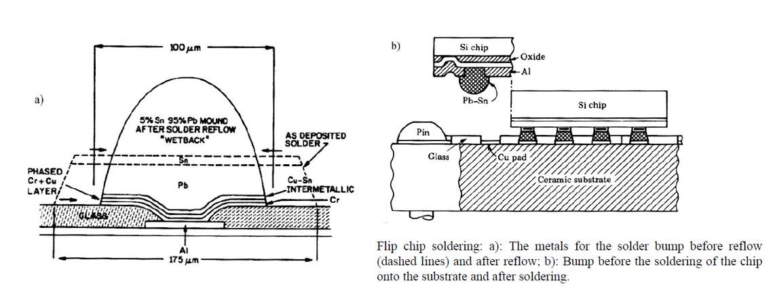Then one heats up until reflow of the solder metal takes place again 🡪 final shape is reached (figure “b” below)

TIPS:

* We use capillary techniques to remove voids in the soldering while we are placing chips 🡪 we use filling materials which eliminate voids and protect soldered points (see blue figure above).
* On the wafer (and/or on the substrate) we can add bumps to enforce the solidity of the soldering (see coloured figure below) 🡪 small bumps (<135 um) with typical pitch around 150 um

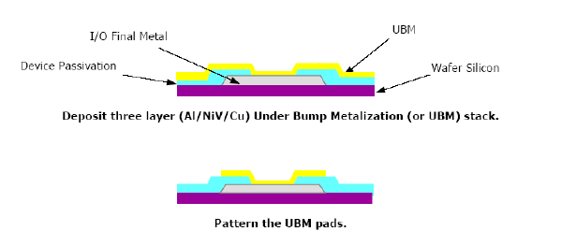

ADVANTAGES:

* one gets a placement on the substrate that does not require more space than the chip itself
* one can have terminals everywhere on the chip area, not only along the periphery
* The electrical properties are better than for other mounting methods, with low electrical resistance and low inductance
* Shortest leads 🡪 best frequency behaviour among all the possible bonding techniques
* We can reach up to 10k I/O pins from a single chip

DISADVANTAGES:

* lack of thermal flexibility, because of the short "conductors" between chip and substrate 🡪 this method thus is best suited for silicon substrate or for small chips on Al2O3 or AlN substrate
* The heat conduction is not so good
* Repair is almost impossible
* Demanding assembly

USAGES: multichip modules in computer and telecommunication applications where extreme erformance and minimum space are required.

**Another technique similar to flip-chip: BALL GRID ARRAY AND CHIP-SCALE PACKAGES**

Combination of flip-chip and package: inside a package we put a chip 🡪 this can be connected to the package substrate with wire bonding, flip chip technique…

The whole package then is connected to the substrate of the PCB by flip-chip technique 🡪 this is a bit more flexible than attaching the chip directly to the PCB

As a rule of thumb, the package should not be much bigger than the the chip itself, otherwise the advantage is reduced.

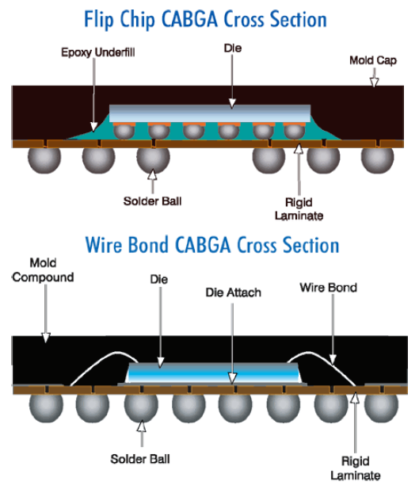

1. **Electronic components**

Objectives:

* Give an overview of the how various central categories of electronic components work, and how they are packaged
* Give an overview of how generic package types are constructed and named
  1. **Introduction to passive components**

**Passive** components (resistors, capacitors and inductors) are extensively used in virtually all electronic circuits. Passive components can sense, transfer, attenuate and control voltage, but they cannot differentiate between different polarities, nor can they render any amplification or gain. The latter functions are only possible using **active**, semiconductor components. Passive components come in large varieties of different packages for surface mount or thru‐hole montage. In some circuit technologies, such as ceramic hybrids, passive components can be integrated in the circuit as part of the circuit board manufacturing process. However, in conventional PCB technology, passive components are mainly realized as discrete components attached to the circuit board during assembly stages. This chapter will only consider discrete components.

* 1. **Passive components: Resistors**
     1. **Thru-hole mounting**

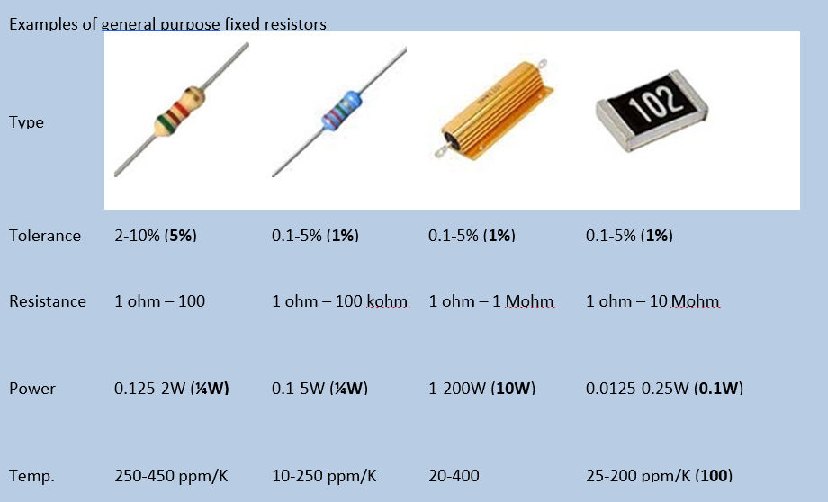Usually are cylindrically shaped with axial leads. High power resistors may have one of their leads designed to function as a heat sink (see for example the third resistor in the figure below).

There are 3 main types of hole mounted resistors:

* **Carbon composite**, which has a massive body of conductive carbon in a matrix of insulating materials
  + The temperature coefficient of resistance is rather high (up to 450 ppm/K) 🡪 the actual value of the resistor may change considerably under temperature changes
  + Carbon composites also have relatively low stability
  + relatively poor resistance tolerances: 5%, 10%, 20%
  + Values: 1 Ohm - 100 MOhm
  + Power dissipation: 1/8 - 2 W
* **Film layer resistors** have a thin film of metal, tin oxide (ossido di stagno) or carbon around an insulating core
  + The film often has a spiral cut to increase the wire length and thereby the resistance. This cutting process also can also be used to trim resistors to accurate values.
  + <1 Ohm – 1 MOhm
  + 20 – 250 ppm/°C
* **Wire wound resistors** consist of an insulating body around which a metal wire, for example NiCr, is wounded, and covered by insulation
  + Wire wound resistors have better (lower) temperature coefficient of resistance than carbon composite resistors (around 70 ppm/°C)
  + also better in terms of stability and tolerance ranges possible.
  + 1 – 100 kOhm
  + 0.1 – 0.5% tolerance

Thru-hole mounted resistors have also a color code to specify value and undertainties.

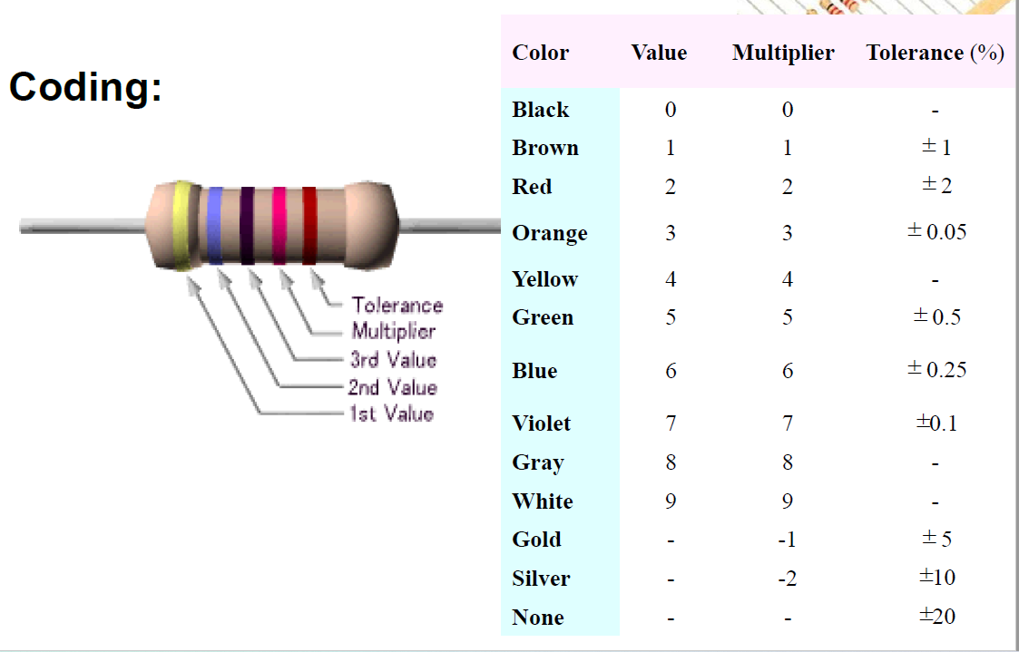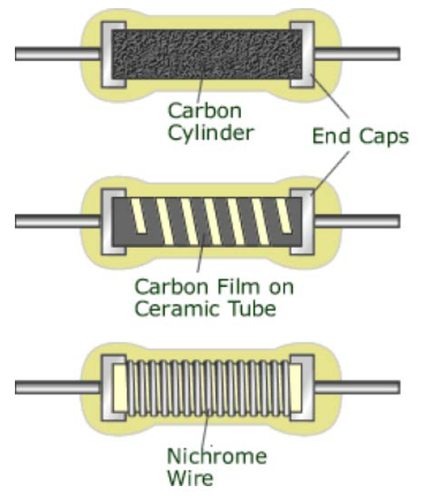

* + 1. **Surface mounted**

Surface mounted resistors normally are rectangular, and with a ceramic body.

The resistors are made using thick film hybrid technology 🡪 A layer of for example ruthenium oxide is used as resistor material, and it is covered with dielectric layer on top. Resistors are often trimmed by laser cutting until the target value is reached.

TIP: Surface mounted ceramic resistors have a AgPd connection from the resistance material towards the electrodes on the side. The AgPd ink must however be coated by a diffusion barrier in order to prevent diffusion of silver into Sn‐based solders.

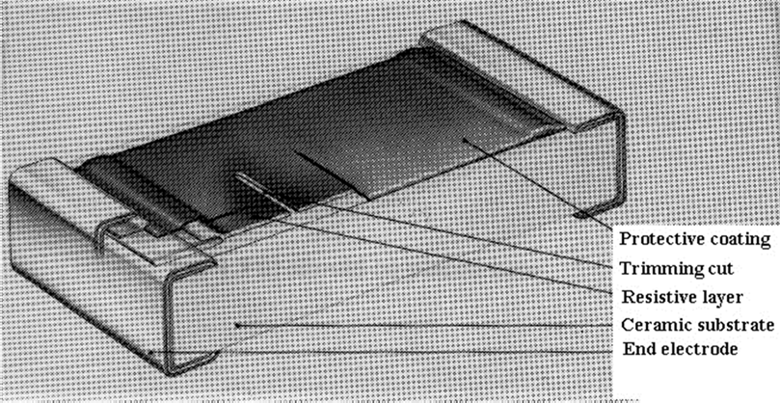

Table 3 summarizes typical ratings for ceramic resistors for surface mounting.

*Table 3: Summary of typical ratings for ceramic resistors for surface mounting.*

|  |  |  |
| --- | --- | --- |
| Resistance range and tolerance | | 10 ohm to 1 Mohm (E24* series) ± 2%  1 ohm to 10 Mohm (E24 series) ± 5%  1 ohm to 10 Mohm (E12 series) ±10% |
| Dimensions | | 3,2 x 1,6 x 0,6 mm |
| Operating temperature range |  | -55°C to + 155°C |
| Temperature coefficient  125°C) | (-40°C to | <+200 x 10-6/K |
| Absolute max. dissipation  70°C | at Tamb= | 0,25 W |
| Maximum permissible voltage | | 200 V (r.m.s.) |
| Climatic category (IEC68) |  | 55/155/56 |
| Jumper resistance | | ≤ 50 mohm |
| Maximum current |  | 2 A |

**Dimensions of surface mount discrete components**

Sizes of discrete components are usually defined according to their size using a condensed code. A summary of codes and dimensions are given below. The table also gives a typical power rating for surface mounted resistors

Beware! Within electronics, both Imperial (inch) and Metric standards are used. 0603 metric is not identical to

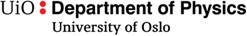

##### FYS 4260/FYS 9260 Microsystems and electronic packaging and interconnection technologies

0603 imperial!

|  |  |  |  |  |  |  |  |  |
| --- | --- | --- | --- | --- | --- | --- | --- | --- |
|  | | | | | | | | |
| Code | | Length (l) | | Width (w) | | Height (h) | | Power |
| Imperial | Metric | inch | mm | inch | mm | inch | mm | Watt |
| 0201 | 0603 | 0.024 | 0.6 | 0.012 | 0.3 | 0.01 | 0.25 | 1/20 (0.05) |
| 0402 | 1005 | 0.04 | 1.0 | 0.02 | 0.5 | 0.014 | 0.35 | 1/16 (0.062) |
| 0603 | 1608 | 0.06 | 1.55 | 0.03 | 0.85 | 0.018 | 0.45 | 1/10 (0.10) |
| 0805 | 2012 | 0.08 | 2.0 | 0.05 | 1.2 | 0.018 | 0.45 | 1/8 (0.125) |
| 1206 | 3216 | 0.12 | 3.2 | 0.06 | 1.6 | 0.022 | 0.55 | 1/4 (0.25) |
| 1210 | 3225 | 0.12 | 3.2 | 0.10 | 2.5 | 0.022 | 0.55 | 1/2 (0.50) |
| 1218 | 3246 | 0.12 | 3.2 | 0.18 | 4.6 | 0.022 | 0.55 | 1 |
| 2010 | 5025 | 0.20 | 5.0 | 0.10 | 2.5 | 0.024 | 0.6 | 3/4 (0.75) |
| 2512 | 6332 | 0.25 | 6.3 | 0.12 | 3.2 | 0.024 | 0.6 | 1 |

* 1. **Passive Components: Capacitors**

Before discussing capacitors in detail, it is helpful to review the electrical model of passive components, and it is instructive to consider the capacitor in particular, see Section 5.3.1. One important take‐home message is however that also resistors and inductors are not ideal; they tend have both a resistive (real) and a reactive (imaginary) impedance component, and this usually becomes more prominent with increasing frequencies.

We will then consider capacitors of the following main types:

* + - Ceramic multilayer capacitors (Section 5.3.2)
    - Electrolytic capacitors (Section 5.3.3)
    1. **Electrical models of passive components**

For an ideal capacitor, the capacitance *C* is given as



***FYS 4260/FYS 9260 Microsystems and electronic packaging and interconnection technologies***

𝐶 = 𝜀O𝜀r𝐴

𝑑

where *ε0* is the permittivity of vacuum, *εr* is the relative capacitance of the capacitor interface, *A* is the cross‐section area, and *d* is the distance between the capacitor plates.

*Figure 25: Ideal capacitor*

However, for a real, physical capacitor, we need to consider that a capacitor also has resistive and inductive properties, and these affect the frequency response of the capacitor5. A physical model is shown in Figure 26. The term *Rp* represents the capacitors tendency of current leakages through the capacitor, and *Rs* and *Ls* represent the resistive and inductive contributions to the component.

*Figure 26: Electrical model for a real capacitor*

Usually, *Rp* can be neglected, and we obtain the following term for the impedance:

|𝑍| = J𝑅 2 + (𝜔𝐿 — 1 )2

c c 𝜔𝐶

From the equation, is it evident that there will be a resonant behaviour around *Zmin* = *Rs*

corresponding to a cancelling of the inductive and capacitive terms.

𝜔𝐿c

= 1

𝜔𝐶

Above this resonance frequency, the capacitor in fact functions as an inductor.

5 This is indeed the case for resistors and inductors as well. At high frequencies, a resistor will have capacitor features (consider the end terminals as capacitor plates) and induction of surface currents will contribute to a inductive term. An inductor will obviously have a resistive contribution throuh ist windings, and capacitive features will occurs between windings and between terminals.



##### FYS 4260/FYS 9260 Microsystems and electronic packaging and interconnection technologies

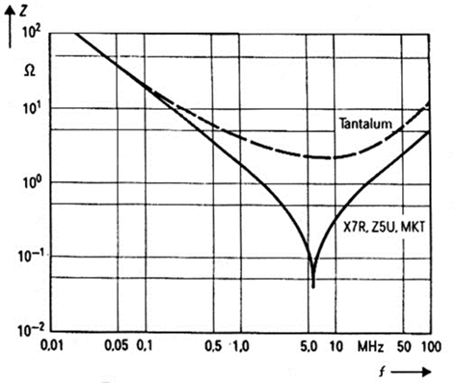

*Figure 27: The frequenzy dependende of impedance for multilayer ceramic capacitors and tantalum electrolytic capacitors, all having 100 nF capacitance value. From [1].*

From circuity theory, it is known that the complex impedance *Z* generally consists of a real, resistive component, and an imaginary, phase adjusting part known at the reactance. In the impedance for a capacitor, a real term means that the component has losses of energy. A convenient way to assess this is through the loss tangent *tan *, which is the relation between the real and the imaginary parts of the equation:

𝑅 𝑅 + 𝑅 (1 + (𝜔𝐶𝑅

)2)

tan 𝛿 =

= p c p

|𝐼𝑚 𝑍|

𝜔𝐶𝑅 2 — 𝜔𝐿 (1 + (𝜔𝐶𝑅

)2)

p c p

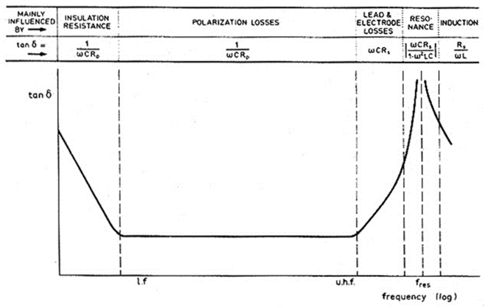Most capacitors will have a relatively wide range within which their loss tangent will be relatively stable, and will primarily be used within this range. Figure 28 displays schematically the frequency dependence of the loss tangent *tan *.



***FYS 4260/FYS 9260 Microsystems and electronic packaging and interconnection technologies***

*Figure 28: Frequency dependence of the loss tangent tan  schematically. From [1]*

## Ceramic multilayer capacitors

Ceramic multilayer capacitors are the most produced and used capacitors in electronic equipment. The construction of ceramic multilayer capacitors is shown in Figure 29. These are made from a stack of metal electrodes with thin (~ 20µm thick) ceramic dielectrics in‐between, and these may have very strong dielectric properties. Every other conductor layer is connected to the one or the opposite side of the capacitor. In this way, high capacitance values can be obtained within a small volume.

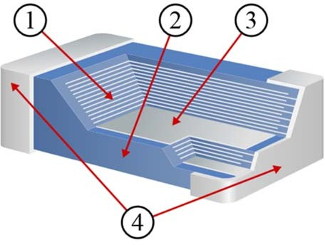

*Figure 29: Detailed construction of a multilayer ceramic chip capacitor. [7]*

* + - 1. *Ceramic dielectric,*
      2. *Ceramic or lacquered coating,*
      3. *Metallized electrode,*
      4. *Connecting terminals*

Multilayer ceramic capacitors are grouped into two main classes [8]:

* **Class 1** ceramic capacitors offer high stability and low losses for resonant circuit applications. They offer the most stable voltage, temperature, and to some extent, frequency. They have the lowest losses and therefore are especially suited for resonant circuit applications where stability is essential or where a precisely defined temperature coefficient is required, for example in compensating temperature effects for a circuit. The basic materials of class 1 ceramic capacitors are composed of a mixture of finely ground granules of paraelectric materials such as Titanium dioxide (TiO 2), modified by additives of Zinc, Zirconium, Niobium, Magnesium, Tantalum, cobalt and Strontium, which are necessary to achieve the capacitor’s desired linear characteristics. Class 1 ceramic capacitors have the lowest volumetric efficiency among ceramic capacitors. This is the result of the relatively low permittivity (6 to

200) of the paraelectric materials. NP0 components are especially attractive because of their virtually zero capacitance drift due to temperature changes



***FYS 4260/FYS 9260 Microsystems and electronic packaging and interconnection technologies***

* **Class 2** ceramic capacitors offer high volumetric efficiency for buffer, by‐pass, and coupling applications. The ceramic dielectric is characterized by a nonlinear change of capacitance over the temperature range. The capacitance value also depends on the applied voltage.

They are suitable for bypass, coupling and decoupling applications or for frequency discriminating circuits where low losses and high stability of capacitance are less important. Class 2 capacitors are made of ferroelectric materials such as barium titanate (BaTiO3) and suitable additives such as aluminium silicate, magnesium silicate and aluminium oxide.

These ceramics have high to very high permittivity (200 to 14,000), which depends on the field strength. Hence the capacitance value of class 2 capacitors is nonlinear, and depends on temperature and voltage applied. Additionally, class 2 capacitors age over time, and it is simply a decrease in capacitance over time due to crystalline changes that occur in all Class II dielectrics. This is caused by the relaxation or realignment of the electrical dipoles within the capacitor. The phenomenon is affected by time, temperature, voltage (voltage has a minute effect), and is in fact a reversible effect6. Class 2 capacitors have designations such as X5R, X7R, and Y5V and functionality that can be derived from this code.7

In summary, Class 1 capacitors are modest, nice and well‐behaved, whereas Class 2 capacitors employ high permittivity materials, giving rise to high capacitance per volume, but a less stable nature with temperature and aging effects associated. The aging effect is illustrated in Figure 30.

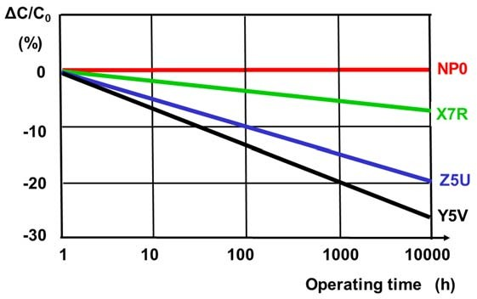

*Figure 30: Change of relative capacitance value as a function of operating time for one Class 1 capacitor (NP0) and three Class 2 capacitors. From [9].*

*6 The effect of time imposes a predictable loss of capacitance in Class II capacitors. For X7R and X5R the loss is calculated at ‐ 2.5% per decade hour and for Y5V it is ‐7% per decade hour. After manufacturing the crystalline structure of the dielectric material is reset. It is due to the realignment of these crystals after firing that the capacitor goes through a logarithmic loss of capacitance. By heating the capacitors over the “Curie Point” (approx 125c for Barium Titanate capacitors) the crystalline structure of the capacitor is returned to its original state and the capacitance value observed after manufacturing. Exposure to 150c for 1.5 hours is sufficient to return the capacitor to its original value.*

*7 In the naming convention of Class 2 ceramic capacitors, the first code gives low limit temperature, the digit gives the highest use temperature, and the final character gives the relative temperature change within this range, for example X7R (−55/+125 °C, ΔC/C0 = ±15%), X5R (−55/+85 °C, ΔC/C0 = ±15%), and Z5U (+10/+85 °C, ΔC/C0 = +22/−56%). More info in [8].*



***FYS 4260/FYS 9260 Microsystems and electronic packaging and interconnection technologies***

**5.3.2.1 Failure modes in multilayer ceramic capacitors.**

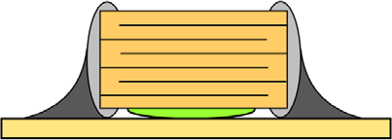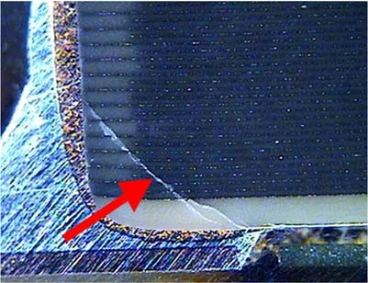Multilayer ceramic capacitors tend to be prone to failures due to mechanical stresses, either originating during assembly or due to thermomechanical stresses during use. Especially the solder edge of the component is known to be a crack starting point where stresses tend to concentrate. This is illustrated in Figure 31. In addition to static stresses, ceramic capacitors also easily become damages due to mechanical shocks, since these propagate more or less undamped through the circuit board and into the ceramic capacitor‐

*Figure 31: Cross‐section of an ideally soldered multilayer capacitor (left) and a cross‐section microscopy image of a capacitor with a crack (right) originating . From [9]*

Cracking ceramic capacitors might initially cause a lowering of the actual component capacitance since some of the metal layers are not contributing to the capacitor anymore. In more progresses stages, the component fails completely. Until an obvious failure can be observed, ceramic capacitor failures can be gradually change the performance of an electronic system and cause effects that are difficult to identify and understand.

* + 1. **Electrolytic capacitors**

Electrolytic capacitors are a range of polarized capacitors with very high capacitance‐to‐volume capacity. The high capacitance is obtained by using a very thin (~ 1 µm) metal oxide layer as dielectric. Metals that can form such oxides include aluminium, tantalum and niobium. The oxide forming process is also done in such a way that the oxide interface becomes very rough and with a large surface area. This situation is illustrated in Figure 32. The main challenge now in order to realize a high capacitance value lies in *how to realize an intimate electrode contact on the cathode side*. Both dry materials (dry electrolyte capacitors) and liquids (wet electrolyte capacitors) are used to obtain this interface, and we will exemplify this for the cases of dry tantalum electrolyte capacitors and wet aluminium electrolyte capacitors.



***FYS 4260/FYS 9260 Microsystems and electronic packaging and interconnection technologies***

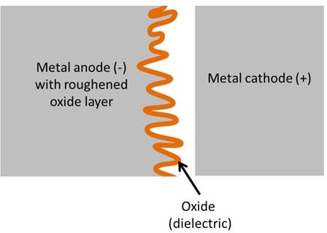

*Figure 32: Dielectric oxide layer in electrolyte capacitors.*

It is essential to understand that electrolyte capacitors are *polarized:* They should only be charged with on bias. The opposite bias will cause the oxygen ions in the dielectric layer to start to diffuse, and will break down the oxide layer so that the capacitor is destroyed.

* + - 1. **Dry tantalum electrolyte capacitors**

Dry tantalum electrolyte capacitors are formed from tantalum metal powder that is sintered to form a large surface, see Figure 33 a). The sintered body is then oxidised to form the dielectric oxide layer of the capacitor. The structure is then impregnated with manganese oxide powder, which fill all interfaces and forms the intimate cathode interface, see Figure 33 b). The manganese oxide powder, in turn is electrically interfaced with a graphite layer and a silver electrode. Figure 33 c) shows how a tantalum dry electrode capacitor can be packaged as a surface mount device.

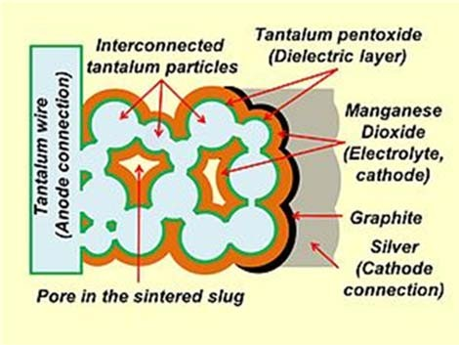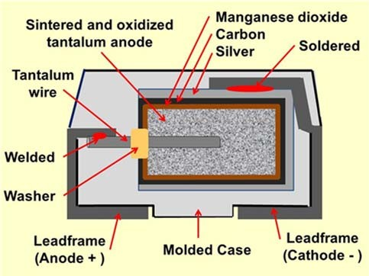

***FYS 4260/FYS 9260 Microsystems and electronic packaging and interconnection technologies***

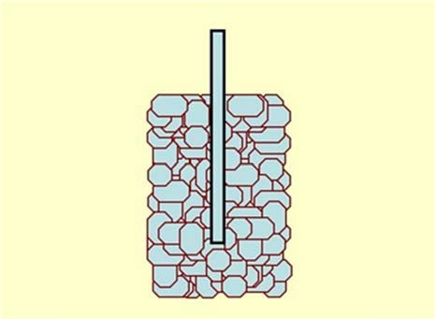

1. *: The tantalum sintered body with tantalum connector wire*
2. *Electrical connection illustration*
3. *Structure of a surface mount tantalum dry electrolyte capacitor*

*Figure 33: Process flow to form a tantalum dry electrolytic capacitor. All figures from [8].*

Tantalum capacitors distinguish themselves from other capacitors in having high capacitance per volume and weight. Tantalum capacitors have lower equivalent series resistance (ESR), lower leakage, and higher operating temperature than other electrolytic capacitors, although other types of capacitors are even better in these regards. Tantalum capacitors are more expensive than other

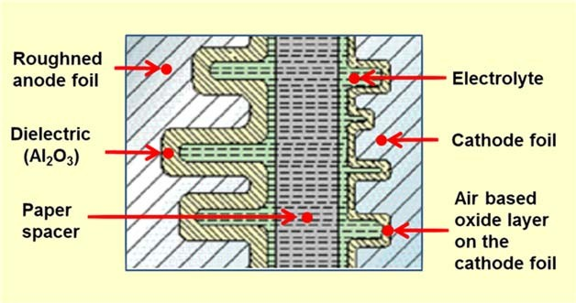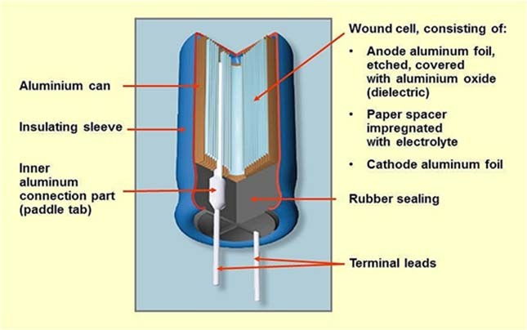

***FYS 4260/FYS 9260 Microsystems and electronic packaging and interconnection technologies***

commonly used type of capacitor, so they are used only in applications where the small size or better performance are important.

* + - 1. **Wet aluminium electrolyte capacitors**

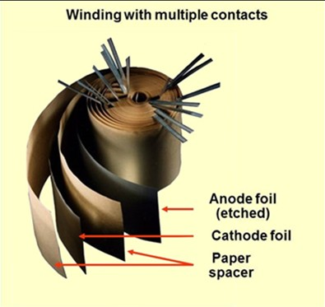

1. *Physical arrangement of electrode and anode foils with porous paper spacers in‐between.*
2. *Detailed structure of the capacitor interface*
3. *Physical realization of an aluminium wet electrolyte capacitor for thru‐hole mounting*

*Figure 34: Working principle and construction of a aluminium wet electrolyte capacitor. All figures from [9].*



***FYS 4260/FYS 9260 Microsystems and electronic packaging and interconnection technologies***

Figure 34 describes how an aluminium wet electrolyte capacitor is formed. Two aluminium foils are used as cathode and anode. The anode foil is roughened to create a large interface area, see Figure 34 b). Between the foils, a porous material (paper) is placed to separate the two foils. The structure is winded up in a cylindrical shape, and the structure with the porous material is soaked in a liquid material to form the electrolyte, which then fills all voids between the two aluminium foils. Figure 34

1. shows how a capacitor for thru‐hole mounting can be constructed. Take home messages when selecting capacitors:

A capacitor is not just a capacitor! You need to select capacitors based on a wide range of features. This includes:

* + Maximum voltage rating
  + Temperature dependence of the capacitance (temperature coefficient)
  + Loss tangent (tan δ)
  + Equivalent series resistance
  + Long term stability and ageing phenomena
  + Bias requirements (can electrolyte capacitors be used?)
  + High frequency properties
  + Leakage current
  + Ability to withstand various production processes (high temperature, etc.)
  + Price, physical size, etc.
  1. **Packaging and package types for ICs**
     1. **Package types and materials**

*Table 4: Summary of performance of plastic vs ceramic IC packages*

|  |  |  |
| --- | --- | --- |
| Feature | Plastic | Ceramic |
| Hermeticity | Humidity will diffuse into the package over time. | Yes |
| Price | Low price in large quantities High initial cost | Relatively high cost in volume Inexpensive prototyping possible |
| Thermal conductivity | Poor (limited by epoxy) | Good |
| Max use temperature | Limited time at high temperature (for example during soldering). Normally not used in high  temperature applications (above~100 °C) | The package is usually not limiting a limiting factor for use in high  temperatures |
| Thermal expansion coefficient match | Coefficients typically one order of magnitude larger than Silicon and Kovar | Ceramic thermal expansions coefficients usually within the same  order of magnitude as Silicon |
| High frequency applications | Not suitable | Suitable – ceramics have a well‐ defined frequency response. |
| Reliability | OK | Excellent |



##### FYS 4260/FYS 9260 Microsystems and electronic packaging and interconnection technologies

Integrated circuits are put into protective packages to allow easy handling and assembly onto printed circuit boards and to protect the devices from damage. A very large number of different types of package exist, and several of them exist in both plastic and ceramic versions, and vendors often offer their ICs in different packaging solutions. As always, it is the requirements for the application at hand that must determine the final choice. A comparison of some packaging features for plastic and ceramic packages is given in Table 4. In addition to plastic and ceramic packages, also metal packages are used in some cases, especially in the so‐called TO‐cans, which will be described separately.

The following summary of different IC packages is structured according to features, but also represents an historic packaging development in the move towards smaller and smaller chip footprints. We will start with diode and transistor packages. We will then move to more complex ICs, starting with the thru‐hole mounted packages. We then cover package approaches translating these packages towards surface mounting, before we consider packages entirely dedicated to surface mounting and enabled by the introduction of flip chip technology.

* + 1. **Diode and transistor packages**

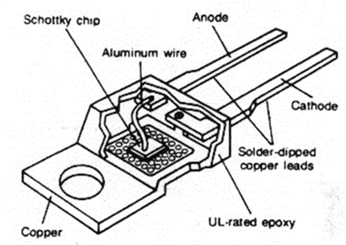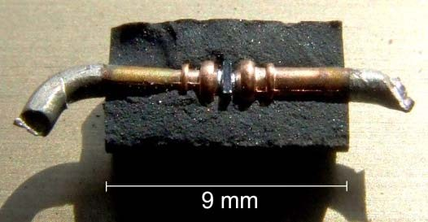

*A plastic can with metal base for power diodes. It can be hole mounted or surface mounted, depending on how the leads are bent. The base is screwed to the substrate for good thermal contact. From [1].*

*Cross‐section of a moulded package where metal pins are soldered directly to the diode. The semiconductor in the center (rectangular component)makes a Schottky barrier against one metal electrode (providing rectifying action) and an ohmic contact with the other electrode. From [13]*

*Figure 35: Examples of diode packaging.*

Diodes and transistors are examples of small active components. Figure 35 illustrates packaging of diodes in thru‐hole packages. In addition, there is a wide range of surface mount components available.

The transistor outline (TO) package family consists of many types of packaging solutions for transistors and similar discrete devices as well as simple IC's with low pin counts. The structures of TO packages vary widely, from expensive metal can enclosures to low‐cost plastic‐molded package bodies. TO cans are used for thru‐hole mounting, and are also very convenient for protoyping. Some examples of TO cans are illustrated in Table 5.



***FYS 4260/FYS 9260 Microsystems and electronic packaging and interconnection technologies***

*Table 5: Examples of TO can packages*

|  |  |  |  |
| --- | --- | --- | --- |
|  | TO‐3 ‐ Transistor Outline Package, Case Style 3 |  | TO‐39 ‐ Transistor Outline Package, Case Style 39 |
|  | TO‐5 ‐ Transistor Outline Package, Case Style 5 |  | TO‐46 ‐ Transistor Outline Package, Case  Style 46 |
|  | TO‐8 ‐ Transistor Outline Package, Case Style 8 |  | TO‐52 ‐ Transistor Outline Package, Case  Style 52 |
|  | TO‐18 ‐ Transistor Outline Package, Case  Style 18 |  | TO‐66 ‐ Transistor Outline Package, Case  Style 66 |
|  | TO‐36 ‐ Transistor Outline Package, Case  Style 36 |  | TO‐72 ‐ Transistor Outline Package, Case  Style 72 |

## IC Packages for thru‐hole mounting

Through hole technology uses holes drilled through the PCB for mounting the components. The component has leads that are soldered to pads on the PCB to electrically and mechanically connect them to the PCB.

Examples of packages includes the single‐in‐line package (SIP) and the very common dual in line package (DIP), as well as its ceramic counterpart; the CERDIP. Historically, DIP packages have had 0.1 inch pitch (2.54 mm), and have had 32 or more pins making them large components. In effect, electronics packaging development have focused on developing alternative packaging solutions with a smaller footprint. Figure 36 illustrates the build‐up of a plastic DIP package. While plastic packages are produced by epoxy injection moulding after the chip has been mounted and electrically connected to a lead frame, the corresponding ceramic DIP will produce the leadframe and package manufacturing before the chip is placed in a package cavity, connections are made, and the package sealed using a lid.



***FYS 4260/FYS 9260 Microsystems and electronic packaging and interconnection technologies***

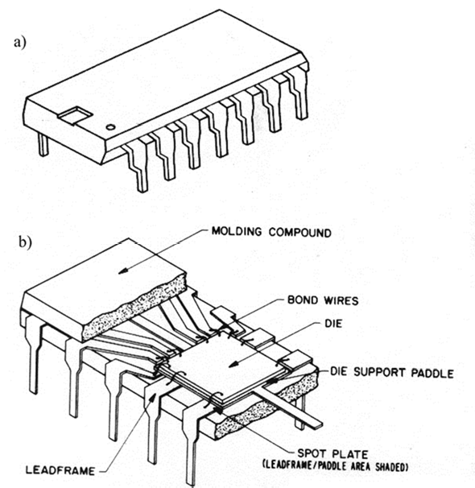

*Figure 36: Dual in line package. a) Complete package. The small imprint on the package top is used to define pin numbering (starting with Pin 1 to the left and continuing counter‐clockwise). b) Partly cross‐sectioned package to show the silicon chip, bonding wires, lead frame and plastic body. From [1]*

*Table 6: Illustration of common in‐line packages.*

|  |  |
| --- | --- |
| Figure | Description |
|  | Single in line package (SIP) |
|  | Dual in line package (DIP) |
|  | Ceramic dual in line package (CERDIP) |



***FYS 4260/FYS 9260 Microsystems and electronic packaging and interconnection technologies***

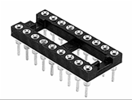

Socket for montage of removable Ics

Table 6 gives an overview of common in‐line packages, as well as an example of sockets for connection of replaceable components. A very nice feature with SIP and DIP packages is however their usefulness in prototyping. They fit in breadboard and Vero board applications, and they can be used in combination with sockets in cases where it is of interest to be able to easily remove a component from the PCB.

Pin grid array packages (Figure 37) are a logical extension of the in‐line packages. In pin grid array packages, there is room for many more connectors, and packages have been made containing several hundred I/O's. These packages are also attractive for applications where for example one wants to have a removable/exchangeable processor. However, with increasing pin count, these packages become very hard to insert and remove.

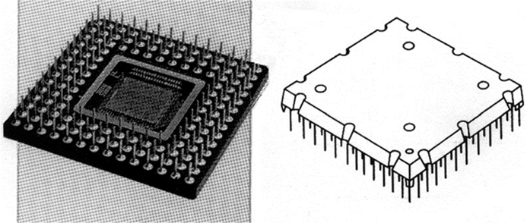

*Figure 37: Pin grid package. To the left a cavity up ceramic package, and to the right a plastic moulded package*

## Moving from thru‐hole to surface mount packages

*Figure 38: Lead shape effect on package outline*

The transition from thru‐hole to surface mount packages illustrates some of the different packaging trends and strategies. Figure 38 illustrates how the initial DIP package with legs at first have had its



***FYS 4260/FYS 9260 Microsystems and electronic packaging and interconnection technologies***

pins bent to allow surface mounting, then how pins have been bent in a J‐shape below the package to lower footprint, until packages with no leads, but only flat, solderable terminals have been realized.

Dual in line package development trend with time

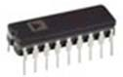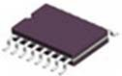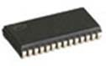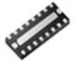

Dual in‐line package for thru‐hole mounting

Small outline package for surface mounting. Pins bent outward – not really making footprint smaller

Small Outline J‐Lead Package.

Pins bent inward below the chip in a J form

Dual Flat No Leads Package. Leads replaced with connector points integrated in package

*Figure 39: Development trend for dual in line packages from DIP to smaller footprint packages.*

The process described in Figure 39 represents an evolution of packages, and similar trends have taken place for quadratic packages.

* + 1. **Quadratic packages**

Using all four edges and a square package makes it possible to fit more pins on smaller package footprints.

Chip carriers may have either J‐shaped metal leads for connections by solder or by a socket, or may be lead‐less with metal pads for connections. If the leads extend beyond the package, the preferred description is "flat pack". Chip carriers may be made of ceramic or plastic.

A QFP or Quad Flat Package is a surface mount integrated circuit package with "gull wing" leads extending from each of the four sides. Versions ranging from 32 to 304 pins with a pitch ranging from

0.4 to 1.0 mm are common.

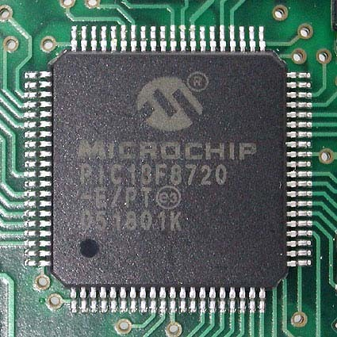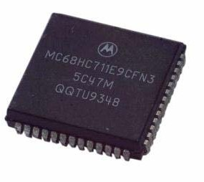



***FYS 4260/FYS 9260 Microsystems and electronic packaging and interconnection technologies***

An 80‐pin Thin Quad Flat package (TQFP) .Public Domain, https://commons.wikimedia.org/w/index.php?curid=1215948

Leadless Chip Carrier. By DLKS ‐ http://de.wikipedia.org/wiki/Bild:Qfj52.jpg, Public Domain,

https://commons.wikimedia.org/w/index.php?curid=1449250

*Figure 40: Examples of quadratic packages: Quad Flat Package and Leadless Chip Carrier*

## Chip Scale Packages

Whereas this section so far has dealt with rather simple packages and package evolution, there has also been a disruptive technology change towards small chip scale size packages. Flip chip technology has been the main enabler for this change, which also has made high density chip connect without wire‐bonding possible.

The idea is to place the flip‐chipped die on a small laminate, which in turn allows attachment for example by larger ball grid array attachment (see Figure 41) or using small leaded or leadless packages.

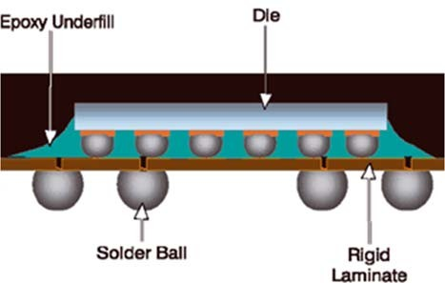One defintion of chip scale is that the package must have an area no greater than 1.2 times that of the die and it must be a single‐die, direct surface mountable package.

*Figure 41: Ball Grid Array package. Example of approach for chip scale packages.*

## Electrostatic discharge

More to come.

* 1. **MEMS packaging**

MEMS packages are to less degree than ICs standardized. The main reason is that MEMS packages usually need an additional window to the outside environment. This is illustrated in , where a differential pressure sensor need defined interfaces towards the measurement environment in which pressure will be measured. Still, you will see that the device is made so that it possibly can be



***FYS 4260/FYS 9260 Microsystems and electronic packaging and interconnection technologies***

handled with automated pick‐and‐place assembly equipment, but additional manual after‐work to attach tubing is certainly needed.

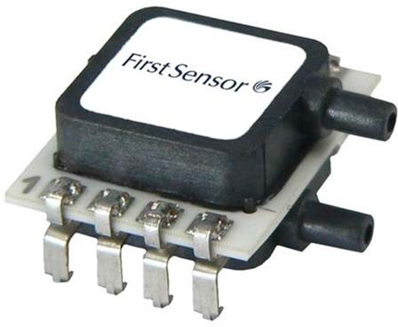 *Figure 42: Illustration of a MEMS differential pressure sensor.*

*In addition to the need for access to a measurement environment, MEMS are also non‐standard in the sense that they usually require a combination of a very delicate MEMS element and a corresponding ASIC. Still, most MEMS device vendors will try to make their devices compatible with PCB assembly techniques. One example of this was given in*

Figure 1 where a MEMS crash sensor element and ASIC are mounted together on a metal lead frame, and where the objective is to injection mould the system in the end to form a plastic package that does not deviate much from IC packages.

We will revisit MEMS packaging later in the course.

* 1. **Component delivery**

Components are usually delivered in standardized formats prepared for automated pick‐and‐place robots. These include:

* + - Paper tape (hole mounted passives)
    - Blister tape (SMD passives, discretes, small ICs)
    - Sticks (DIPs, SMD ICs)
    - Waffle trays (Flatpacks)
    - Stack magazine
    - Bulk: Not suited for automatic mounting



***FYS 4260/FYS 9260 Microsystems and electronic packaging and interconnection technologies***

* 1. **Appendix: Overview of IC packages**

|  |  |  |  |  |  |
| --- | --- | --- | --- | --- | --- |
| Image | Description | Image | Description | Image | Description |
|  | CBGA - Ceramic Ball Grid Array |  | MQFP - Metric Quad Flat Package |  | PQFP - Plastic Quad Flat Pack |
|  | CCGA - Ceramic Column Grid Array |  | MSOP - Micro Small Outline Package |  | PSOP - Power Small Outline Package |
|  | CerDIP - Ceramic Dual-in-Line Package |  | PBGA - Plastic Ball Grid Array |  | QFN - Quad Flat No Leads Package |
|  | CerPack - Ceramic Package |  | PDIP - Plastic Dual-in-Line Package |  | QSOP - Quarter Size Outline Package |
|  | CLCC - Ceramic Leadless Chip Carrier |  | PLCC - Plastic Leaded Chip Carrier |  | SBDIP - Sidebraze Dual-in-Line Package |
|  | CPGA - Ceramic Pin Grid Array |  | PPGA - Plastic Pin Grid Array |  | SC-70 - Small Outline Transistor |
|  | CQFP - Ceramic Quad Flat Pack |  | PQFN - Power Quad Flat No Leads Package |  | SIP - Single-In-Line Package |
|  | D2PAK or  DDPAK - Dou-ble Decawatt  Package |  | TFBGA - Thin Fine-Pitch Ball Grid Array |  | SOIC - Small Outline IC Package |
|  | D3PAK -  Decawatt Package 3 |  | TQFN - Thin Quad Flat No Leads Package |  | SOJ - Small Outline J-Lead Package |
|  | DFN - Dual Flat No Leads Package |  | TQFP - Thin Quad Flat Pack |  | SOT-23 - Small Outline Transistor |
|  | DPAK - Decawatt Package |  | TSOP - Thin Small Outline Package |  | SPDIP - Shrink Plastic Dual-in-Line Package |
|  | FBGA - Fine- Pitch Ball Grid Array |  | TSSOP - Thin Shrink Small Outline Package |  | SSOP - Shrink Small Outline Package |
|  | JLCC - J-Leaded Ceramic Chip Carrier |  | UTDFN - Ultra Thin Dual Flat No Leads Package |  | TDFN - Thin Dual Flat No Leads Package |
|  | LFBGA - Low  Profile Fine-Pitch Ball Grid Array |  | UTQFN - Ultra Thin Quad Flat No Leads Package |  | TFBGA - Thin Fine- Pitch Ball Grid Array |



***FYS 4260/FYS 9260 Microsystems and electronic packaging and interconnection technologies***

|  |  |  |  |  |  |
| --- | --- | --- | --- | --- | --- |
|  | LGA - Land Grid Array |  | VFBGA - Very Thin Fine-Pitch Ball Grid Array |  | VSOP - Very Small Outline Package |
|  | LQFP - Low-  Profile Quad Flat Package |  | PQFP - Plastic Quad Flat Pack |  | XDFN - Extreme Thin Dual Flat No Leads Package |
|  | MLP - Micro Leadframe Package |  | PSOP - Power Small Outline Package |  | XQFN - Extreme Thin Quad Flat No Leads Package |

**CHAPTER 5**

**TYPES OF PRINTED**

**WIRING BOARDS**

**Dr. Hayao Nakahara**

*N.T. Information Ltd., Huntington, New York*

* 1. ***INTRODUCTION***

Since the invention of printed wiring technology by Dr. Paul Eisner in 1936, several methods and processes have been developed for manufacturing printed wiring board (PWBs) of vari- ous types. Most of these have not changed significantly over the years; however, some specific trends continue to exert major influences on the types of PWBs required and the processes that create them:

* + 1. Computers and portable telecommunications equipment require higher-frequency cir- cuits, boards, and materials, and also use more functional components that generate con- siderable amounts of heat that need to be extracted.
    2. Consumer products have incorporated digital products into their design, requiring more functionality at ever-lower total cost.
    3. Products for all uses continue to get smaller and more functional, driving the total circuit package itself to become more dense, causing the PWBs to evolve to meet these needs.

These trends have led to the larger use of nonorganic base substrates, such as aluminum and soft iron. In addition, alternate ways to create boards have been developed. These will be discussed in this chapter, along with the traditional board structures and processes. The terms *printed wiring board, PWB,* and *board* will be used synonymously. Also, the words *laminate, substrate,* and *panel* will be used interchangeably.

#### **CLASSIFICATION OF PRINTED WIRING BOARDS**

PWBs may be classified in many different ways according to their various attributes. One fun- damental structure common to all of them is that they must provide electrical conductor paths which interconnect components to be mounted on them.

**5.2.1 Basic PWB Classifications**

There are two basic ways to form these conductors:

**5.1**

Copyright © 2008 by The McGraw-Hill Companies. Click here for terms of use.

* 1. PRINTED CIRCUITS HANDBOOK
     1. *Subtractive:* In the subtractive process, the unwanted portion of the copper foil on the base substrate is etched away, leaving the desired conductor pattern in place.
     2. *Additive:* In the additive process, formation of the conductor pattern is accomplished by adding copper to a bare (no copper foil) substrate in the pattern and places desired. This can be done by plating copper, screening conductive paste, or laying down insulating wire onto the substrate on the predetermined conductor paths.

The PWB classifications given in Fig. 5.1 take into consideration all these factors, i.e., fab- rication processes as well as substrate material. The use of this figure is as follows:

* Column 1 shows the classification of PWBs by the nature of their substrate.
* Column 2 shows the classification of PWBs by the way the conductor pattern is imaged.
* Column 3 shows the classification of PWBs by their physical nature.
* Column 4 shows the classification of PWBs by the method of actual conductor formation.

Graphic or discrete

Rigid or flex

Base material

wiring

1 2 3

Subtractive or

additive

Structure

4 5

PTH

or non-PTH

Process

6 7

SSB

Non

Subtractive DSB

Non

Rigid

MLB

PTH

Graphic

DSB

PTH

Additive

MLB

PTH

SSB

Non

Organic base

Flex

Subtractive DSB

Non

MLB PTH

Pattern plating

DSB

PTH

RigiFlex Subtractive

MLB

PTH

PWB

Rigid

Wirewrap

Discrete wire

Flex

Multiwire

PTH

RigiFlex

SSB

Subtractive

Inorganic base

Graphic

Rigid

DSB

Additive DSB

Pattern plating

Panel plating

Panel plating

Print & etch

Panel plating

Pattern plating

Panel plating

Pattern plating

Print & etch

PTH

PTH

**FIGURE 5.1** Classification of printed wiring boards.

TYPES OF PRINTED WIRING BOARDS **5.3**

* Column 5 shows the classification of PWBs by the number of conductor layers.
* Column 6 shows the classification of PWBs by the existence or absence of plated-through- holes (PTHs).
* Column 7 shows the classification of PWBs by production method.

#### **ORGANIC AND NONORGANIC SUBSTRATES**

One of the major issues that has arisen with the ever-higher speed and functionality of com- ponents used in computers and telecommunications is the availability of materials for the PWB substrate that are compatible with these product and process needs. This includes the stresses on substrate material created by more and longer exposure to soldering temperatures during the assembly process, as well as the need to match the coefficient of thermal expansion for components and substrate. The resultant search has found new materials, both organic and nonorganic based. The details of these materials are explained in Chaps. 6 through 11, but this outlines the basic character of the two types of substrate.

* + 1. **Organic Substrates**

Organic substrates consist of layers of paper impregnated with phenolic resin or layers of woven or nonwoven glass cloth impregnated with epoxy resin, polyimide, cyanate ester, BT resin, etc. The usage of these substrates depends on the physical characteristics required by the application of the PWB, such as operating temperature, frequency, or mechanical strength.

* + 1. **Nonorganic Substrates**

Nonorganic substrates consist mainly of ceramic and metallic materials such as aluminum, soft iron, and copper-invar-copper. The usage of these substrates is usually dictated by the need of heat dissipation, except for the case of soft iron, which provides the flux path for flex- ible disk motor drives.

#### **GRAPHICAL AND DISCRETE-WIRE BOARDS**

Printed wiring boards may be classified into two basic categories, based on the way they are manufactured:

* + 1. Graphical
    2. Discrete-wire
    3. **Graphical Interconnection Board**

A *graphical PWB* is the standard PWB and the type that is usually thought of when PWBs are discussed. In this case, the image of the master circuit pattern is formed photographically on a photosensitive material, such as treated glass plate or plastic film. The image is then transferred to the circuit board by screening or photoprinting the artwork generated from

* 1. PRINTED CIRCUITS HANDBOOK

the master. Due to the speed and economy of making master artwork by laser plotters, this master can also be the working artwork.

Direct laser imaging of the resist on the PWB can also be used. In this case, the conductor image is made by the laser plotter, on the photoresistive material, which is laminated to the board, without going through the intermediate step of creating a phototool*.* This tends to be somewhat slower than using working artwork as the tool and is not generally applied to mass production. Work continues on faster resists, as well as exposure systems, and this method will undoubtedly continue to emerge.

* + 1. **Discrete-Wire Boards**

Discrete-wire boards do not involve an imaging process for the formation of signal conduc- tors. Rather, conductors are formed directly onto the wiring board with insulated copper wire. Wire-wrap® and Multiwire® are the best known discrete-wire interconnection technologies. Because of the allowance of wire crossings, a single layer of wiring can match multiple con- ductor layers in the graphically produced boards, thus offering very high wiring density. How- ever, the wiring process is sequential in nature and the productivity of discrete-wiring technology is not suitable for mass production. Despite this weakness, discrete-wiring boards are in use for some very high density packaging applications. See Fig. 5.2 for an example of a discrete-wiring board.

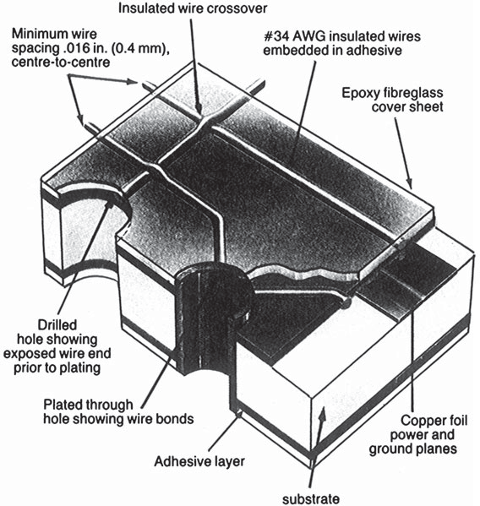

**FIGURE 5.2** Example of discrete-wiring board.

TYPES OF PRINTED WIRING BOARDS **5.5**

#### **RIGID AND FLEXIBLE BOARDS**

Another class of boards is made up of the *rigid* and *flexible* PWBs. Whereas boards are made of a variety of materials, flexible boards generally are made of polyester and polyimide bases. *Rigi- flex boards,* a combination of rigid and flexible boards usually bonded together, have gained wide use in electronic packaging (see Fig. 5.3). Most rigi-flex boards are three-dimensional

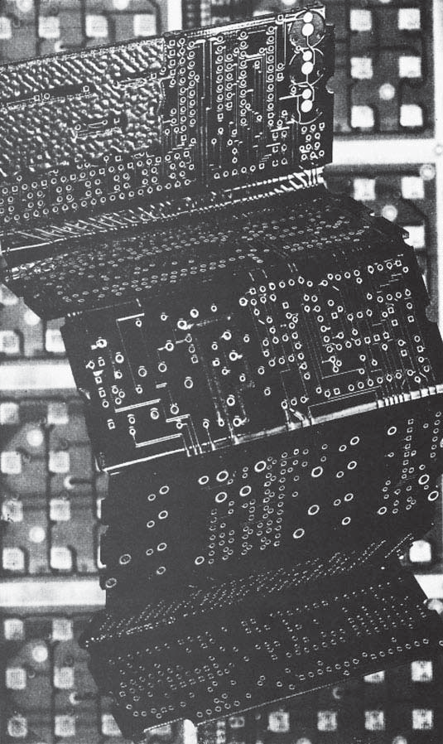

**FIGURE 5.3** Rigi-flex printed wiring board.

* 1. PRINTED CIRCUITS HANDBOOK

structures that have flexible parts connecting the rigid boards, which usually support compo- nents; this packaging is thus volumetrically efficient.

#### **GRAPHICALLY PRODUCED BOARDS**

The majority of boards produced in the world are graphically produced. There are three alter- native types:

* + 1. Single-sided boards
    2. Double-sided boards
    3. Multilayer boards
    4. **Single-Sided Boards (SSBs)**

Single-sided boards (SSBs) have circuitry on only one side of the board and are often referred to as print-and-etch boards because the etch resist is usually printed on by screen-printing techniques and the conductor pattern is them formed by chemically etching the exposed, and unwanted, copper foil.

* + - 1. ***Typical Single-Sided Board Materials.*** This method of board fabrication is gen- erally used for low-cost, high-volume, and relatively low functionality boards. In the Far East, for example, the majority of SSBs are made of paper-based substrates for lowest cost, with the most popular grade of paper-based laminate being XPC-FR, which is a flame-retardant phe- nolic material that is also highly punchable. In Europe, FR-2 grade paper laminate is the most popular substrate for SSBs because it emits less odor than XPC-FR when placed in high- voltage, high-temperature environments, such as inside a television set chassis. In the United States, CEM-1 material, which is a composite of paper and glass impregnated with epoxy resin, is the most popular substrate for SSBs. While not as low cost as XPC-FR or FR-2, CEM-1 has gained popularity because of its mechanical strength and also because of the rel- ative unavailability of paper phenolic laminates.
      2. ***Single-Sided Board Fabrication Process.*** Given the emphasis on cost and low complexity, SSBs are generally produced in highly automated, conveyorized print-and-etch lines, using the following basic process flow.

*Step 1:* Cut substrate into appropriate panel size by either sawing or shearing.

*Step 2:* Place panel in loader which feeds them into the line.

*Step 3:* Clean panels.

*Step 4:* Screen panel with ultraviolet curable etch-resist ink.

*Step 5:* Cure the etch-resist ink.

*Step 6:* Etch exposed copper.

*Step 7:* Strip the resist. *Step 8:* Apply solder resist. *Step 9:* Screen legend.

*Step 10:* Form holes by drilling or punching.

*Step 11:* Test for shorts and opens.

TYPES OF PRINTED WIRING BOARDS **5.7**

The conveyor speed of automated print-and-etch lines ranges from 30 to 45 ft/min. Some lines are equipped with an online optical inspection which enables the elimination of the final electrical open/short test.

As previously noted, after the conductor pattern is generated in the print-and-etch line, holes for component insertion are formed on the panel by punching when the panel is made of paper- based substrate, but must be formed by drilling when the panel is made of glass-based substrate.

* + - 1. ***Process Variations.*** In some variations, the conductor surface of the PWB gets insulated, exposing only pads, and then conductive paste is screened to form additional con- ductors on the same side of the board, thus forming double conductive layers on a single side. Most metal-core PWB consumer applications are made of aluminum substrate, which comes as a copper-clad material. PWBs made of such material do not have through-holes, and components are usually surface-mount types. These circuits are frequently formed into three-

dimensional shapes.

* + 1. **Double-Sided Boards**

By definition, double-sided boards (DBs) have circuitry on both sides of the boards. They can be classified into two categories:

1. Without through-hole metallization
2. With through-hole metallization

The category of through-hole metallization can be further broken into two types:

1. Plated-through-hole (PTH)
2. Silver-through-hole (STH)
   * + 1. ***Plated-Through-Hole Technology.*** PTH technology is discussed in some detail in Sec. 5.7; however, some comments are appropriate here.

Metallization of holes by copper plating has been practiced since the mid-1950s. Since PWB substrate is an insulating material, and therefore nonconductive, holes must be metal- lized first before subsequent copper plating can take place. The usual metallization procedure is to catalyze the holes with palladium catalyst followed by electroless copper plating. Then, thicker plating is done by galvanic plating. Alternately, electroless plating can be used to plate all the way to the desired thickness, which is called *additive plating.*

The biggest change in the manufacturing process of double-sided PTH boards, and also of multilayer boards (MLBs), is the use of *direct metallization* technologies. (See Chap. 30 for full discussion of electroless and direct metallization for through-hole boards.) Here, simply, it eliminates the electroless copper process. The hole wall is made conductive by palladium cat- alyst, carbon, or polymer conductive film, then copper is deposited by galvanic plating. The elimination of electroless copper, in turn, allows the elimination of environmentally haz- ardous chemicals, such as formaldehyde, and EDTA, which are two main components of elec- troless copper-plating solutions.

* + - 1. ***Silver-Through-Hole Technology.*** STH boards are usually made of paper phenolic materials or composite epoxy paper and glass materials, such as CE-1 or CE-3. After double- sided copper-clad materials are etched to form conductor patterns on both sides of the panel, holes are formed by drilling. Then the panel is screened with silver-filled conductive paste. Instead of silver, copper paste can also be used.

Since STHs have a relatively high electrical resistance compared with PTHs, the applica- tion of STH boards is limited. However, because of their economic advantage (the cost of

**5.8** PRINTED CIRCUITS HANDBOOK

STH boards is usually one-half to two-thirds that of functionally equivalent PTH boards), their application has spread to high-volume, low-cost products such as audio equipment, floppy disk controllers, car radios, remote controls, etc.

* + 1. **Multilayer Boards (MLBs)**

By definition, MLBs have three or more circuit layers (see Fig. 5.4). Main applications of MLBs used to be confined to sophisticated industrial electronic products. Now, however, they are the mainstream of all electronic devices, including consumer products such as portable video cameras, cellular phones, and audio discs.

* + - 1. ***Layer Count.*** As personal computers and workstations become more powerful, mainframe computers and supercomputers are being replaced in many applications by these smaller machines. As a result, the use of highly sophisticated MLBs, which have layer counts over 70, are being reduced, but the technology to produce them is proven. At the other end of the layer-count spectrum, thin and high-density MLBs with layer counts between 4 and 8 are mainstream. The drive toward thinner MLBs will continue and is made possible by the con- tinuing concurrent advancement of materials and equipment to handle thin core materials.
      2. ***Via and Via Production Technologies.*** As PWBs have had to address the issues of higher speed, higher density, and the rise of surface-mount components that use both sides, the need to communicate between layers has increased dramatically. At the same time, the space available for vias has decreased, causing a continuing trend toward smaller holes, more holes on the board, and the decline of the use of holes that penetrate the entire board, which use space on all layers. As a result, the use of buried and blind vias has become a stan- dard part of multilayer board technology, driven by the need for this increased package den- sity (Fig. 5.4).

One of the immediate issues that arise from these trends is the problems of drilling and the associated cost of this fabrication step. Printed wiring boards, which once were stacked three high on a drilling machine, must be drilled individually, and the number of holes per board has risen, to accommodate the need for vias. This has caused a major problem for fabricators, who find that a lack of drilling capacity is creating a big demand on funds for additional machines, while the cost of drilling continues to increase dramatically. Therefore, alternate methods for creating vias are being developed. These pressures will be ongoing, and therefore the process listed here, or some equivalent, will undoubtedly become more important as the drive to miniaturization continues and drilling individual holes becomes less and less practical.

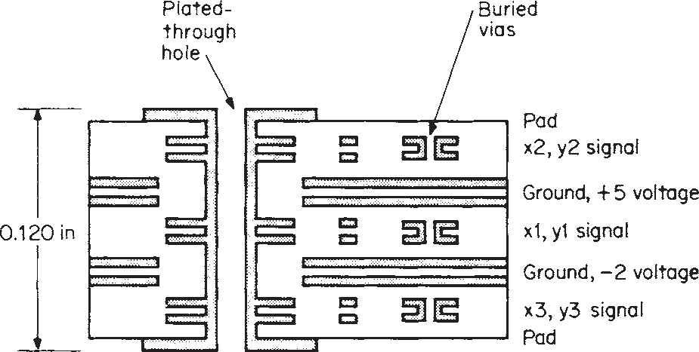

**FIGURE 5.4** Cross-section multilayer board with buried via holes. Buried vias are built into each of the double-sided boards that make up the final multilayer structure.

TYPES OF PRINTED WIRING BOARDS **5.9**

These processes have been developed to mass-produce vias without drills.

*Surface Laminar Circuits (SLCs).* The most notable MLB technology developed to form vias is the *sequential* fabrication of multilayers without press operations. This is particularly important for surface blind via holes.

The process for fabricating a board using surface laminar circuits is as follows (see Fig. 5.5):

1. Innerlayer ground and power distribution patterns are formed.
2. Panel receives an oxide treatment.
3. Insulating photosensitive resin is coated over the panel by curtain or screen-coating methods.
4. Holes are formed by photoexposure and development.
5. Panel is metallized by usual copper reduction process (consisting of catalyzing and elec- troless copper plating or by direct metallization process).
6. Thicker deposition of copper is made by continuation of electroless copper plating or gal- vanic plating.
7. Circuit patterns are formed by dry film tenting process.

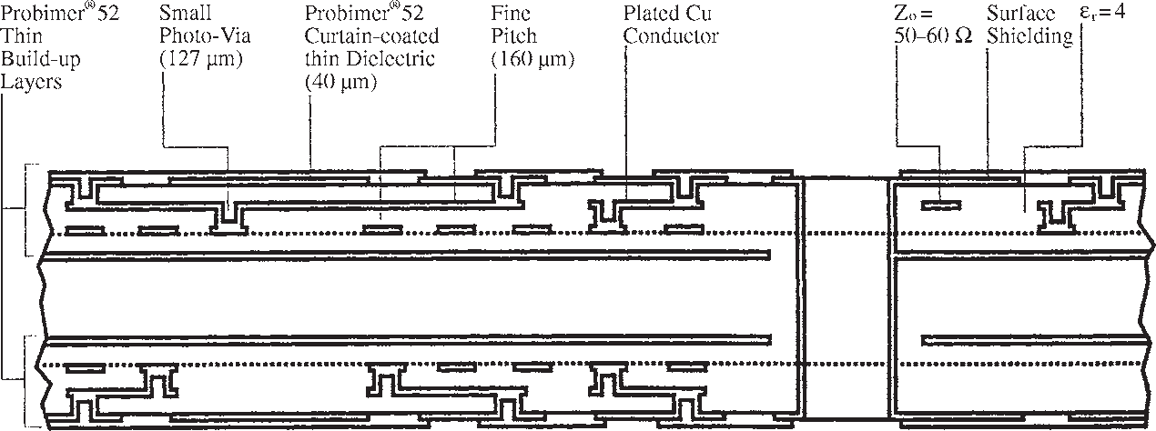

**FIGURE 5.5** Example of surface laminar circuit (SLC) board cross section. *(Courtesy IBM Yasu and Ciba-Geigy Limited.)*

*DYCOstrate®.* A different approach to small via creation has been taken by Dyconex AG of Switzerland. After ground and power patterns are formed on the panel, and the panel is oxide-treated, polyimide-backed copper foil is laminated on the panel. Holes in the copper are formed by a chemical etching process, and the insulating polyimide material underneath the holes is removed by plasma etching. PWBs made in such a way are called DYCOstrate. In other, similar technologies, different dielectric materials are used, and they are removed by alkaline solutions. The rest of the process is similar to that for SLC; that is, holes are metallized and a thick copper deposition is made by electroless or galvanic plating, and the circuit pat- tern is formed by a tent-and-etch process (see Fig. 5.5).

*Drilled Vias.* In both SLC and DYCOstrate cases, through-holes can also be made by con- ventional drilling and plating processes, in addition to the surface blind via holes.

*Cost Impact.* The manufacturing cost of these sequential technologies is not necessarily directly cheaper than conventional MLB technology, which depends on a laminating press operation. However, since the cost of making standard holes in a board can be as high as 30 percent of the total manufacturing cost, and the creation of holes in these processes is com- paratively inexpensive, the overall cost for equivalent functionality can be less. In addition, the fine pattern capability for this process is excellent. For example, an eight-layer conven- tional structure can often be reduced to a four-layer structure, reducing the total cost for the same packaging density.

**5.10** PRINTED CIRCUITS HANDBOOK

#### **MOLDED INTERCONNECTION DEVICES**

Three-dimensional circuit technology was of great interest in the early to mid-1980s. The pro- ponents for this technology, however, realized the mistake of trying to make it directly com- petitive with conventional flat circuits and have developed a niche where the substrate also offers other functional uses, such as structural support for the product.

Manufacturers of three-dimensional circuits prefer to call them *molded interconnection devices* (MIDs). In many applications of MIDs, the number of components to interconnect the electronic and electrical components can be reduced, thus making the total assembly cost cheaper and the final structure more reliable.

#### **PLATED-THROUGH-HOLE (PTH) TECHNOLOGIES**

In 1953, the Motorola Corporation developed a PTH process called the *Placir* method,1 in which the entire surface and hole walls of an unclad panel are sensitized with SnCl2 and met- allized by spraying on silver with a two-gun spray. Next, the panel is screened with a reverse conductor pattern, using a plating resist ink, leaving metallized conductor traces uncovered. The panel is then plated with copper by an electroplating method. Finally, the resist ink is stripped and the base silver removed to complete the PTH board. One problem associated with the use of silver is the migration caused by silver traces underneath the copper conductors. The Placir method was the forerunner of the semiadditive process, which is discussed in

Chap. 31.

In 1955, Fred Pearlstein2 published a process involving electroless nickel plating for metal- lizing nonconductive materials. This catalyzer consists of two steps. First, the panel is sensitized in SnCl2 solution, and then it is activated in PdCl2 solution. This process presented no problem for metallizing nonconductive materials.

At the same time that Pearlstein’s paper was published, copper-clad laminates were start- ing to become popular. Manufacturers of PWBs applied this two-step catalyzing process to making PTHs using copper-clad laminates. This process, however, turned out to be incompat- ible with the copper surface. A myriad of black palladium particles called *smads* were gener- ated between copper foil and electrolessly deposited copper, resulting in poor adhesion between the electroless copper and the copper foil. These smads and electroless copper had to be brushed off with strong abrasive action before the secondary electroplating process could begin. To overcome this smad problem, around 1960 researchers began attempting to develop better catalysts; the products of their research were the predecessors of modern pal- ladium catalysts.3

The mid-1950s was a busy time in the area of electroless copper-plating solutions. Electro- lessly deposited nickel is difficult to etch. But since it adheres somewhat better to the base than does electroless copper, research for the development of stable electroless copper- plating solutions was quite natural. Many patent applications for these solutions were filled in the mid-1950s. Among the applicants were P. B. Atkinson, Sam Wein, and a team of General Electric engineers, Luke, Cahill, and Agens. Atkinson won the case, and a patent4 teaching the use of Cu-EDTA as a complexing agent was issued in January 1964 (the application had been filed in September 1956).

* + 1. **Subtractive and Additive Processes**

Photocircuits Corporation was another company engaged throughout the 1950s in the devel- opment of chemicals for PTH processes. Copper-clad laminates were expensive, and a major

TYPES OF PRINTED WIRING BOARDS **5.11**

portion of expensive copper foil had to be etched (*subtracted*) to form the desired conductor pattern. The engineers at Photocircuits, therefore, concerned themselves with plating (*adding*) copper conductors wherever necessary on unclad materials for the sake of economy. Their efforts paid off. They were successful in developing not only the essential chemicals for reli- able PTH processes but also the fully additive PWB manufacturing technology known as the CC-4* process. This process is discussed in detail in Chap. 31.

With the use of SnCl2-PdCl2 catalysts and EDTA-base electroless copper-plating solutions, the modern PTH processes became firmly established in the 1960s. The process of metallizing hole walls with these chemicals for the subsequent formation of PTHs is commonly called the *copper reduction process.* In the subtractive method, which begins with copper-clad laminates, pattern plating and panel plating are the two most widely practiced methods of making PTH boards. These methods are discussed in the following subsections.

* + 1. **Pattern Plating**

In the pattern-plating method, after the copper reduction process, plating resist layers of the reverse conductor image are formed on both sides of the panel by screening resist inks. In most fineline boards, photosensitive dry film is used instead. There are some minor variations in the pattern-plating method (see Fig. 5.6):

* + - 1. Catalyzing (preparing the nonconductive surface to cause copper to come out of solution onto that surface)
      2. Thin electroless copper (0.00001 in) followed by primary copper electroplating; thick electroless copper (0.0001 in)
      3. Imaging (application of a plating resist in the negative of the desired finished circuit)
      4. Final electroplating copper
      5. Solder plating (as etching resist) 0.0002 or 0.0006 in
      6. Stripping plating resist
      7. Etching of base copper
      8. Solder etching (0.0002-in case); solder reflow (0.0006-in case)
      9. Solder mask followed by hot-air solder coater leveler if solder etching is used
      10. Final fabrication and inspection

Most manufacturers of DSBs with relatively wide conductors employ thick electroless copper plating. However, thin electroless copper followed by primary electroplating is pre- ferred for boards having fine-line conductors, because a considerable amount of surface is brushed off for better adhesion of dry film. This provides a higher reliability for PTHs. Solder reflow boards had been preferred by many customers, particularly in military and telecom- munications applications, until the emergence of hot-air solder coater levelers. Although the solder-over-copper conductors protect the copper from oxidization, solder reflow boards have some limitations. Solder mask is hard to apply over reflowed solder, and it tends to wrin- kle and peel off in some areas when the boards go through component soldering. A more seri- ous problem is the solder bridging that occurs when the conductor width and clearance become very small.

In step 9, the entire surface of the board except for the pads is covered by solder mask, and then the board is immersed into the hot-air solder coater leveler, resulting in a thin coating of

* CC-4 is a registered trademark of Kollmorgen Corporation.

**5.12** PRINTED CIRCUITS HANDBOOK

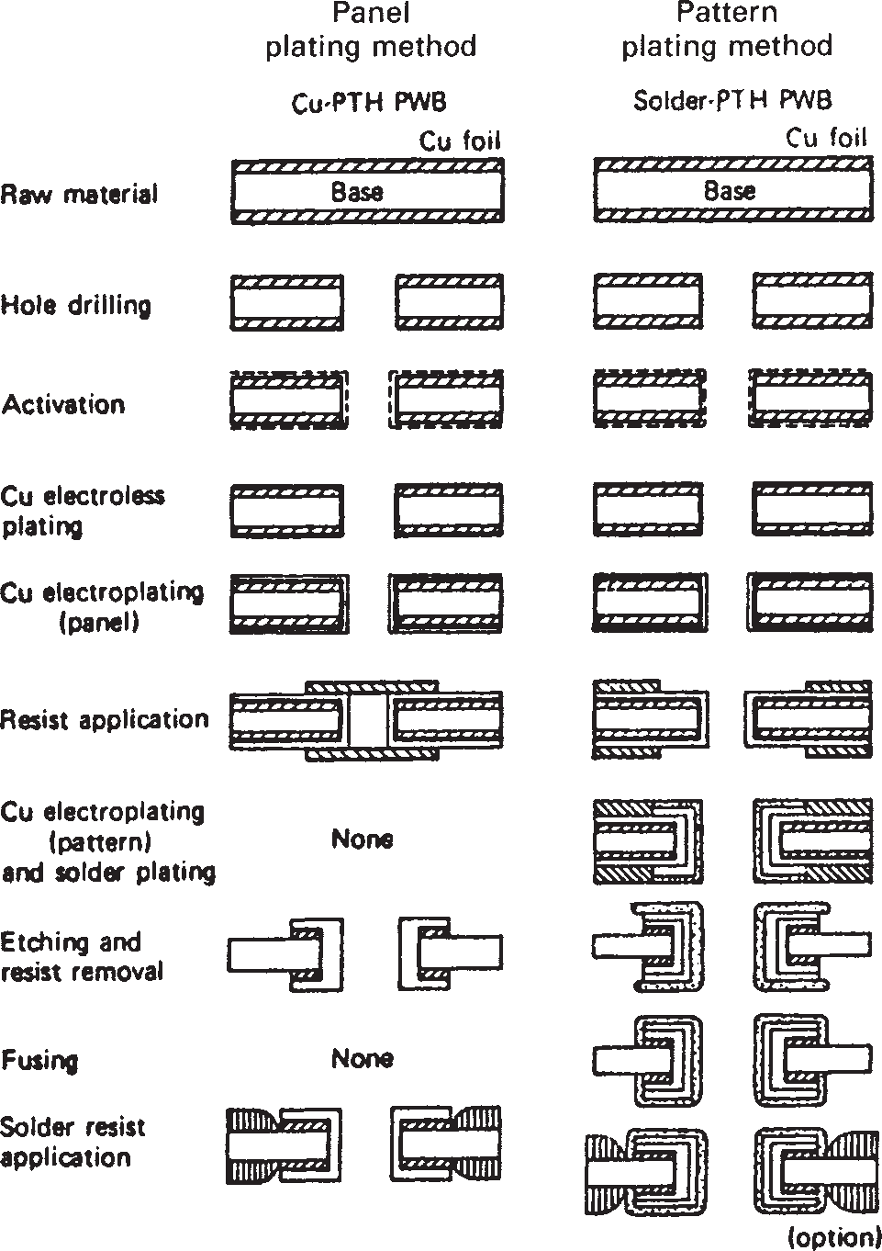

**FIGURE 5.6** Key manufacturing steps in panel plating and pattern- plating methods.

solder over the pads and the hole walls. The operation sounds simple, but it requires constant fine-tuning and maintenance of the hot-air solder coater leveler; otherwise, some holes may become heavily clogged with solder and are then useless for component insertion.

One advantage of the pattern-plating method over the panel-plating method is in etching. The pattern-plating method needs to etch only the base copper. The use of ultrathin copper foil (UTC), which is usually 1⁄8 or 1⁄4 oz thick, offers a real advantage. However, as long as elec- troplating is used, the pattern-plating method cannot escape from a current distribution prob- lem, regardless of the thickness of the base foils. The panel-plating method by electroplating suffers from the same problem but to a lesser degree. Good current distribution is very diffi- cult to achieve when the boards are not of the same size or type, and particularly if some have large ground planes on the outer faces being plated. When the board has a few holes in an iso- lated area remote from the bulk of the circuitry, these tend to become overplated, making component lead insertion difficult during assembly. To minimize this current distribution problem, various countermeasures are practiced, such as special anode position, anode mask- ing, agitation, and plating thieves. But none of these offers a decisive solution to the distribu- tion problem, and they are extremely difficult to implement flexibly and effectively in a large plating operation, where a large number of product mixes have to be handled all the time.

TYPES OF PRINTED WIRING BOARDS **5.13**

Another advantage of the pattern-plating method is its ability to form padless micro-via holes of a diameter ranging from 0.012 to 0.016 in. Micro-via holes enable better usage of con- ductor channels, thereby increasing the connective capacity of the board.

* + 1. **Panel Plating**

In the panel-plating method, there are two variations for finishing the board after the panel is plated with electrolytic copper to the desired thickness. In the *hole-plugging* method, the holes are filled with alkaline-etchable ink to protect the hole walls from being etched; this is used in conjunction with screened etch resist. In the other method, called *tent-and-etch* or sim- ply *tenting,* the copper in the hole is protected from etching by covering the hole or tenting with dry film, which is also used as an etch resist for conductors on the panel surface. The sim- plified sequence of the panel-plating method is as follows (see Fig. 5.6):

* + - 1. Catalyzing
      2. Thin electroless copper deposition (0.0001 in)
      3. Electroplating copper (0.001 to 0.0012 in)
      4. Hole plugging with alkaline-resolvable ink; tenting (dry film lamination)
      5. Screen-print etching resist (conductor pattern); photoexpose the panel for conductor pattern
      6. Etching copper
      7. Stripping etching resist
      8. Solder mask
      9. Solder coater leveler (optional)
      10. Final fabrication and inspection

The panel-plating method is ideal for bare copper board. However, it is a difficult way to make padless via holes, which are becoming more popular. Generally, the conductor width of

0.004 in is considered to be the minimum realizable by this method for mass production.

Although the use of the panel-plating method in the United States and western Europe is limited, nearly 60 percent of the PTH boards in Japan are manufactured by this method.

* + 1. **Additive Plating**

Plated-through holes can be formed by additive (electroless) copper deposition, of which there are three basic methods: fully additive, semiadditive, and partially additive. Of these, semiadditive involves pattern electroplating for PTHs with very thin surface copper, but the other two form PTHs solely by electroless copper deposition. The additive process has vari- ous advantages over the subtractive process in forming fineline conductors and PTHs of high aspect ratio. A detailed account of the additive process is given in Chap. 31.

#### **5.9 SUMMARY**

Modern electronic packaging has become very complex. Interconnections are pushed more into lower levels of packaging. The choice of which packaging technology to use is governed by many factors: cost, electrical requirements, thermal requirements, density requirements, and so on. Material also plays a very important role. All things considered, PWBs still play important roles in electronic packaging.

* 1. PRINTED CIRCUITS HANDBOOK

#### **REFERENCES**

* + 1. Robert L. Swiggett, *Introduction to Printed Circuits,* John F. Rider Publisher, Inc., New York, 1956.
    2. Private communication with John McCormack, PCK Technology, Division of Kollmorgen Corporation. 3. C. R. Shipley, Jr., U.S. Patent 3,011,920, Dec. 5, 1961.

4. R. J. Zebliski, U.S. Patent 3,672,938, June 27, 1972.

# CHAPTER 6

**INTRODUCTION TO BASE MATERIALS**

## Edward J. Kelley

*Isola Group, Chandler, Arizona*

#### **INTRODUCTION**

The field of base materials can appear deceptively simple. In simple terms, base materials are comprised of just three components: the resin system, the reinforcement, and the conductive foil. However, the variants in each of these components and the many possible combinations of these components make the discussion of base materials much more complex. One of the primary reasons for this complexity is the fact that printed circuits are used in so many differ- ing applications. This results in many different sets of requirements in terms of cost and per- formance, and therefore many grades of base materials.

Also, because base materials are the most fundamental components of the printed circuit itself, they interact with virtually every other printed circuit manufacturing process. Therefore, not only are the physical and electrical properties of the material critical, but their compati- bility with manufacturing processes is also of great importance.

In addition, the advent of the European Union’s Restriction of Hazardous Substances (RoHS) directive and the lead-free assembly processes that result are redefining the require- ments for base materials. RoHS has a severe impact on all aspects of base materials technol- ogy. The impact of lead-free assembly on base materials and a method of selecting materials for lead-free assembly are discussed in Chaps. 10 and 11. Requirements to support circuit densification, reliability, and electrical performance are also critical and will be discussed in Chap. 9. This chapter discusses grades and specifications of base materials, as well as the manufacturing processes used to make them.

#### **GRADES AND SPECIFICATIONS**

The various types of base materials can be classified by the reinforcement type, the resin system used, the glass transition temperature (Tg) of the resin system, as well as many other properties of the material. With the advent of lead-free assembly processes, proper- ties other than Tg are becoming as important, if not more important when selecting a base material. The decomposition temperature (Td) is one of these properties and will be defined shortly.

Copyright © 2008 by The McGraw-Hill Companies. Click here for terms of use.

* 1. PRINTED CIRCUITS HANDBOOK

The most commonly referenced specification for base materials is IPC-4101, “Specification for Base Materials for Rigid and Multilayer Printed Boards.” Historically, the National Electrical Manufacturers Association, NEMA, has also been used in specifying base materials.

###### NEMA Industrial Laminating Thermosetting Products

One of the first classifications of base materials for printed circuits (and other electrical com- ponents) was completed by the National Electrical Manufacturers Association (NEMA). NEMA’s industrial laminating thermosetting products standard documents many of the materials used in printed circuits as well as specifications for some of their properties. Historical NEMA grades are outlined in Table 6.1 and cross-referenced with IPC-4101 in Table 6.2. Some of the commonly used materials have been FR-2, CEM-1, CEM-3, and, of course, FR-4.

**TABLE 6.1** NEMA Base Material Grades

|  |  |  |  |
| --- | --- | --- | --- |
| Grade | Resin | Reinforcement | Flame Retardant |
| XXXPC | Phenolic | Cotton Paper | No |
| FR-2 | Phenolic | Cotton Paper | Yes |
| FR-3 | Epoxy | Cotton Paper | Yes |
| FR-4 | Epoxy | Woven Glass | Yes |
| FR-5 | Epoxy | Woven Glass | Yes |
| FR-6 | Polyester | Mat Glass | Yes |
| G-10 | Epoxy | Woven Glass | No |
| CEM-1 | Epoxy | Cotton Paper/Woven Glass | Yes |
| CEM-2 | Epoxy | Cotton Paper/Woven Glass | No |
| CEM-3 | Epoxy | Woven Glass/Mat Glass | Yes |
| CEM-4 | Epoxy | Woven Glass/Mat Glass | No |
| CRM-5 | Polyester | Woven Glass/Mat Glass | Yes |
| CRM-6 | Polyester | Woven Glass/Mat Glass | No |
| CRM-7 | Polyester | Mat Glass/Glass Veil | Yes |
| CRM-8 | Polyester | Mat Glass/Glass Veil | No |

FR-2 is comprised of multiple plies of paper impregnated with a flame-resistant pheno- lic resin. It possesses good punching characteristics and is relatively low in cost. It has typically been used in simple applications such as radios, calculators, and toys, where dimensional sta- bility and high performance are not required. FR-3 is also paper-based, but uses an epoxy resin system.

CEM-1 uses a paper-based core with woven glass cloth on the surfaces, both impregnated with an epoxy resin. This enables the material to be punched while realizing improved electri- cal and physical properties. CEM-1 has been used in both consumer and industrial electronics. CEM-3, a composite of dissimilar core materials, uses an epoxy resin impregnated, non- woven fiberglass core with epoxy resin impregnated, woven fiberglass cloth surface sheets. It is higher in cost than CEM-1, but is more suitable for plated through holes. CEM-3 has been

used in early home computers, automobiles, and home entertainment products.

FR-4, by far the most commonly used material for printed circuits, is constructed of woven fiberglass cloths impregnated with an epoxy resin or epoxy resin blend. The outstanding elec- trical, mechanical, and thermal properties of FR-4 have made it an excellent material for a wide range of applications including computers and peripherals, servers and storage net- works, telecommunications, aerospace, industrial controls, and automotive applications. FR-4 will be discussed in more detail later.

These grades are also used by ANSI, the American National Standards Institute.

**TABLE 6.2** IPC-4101 Base Material Summary

**6.5**

|  |  |  |  |  |  |
| --- | --- | --- | --- | --- | --- |
| Spec. Sheet # | Reinforcement Type | Resin System | ID Reference* | Tg Range | Other Properties |
| 00 | Cellulose Paper | Phenolic | XPC | N/A | UL94 HB |
| 01 | Cellulose Paper | Phenolic | XXXPC | N/A | UL94 HB |
| 02 | Cellulose Paper | Phenolic, Flame Resistant | FR-1 | N/A | UL94 V-1 |
| 03 | Cellulose Paper | Phenolic, Flame Resistant | FR-2 | N/A | UL94 V-1 |
| 04 | Cellulose Paper | Epoxy, Flame Resistant | FR-3 | N/A | UL94 V-1 |
| 05 | Cellulose Paper | Phenolic, Phosphorus Flame | FR-2 | N/A | UL94 V-1, limits on Br |
|  |  | Resistant |  |  | and Cl content |
| 10 | Woven E-Glass Surface/ | Epoxy/Phenolic, Flame | CEM-1 | 100C min. | UL94 V-0 |
|  | Cellulose Paper Core | Resistant |  |  |  |
| 11 | Woven E-Glass Surface/ | Polyester/Vinyl Ester, | CRM-5 | N/A | UL94 V-1, inorganic fillers |
|  | Non-Woven E-Glass Core | Flame Resistant |  |  |  |
| 12 | Woven E-Glass Surface/ | Epoxy, Flame Resistant | CEM-3 | N/A | UL94 V-0, with or without |
|  | Non-Woven E-Glass Core |  |  |  | inorganic fillers |
| 14 | Woven E-Glass Surface/ | Epoxy, Flame Resistant | CEM-3 | N/A | UL94 V-0, limits on Br and |
|  | Non-Woven E-Glass Core |  |  |  | Cl content |
| 20 | Woven E-Glass Fabric | Epoxy, Non-Flame Resistant | G-10, MIL-S-13949/ | N/A | UL94 HB |
|  |  |  | 03–GE/GEN |  |  |
| 21 Woven E-Glass | | Difunctional and | FR-4, MIL-S-13949/04–GF/ | 110C min. | UL94 V-0 |
|  | | Multifunctional Epoxy, | GFN/GFK/GFP/GFM |  |  |
|  | | Flame Resistant |  |  |  |
| 22 Woven E-Glass | | Epoxy, Hot Strength Retention, | G-11 MIL-S-13949/02–GB/ | 135C–175C | UL 94 HB |
|  | | Non-Flame Resistant | GBN/GBP |  |  |
| 23 Woven E-Glass | | Epoxy, Hot Strength Retention, | FR-5, MIL-S-13949/05–GH/ | 135C–185C | UL94 V-1 |
|  | | Flame Resistant | GHN/GHP |  |  |
| 24 Woven E-Glass | | Epoxy/Multifunctional | FR-4, MIL-S-13949/04–GF/ | 150C min. | UL94 V-0 |
|  | | Epoxy, Flame Resistant | GFG/GFN |  |  |
| 25 Woven E-Glass | | Epoxy/PPO, Flame Resistant | MIL-S-13949/04–GF/ | 150C–200C | UL94 V-1 |
|  |  |  | GFG/GFN |  |  |
| 26 Woven E-Glass | | Epoxy/Multifunctional | FR-4, MIL-S-13949/ | 170C min. | UL94 V-0 |
|  | | Epoxy, Flame Resistant | 04–GF/GFT |  |  |
| 27 Unidirectional E-Glass, | | Epoxy/Multifunctional Epoxy, | N/A | 110C min. | UL94 V-1 |
| Cross-Plied | | Flame Resistant |  |  |  |
| 28 Woven E-Glass | | Epoxy/Non-Epoxy, | MIL-S-13949/ | 170C–220C | UL94 V-1 |
|  | | Flame Resistant | 04–GFN/GFT |  |  |
| 29 Woven E-Glass | | Epoxy/Cyanate Ester, | MIL-S-13949/ | 170C–220C | UL94 V-1 |
|  | | Flame Resistant | 04–GFN, GFT |  |  |
|  | |  |  |  | *(continued)* |

**TABLE 6.2** IPC-4101 Base Material Summary (Continued)

**6.6**

|  |  |  |  |  |  |
| --- | --- | --- | --- | --- | --- |
| Spec. Sheet # | Reinforcement Type | Resin System | ID Reference* | Tg Range | Other Properties |
| 30 | Woven E-Glass | Bismaleimide/Triazine | GPY | 170C–220C | UL94 HB |
|  |  | (BT)/Epoxy | MIL-S-13949/ |  |  |
|  |  |  | 26–GIT/GMT |  |  |
| 31 | N/A | Epoxy/Multifunctional Epoxy | N/A | 90C min. | Non-reinforced film, |
|  |  |  |  |  | inorganic fillers, thermal  conductivity |
| 32 | Woven E-Glass | Epoxy/Multifunctional Epoxy | N/A | 90C min. | Inorganic fillers, thermal |
|  |  |  |  |  | conductivity |
| 33 | N/A | Epoxy/Multifunctional Epoxy | N/A | 150C min. | Non-reinforced film, |
|  |  |  |  |  | inorganic fillers, thermal  conductivity |
| 40 | Woven E-Glass | Polyimide | GPY | 200C min. | UL94 HB, |
|  |  |  | MIL-S-13949/10–GI/ |  | with or without |
|  |  |  | GIN/GIJ/GIP/GIL |  | inorganic fillers |
| 41 | Woven E-Glass | Polyimide | GPY | 250C min. | UL94 HB |
|  |  |  | MIL-S-13949/10– |  | with or without |
|  |  |  | GIL/GIP |  | inorganic fillers |
| 42 | Woven E-Glass | Polyimide/Epoxy | GPY | 200C min. | UL94 HB |
|  |  |  | MIL-S-13949/10–GIJ | 200C min. | with or without |
|  |  |  |  |  | inorganic fillers |
| 50 | Woven Aramid | Epoxy/Multifunctional Epoxy | MIL-S-13949/15–AF/ | 150C–200C | UL94 V-1 |
|  |  |  | AFN/AFG |  |  |
| 53 Non-Woven Aramid Paper | | Polyimide | MIL-S-13949/31–BIN/BIJ | 220C min. | UL94 HB |
| 54 Unidirectional Aramid | | Cyanate Ester | N/A | 230C min. | UL94 V-1 |
|  | Fiber, Cross Plied |  |  |  |  |
| 55 | Non-Woven Aramid Paper | Epoxy/Multifunctional Epoxy | MIL-S-13949/22–BF/ | 150C–200C | UL94 V-1 |
|  |  |  | BFN/BFG |  |  |
| 58 | Non-Woven | Multifunctional | N/A | 135C–185C | UL94 V-0, limits |
|  | Aramid Paper | Epoxy/Non-Epoxy, Phosphorus |  |  | on Br and Cl content |
|  |  | Flame Resistant |  |  |  |
| 60 | Woven Quartz Fiber | Polyimide | MIL-S-13949/19–QIL | 250C min. | UL94 HB |
| 70 | Woven S-2 Glass | Cyanate Ester |  | 230C min. | UL94 V-1 |
| 71 | Woven E-Glass | Cyanate Ester | MIL-S-13949/29–GCN | 230C min. | UL94 V-1 |
| 80 | Woven E-Glass | Epoxy/Phenolic | CEM-1 | 100C min. | UL94 V-0, Kaolin or |
|  | Surface/Cellulose | (catalyzed for additive process), |  |  | inorganic catalyst |
|  | Paper Core | Flame Resistant (Bromine |  |  |  |
|  |  | or Antimony) |  |  |  |

inorganic catalyst

|  |  |  |  |  |  |
| --- | --- | --- | --- | --- | --- |
| 81 Woven E-Glass Surface/ Non-Woven E-Glass Core | | Epoxy (catalyzed for additive process), Flame Resistant | CEM-3 | N/A | UL94 V-0, Kaolin or inorganic catalyst |
| 82 Woven E-Glass | | Epoxy/Multifunctional Epoxy, | FR-4 | 110C min. | UL94 V-1, Kaolin or |
|  | | (catalyzed for additive process), |  |  | inorganic catalyst |
|  | | Flame Resistant |  |  |  |
| 83 | Woven E-Glass | Epoxy/Multifunctional Epoxy | FR-4 | 150C–200C UL94 V-1, Kaolin or | |
| 90 | Woven E-Glass | Polyphenylene Ether, Bromine/ | N/A | 175C min. UL94 V-1 | |
|  |  | Antimony Flame Retardant |  |  | |
| 91 | Woven E-Glass | Polyphenylene Ether, | N/A | 175C min. | UL94 V-1 |
|  |  | Flame Retardant |  |  |  |
| 92 Woven E-Glass | | Epoxy/Multifunctional Epoxy, | FR-4 | 110C–150C | UL94 V-1, limits on |
|  | | Phosphorus Flame Retardant |  |  | Br and Cl content |
| 93 Woven E-Glass | | Epoxy/Multifunctional | FR-4 | 110C–150C | UL94 V-1, limits |
|  | | Epoxy, Aluminum Hydroxide |  |  | on Br and Cl content |
|  | | Flame Retardant |  |  |  |
| 94 Woven E-Glass | | Epoxy/Multifunctional | FR-4 | 150C–200C | UL94 V-1, limits |
|  | | Epoxy, Phosphorus Flame |  |  | on Br and Cl content |
|  | | Retardant |  |  |  |
| 95 Woven E-Glass | | Epoxy/Multifunctional | FR-4 | 150C–200C | UL94 V-1, limits |
|  | | Epoxy, Aluminum Hydroxide |  |  | on Br and Cl content |
|  | | Flame Retardant |  |  |  |
| 96 Woven E-Glass | | Polyphenylene Ether | N/A | 175C min. | UL94 V-1, limits on |
|  | |  |  |  | Br and Cl content |
| 97 Woven E-Glass | | Difunctional, | FR-4, MIL-S-13949/ |  |  |
|  | | Multifunctional Epoxy | 04–GF/GFN/GFK/ | 110C min. | UL94 V-0, inorganic fillers |
|  | |  | GFP/GFM |  |  |
| 98 Woven E-Glass | | Epoxy/Multifunctional | FR-4, MIL-S- | 150C min. | UL94 V-0, inorganic fillers |
|  | | Epoxy, Flame Retardant | 13949/04– |  |  |
|  | |  | GF/GFG/GFN |  |  |
| 99 Woven E-Glass | | Epoxy/Multifunctional | FR-4 | 150C min. | UL94 V-0, inorganic |
|  | | Epoxy/Modified or Non-Epoxy |  |  | fillers, Td, Z-axis CTE, |
|  | | (max. wt. 5%) |  |  | and time to delamination |
|  | |  |  |  | requirements |
| 101 Woven E-Glass | | Epoxy/Multifunctional Epoxy/ | FR-4 | 110C min. | UL94 V-0, inorganic fillers, |
|  | | Modified or Non-Epoxy |  |  | Td, Z-axis CTE, and |
|  | | (max. wt. 5%) |  |  | time to delamination |
|  | |  |  |  | requirements |

*(continued)*

**6.7**

**TABLE 6.2** IPC-4101 Base Material Summary (Continued)

**6.8**

|  |  |  |  |  |  |
| --- | --- | --- | --- | --- | --- |
| Spec. Sheet # | Reinforcement Type | Resin System | ID Reference* | Tg Range | Other Properties |
| 121 | Woven E-Glass | Difunctional, Multifunctional | FR-4 | 110C min. | UL94 V-0, Td, Z-axis |
|  |  | Epoxy/Modified or |  |  | CTE, and time to |
|  |  | Non-Epoxy (max. wt. 5%) |  |  | delamination |
|  |  |  |  |  | requirements |
| 124 | Woven E-Glass | Epoxy/Multifunctional | FR-4 | 150C min. | UL94 V-0, Td, Z-axis CTE, |
|  |  | Epoxy/Modified or Non-Epoxy |  |  | and time to delamination |
|  |  | (max. wt. 5%) |  |  | requirements |
| 126 | Woven E-Glass | Epoxy/Multifunctional | FR-4 | 170C min. | UL94 V-0, Inorganic |
|  |  | Epoxy/Modified or Non-Epoxy |  |  | Fillers, Td, Z-axis CTE, |
|  |  | (max. wt. 5%) |  |  | and time to delamination |
|  |  |  |  |  | requirements, 130C max. |
|  |  |  |  |  | operating temp. |
| 129 | Woven E-Glass | Epoxy/Multifunctional | FR-4 | 170C min. | UL94 V-0, Td, Z-axis CTE, |
|  |  | Epoxy/Modified or Non-Epoxy |  |  | and time to delamination |
|  |  | (max. wt. 5%) |  |  | requirements, 130C max. |
|  |  |  |  |  | operating temp. |

* ANSI, NEMA, and/or MIL-S-13949 grade.

INTRODUCTION TO BASE MATERIALS **6.9**

###### PC-4101 Specification for Base Materials for Rigid and Multilayer Printed Boards

The most commonly used specification for base materials is IPC-4101. This specification presents a classification scheme and specification sheets for the various materials in use. Table 6.2 summarizes the various materials by specification sheet number. Each specifica- tion sheet in IPC-41011 includes property requirements for that particular material type. As these specification sheets are updated periodically, it is recommended that the latest revision of this document be reviewed. This is particularly true in light of new require- ments for materials that must be compatible with lead-free assembly. Table 6.2 is presented for reference only and is not all-inclusive. UL94 comments in Table 6.2 reference the min- imum flammability requirements for that material. Materials may exceed these minimum ratings. Also note that where a non-halogen-based flame retardant is used, it is shown along with the resin system description. Definitions of the UL flammability ratings are given in Chap. 8.

Some of the properties documented in the specification sheets of IPC-4101 include Tg, copper peel strengths at different conditions, volume resistivity, surface resistivity, moisture absorption, dielectric breakdown voltage, permittivity, loss tangent, flexural strengths and arc resistance. These properties will be discussed further in Chap. 8.

IPC-4101 also provides a classification scheme for identification of laminate and prepreg materials; this is described in Secs. 6.5 and 6.6.

#### **PROPERTIES USED TO CLASSIFY BASE MATERIALS**

Historically, the Tg has been the most common property used to classify FR-4 base materials, and this is one of the primary properties documented in IPC-4101. Materials with high Tg val- ues were generally viewed as being more reliable. While this question was never as simple as specifying only the Tg, the move toward lead-free assembly has caused a fundamental redefi- nition of what properties are needed to ensure a given level of reliability. The reason is that the alloys used in lead-free assembly require higher peak temperatures than those used in tin- lead assembly. These higher peak temperatures can approach the point where many base materials begin to decompose. For this reason, the decomposition temperature is becoming another property used to classify base materials.

Other important properties include Z-axis expansion characteristics, moisture absorption, and adhesion characteristics within the material, commonly measured using time-to- delamination tests such as the T260 test. The Tg and its impact on Z-axis expansion are summarized below along with the decomposition temperature. The other properties will be discussed in Chaps. 8 and 10.

###### Glass Transition Temperature, Tg

The Tg of a resin system is the temperature at which the material transforms from a relatively rigid or “glassy” state, to a more deformable or softened state. This is a thermodynamic change in the material which is reversible as long as the resin system has not been degraded. This is to say that when a material that has been heated above its Tg is cooled back below the Tg, it returns to a more rigid state with essentially the same properties as before. However, if the material is heated to too high a temperature beyond Tg, irreversible changes in properties may result. The temperature at which this will happen varies by material type and is related to resin decomposition, discussed later.

* 1. PRINTED CIRCUITS HANDBOOK

Tg

Thickness

Temperature

**FIGURE 6.1** Glass transition temperature by TMA.

A material is not in a liquid state when it is above the Tg, as some discussions of Tg imply. It is a temperature at which physical changes take place due to the weakening of mole- cular bonds within the material. It is important to under- stand Tg since the properties of base materials are different above Tg than below Tg. While the Tg is typically described as being a very precise temperature, this is somewhat mis- leading, because the physical properties of the material can begin to change as the Tg is approached and some of the molecular bonds are affected. As the temperature increases, more of the bonds become weakened until for all practical purposes, all relevant bonds are affected. This explains the curved line in Fig. 6.1, which is discussed in the following text.

The Tg of a resin system has several important implications. These include:

* + - The impact on thermal expansion.
    - A measure of the degree of cure of the resin system.
      1. ***Thermal Expansion.*** All materials will undergo changes in physical dimensions in response to changes in temperature. The rate at which the material expands is much lower below the Tg than above. Thermomechanical analysis (TMA) is a procedure used to measure dimensional changes versus temperature. Extrapolating the linear portions of the curve to the point at which they intersect provides a measure of the Tg (see Fig. 6.1). The slopes of the lin- ear portions of the curve above and below the Tg represent the respective rates of thermal expansion, or as they are typically called, the coefficients of thermal expansion (CTEs). CTE values are important since they influence the reliability of the finished circuit. Other things being equal, less thermal expansion will result in greater circuit reliability as less stress is applied to plated holes.
      2. ***Degree of Cure.*** The resin systems used in base materials begin with subcompo- nents that contain reactive sites on their molecular structures. The application of heat to the resin system and curing agents causes the reactive sites to *cross-link* or bond together. This process of curing the resin system brings about physical changes in the material in proportion to the degree to which the cross-linking occurs, including increases in the Tg. When most of the reactive sites have cross-linked, the material is said to be fully cured and its ultimate physical properties will be established.

Besides TMA, two other thermal analysis techniques are also commonly used for measur- ing Tg and degree of cure: differential scanning calorimetry (DSC) and dynamic mechanical analysis (DMA).

* + - DSC measures heat flow versus temperature rather than the dimensional changes mea- sured by TMA. The heat absorbed or given off will also change as the temperature increases through the Tg of the resin system. Tg measured by DSC is often somewhat higher than mea- surements by TMA.
    - DMA measures the modulus of the material versus changes in temperature, and also will give somewhat higher values for Tg.

Materials that are not fully cured can cause problems in circuit manufacturing processes and with finished circuit reliability. For example, an undercured multilayer circuit at the drilling process can result in excessive resin smear across the internal circuit connections in

INTRODUCTION TO BASE MATERIALS **6.11**

the hole formed.This happens because an under- cured resin system, and the resulting lower than normal Tg, will result in excessive softening of the resin when it is subjected to the heat gener- ated during the drilling process. If this smeared resin is not completely removed, it can prevent electrical connection when the hole is plated with copper. In addition, finished circuits in which the resin system is not fully cured can exhibit greater amounts of Z-axis thermal expansion.This adversely affects circuit board reliability due to the increased stress on the plated through holes as the circuit expands.

Because increased cross-linking will require greater amounts of energy (heat) to weaken the

Tg1 Tg2 Temperature

Thickness

**FIGURE 6.2** Measuring the degree of cure by measuring Tg values.

bonds in the molecular structure of the resin system, measurements of Tg can be used to deter- mine the degree of cure of the resin system. For example, a measure of the degree of cure can be obtained by performing two thermal analyses on the same sample. After the first analysis, the sample is subjected to a thermal cycle designed to promote any additional cross-linking available within the resin system, and then a second thermal analysis is performed. The degree of cure is measured by comparing the difference in measured Tg between the two analyses (see Fig. 6.2). If the material is fully cured, the difference between Tg2 and Tg1 will be very small, typ- ically within a few degrees Celsius. Negative differences in these measured values or negative “delta Tg” values where Tg1 is greater than Tg2 are also indicative of full cure. However, great care must be exercised when using these methods to assess degree of cure. An understanding of the resin system is important because not all resins will behave the same way when per- forming sequential tests such as this. The degree of cure for some advanced resin systems is not easily assessed by these techniques. In addition, sample preparation methods, particularly sam- ple drying prior to testing, can also influence results.

* + - 1. ***Advantages and Disadvantages of High Tg Values.*** Implicit in many discussions of Tg is the assumption that higher values of Tg are always better. This is not always the case. While it is certainly true that higher values of Tg will delay the onset of high rates of thermal expan- sion for a given resin system, total expansion can differ from material to material. A material with a lower Tg could exhibit less total expansion than a material with a higher Tg, due to differing resin CTE values or by incorporating fillers into the resin system that lower the CTE of the composite material. This is illustrated in Fig. 6.3. Material C exhibits a higher Tg than material A, but material C exhibits more total thermal expansion because its CTE value above Tg is much higher. On the other hand, with the

same CTE values above and below the Tg, the higher-Tg material B exhibits less total ther- mal expansion than material A. Finally, although the Tg values are the same, material B exhibits less total expansion than material C due to a lower CTE value above Tg. This will be discussed further in Chap. 10 in the context of the impact of lead-free assembly temperatures on base materials.

There are other considerations as well. Most notably, many standard 140C Tg FR-4 materials exhibit higher decomposition tem- peratures, Td’s, than the standard 170C Tg

C

Temperature

A

B

Thickness

FR-4s.Td is an important property for lead-free

**FIGURE 6.3** Tg versus thermal expansion.

**6.12** PRINTED CIRCUITS HANDBOOK

assembly, with higher values generally preferred. Advanced FR-4 resin systems can combine both high-Tg and high- Td. This will be discussed in detail in Chap. 10.

In addition, higher Tg resin systems can be harder and more brittle than lower Tg systems. This can adversely affect productivity in the printed circuit manufacturing process. In partic- ular, the drilling process can be affected as slower drilling, reduced drill bit life or reduced stack heights can be required for high-Tg materials.

Lower copper peel strength values and shorter times to delamination can also be corre- lated with higher Tg values, though other factors influence these properties as well. The time to delamination is a measure of the time it takes for the resin and copper, or resin and rein- forcement, to separate or delaminate, and can be correlated to Td. This will also be discussed in Chaps. 8 and 10, in the context of lead-free assembly. This time-to-delamination test utilizes TMA equipment to bring a sample to a specified temperature and then measures the time it takes for failure to occur. Failure is typically delamination between the resin and copper foil, or resin and glass within the laminate. Temperatures of 260C (T260) and 288C (T288) are commonly used for this testing.

###### Decomposition Temperature, Td

As a material is heated to higher temperatures, a point is reached where the resin system will begin to decompose. The chemical bonds within the resin system will begin to break down and volatile components will be driven off, reducing the mass of the sample. The decomposition temperature, Td, is a property which describes the point at which this process occurs. The traditional definition of Td is the point where 5 percent of the original mass is lost to decomposition. However, 5 percent is a very large number when multilayer PCB reliability is considered, and temperatures where lower levels of decomposition occur are very important to understand, particularly with respect to lead-free assembly. To illustrate this, con- sider Fig. 6.4.

In Fig. 6.4, you can see curves for two FR-4 materials.The “traditional FR-4,” a 140C Tg mate- rial in this case, has a decomposition temperature of 320C by the 5 percent weight loss definition. The “enhanced FR-4” has a decomposition temperature of 350C by the 5 percent weight loss definition. Many standard high-Tg FR-4 materials actually have decomposition

100

95

Weight %

210 270

320 350

400

Typical Sn/Pb assembly temperature range

210C-245C

Lead-free Temperature C

temperature range

assembly

240C-270C

**FIGURE 6.4** Illustration of decomposition curves.

INTRODUCTION TO BASE MATERIALS **6.13**

temperatures in the range of 290–310C, while the 140C Tg FR-4 materials generally have slightly higher Td values. The shaded regions indicate the peak temperature ranges for stan- dard tin-lead assembly and lead-free assembly. A very common question is, if a PCB will be assembled at 260C, and the material has a decomposition temperature of 310–320C, then why wouldn’t it be compatible with lead-free assembly?

The answer lies in the level of decomposition in the temperature ranges where assembly will take place. In the tin-lead temperature range, neither material exhibits a significant level of decomposition. However, in the lead-free assembly temperature range, the traditional FR- 4 begins to exhibit 1.5–3 percent weight loss. This level of decomposition can compromise long-term reliability or result in defects such as delamination during assembly, particularly if multiple assembly cycles or rework cycles are performed.

#### **TYPES OF FR-4**

As can be seen in Table 6.2, several materials listed are considered FR-4. This begs the question: What is FR-4? In Table 6.2, it can be seen that each material considered FR-4 is flame-resistant, uses a woven fiberglass reinforcement and is primarily an epoxy-based resin system.

###### The Many Faces of FR-4

So what can be different about these materials? The most obvious difference between the commercially available FR-4 materials is in Tg values. Specification sheet 21 refers to an FR- 4 with a minimum Tg of 110C. More common are FR-4 materials with Tg values between 130C to 140C and 170C to 180C. Therefore, it is obvious that FR-4 materials can consist of different types of epoxy resins. Indeed, there are many types of epoxy resins that will provide differing Tg values, as well as differences in other properties.

Specification sheets 92-95 list FR-4 materials with non-halogen-based flame retardants, as well as different Tg ranges. Sheets 92 and 94 indicate the use of a phosphorus-based flame retardant, whereas sheets 93 and 95 show the use of aluminum hydroxide. So FR-4 may include different types of flame retardants.

In addition, several FR-4 materials, such as those shown in sheets 99, 101, and 126, show that these materials contain inorganic fillers. These fillers are often used to reduce the amount of Z-axis expansion. Some of these materials also have requirements for Td, Z-axis expansion and time-to-delamination, which historically were not properties included on the specifica- tion sheets. The addition of specification sheets with these properties was partly driven by their relevance to compatibility with lead-free assembly processes.

Finally, specification sheet 82 covers an FR-4 material catalyzed for an additive copper- plating process. A catalyst used for this material is a kaolin clay filler coated with palladium. In short, there are many combinations of resin system, flame retardant and filler that can result in many types of FR-4.

###### The Longevity of FR-4

FR-4 materials have been the most successful, most commonly used materials in printed circuit manufacturing for many years. Why? Well, as we just discussed above, FR-4 actually encompasses a range of material types, even though they share certain properties and are pri- marily epoxy-based. The result is that there is often an FR-4 material readily available for the most common end-use applications. For relatively simple applications, the 130C to 140C Tg FR-4s have become the material of choice. In higher layer count multilayer circuits, in very

**6.14** PRINTED CIRCUITS HANDBOOK

thick circuits, as well as those requiring improved thermal properties, the 170C to 180C Tg FR-4s have become the material of choice. With the advent of lead-free assembly, Td and other properties must also be considered along with Tg. Further, as noted above, higher Tg does not always translate to better performance in lead-free assembly applications. In other words, as the range of end-use applications has grown, so has the range of available FR-4 materials.

In addition, the components used in FR-4 materials, particularly woven fiberglass cloth and epoxy resins, provide a very good combination of performance, processability, and cost. The range of woven fiberglass cloth styles available makes it easy to control dielectric and overall circuit thicknesses. As noted earlier, the range of epoxy resin types also makes it rela- tively simple to tailor material properties to end-use applications. The combination of good electrical, thermal, and mechanical properties of epoxies also explains why they have become the primary type of resin used in printed circuits. Epoxy-based materials are also relatively easy to process through conventional printed circuit manufacturing processes, at least in com- parison to some of the other types of materials available. The processability of these materials has helped control the cost of FR-4-based printed circuits.

Last, the development of FR-4 materials took advantage of established manufacturing processes and materials. Weaving processes have been in place for many years. The funda- mental process of weaving fiberglass yarns into glass cloth is not so different from weaving textile yarns into cloth fabrics. Using the same basic manufacturing technology avoided addi- tional upfront research and development costs, but more importantly it avoids to some extent highly specialized capital assets and aids in achieving economies of scope for the suppliers of fiberglass cloth. The result is good control of the costs of these materials. Likewise, epoxy resins have been in use in a wide range of applications outside of printed circuits, resulting in a very large installed manufacturing base for these types of materials. This also results in good cost competitiveness for epoxy resins. In summary, the range of FR-4 types and their unique combination of performance, processability and cost characteristics have made them the workhorse of the printed circuit industry.

#### **LAMINATE IDENTIFICATION SCHEME**

As IPC specifications are regularly reviewed and updated, it is recommended that the latest IPC specification be used for actual applications. However, an example of a laminate desig- nation in IPC-4101 is:

|  |  |  |  |  |  |
| --- | --- | --- | --- | --- | --- |
| **L** | **25** | **1500** | **C1/C1** | **A** | **A** |
| Material | Specification | Nominal | Metal Cladding | Thickness | Surface |
| Designator | Sheet Number | Laminate Thickness | Type and  Nominal Weight/Thickness | Tolerance Class | Quality Class |

* + - **Material designator** “L” refers to laminate.
    - **Specification sheet number** This designation references the specification sheet number as in Table 6.2.
    - **Nominal laminate thickness** Four digits identify this variable. It may be specified either over the cladding or over the dielectric. For metric specification, the first digit represents whole millimeters, the second represents tenths of millimeters, and so on. For orders requiring English units, the four digits indicate the thickness in ten-thousandths of an inch (tenths of mils). In the example shown, 1500 is designated for the English usage of 0590.

INTRODUCTION TO BASE MATERIALS **6.15**

**TABLE 6.3** Metal Cladding Types Summarized in IPC-4101 (IPC-CF-148, IPC-4562, and IPC-CF-152 are Actual Metal Cladding Specifications)2

Designation Metal Cladding Type

1. Copper, wrought, rolled (IPC-4562, grade 5)
2. Copper, rolled (treated)
3. Copper, electrodeposited (IPC-4562, grade 1)
4. Copper, electrodeposited, double treat (IPC-4562, grade 1) G Copper, electrodeposited, high ductility (IPC-4562, grade 2)

H Copper, electrodeposited, high temperature elongation (IPC-4562, grade 3) J Copper, electrodeposited, annealed (IPC-4562, grade 4)

1. Copper, wrought, light cold rolled (IPC-4562, grade 6)
2. Copper, wrought, annealed (IPC-4562, grade 7)
3. Copper, wrought, rolled, low temperature annealable (IPC-4562, grade 8) N Nickel
4. Unclad
5. Copper, electrodeposited, high temperature elongation, double treat (IPC-4562, grade 3)
6. Copper, reverse treated electrodeposited (IPC-4562, grade 1)
7. Copper, reverse treated electrodeposited, high temperature elongation (IPC-4562, grade 3)
8. Copper, copper foil parameters as dictated by contract or purchase order U Aluminum

V Copper, revers treated electrodeposited, high temperature elongation (IPC-4562, grade 3) for buried capacitance applications

1. As agreed between user and supplier
2. Copper Invar Copper
3. Copper, electrodeposited, high temperature elongation, double-treat (IPC-4562, grade 3) for buried capacitance applications
   * + **Metal cladding type and nominal weight/thickness** Five designators are used to specify cladding type and thickness. The first and fourth indicate the type, the second and fifth indi- cate thickness, and the third is a slash to differentiate sides of the base material. Table 6.3 lists the types of metal cladding. Table 6.4 lists copper foil weights and thicknesses.
     + **Thickness tolerance class** This variable references the thickness tolerance as agreed between user and supplier (see Table 6.5). Classes A, B, and C refer to measurement by micrometer of the base material without cladding. Class D requires measurement by microsection (see Fig. 6.5). Classes K, L, and M refer to measurement by micrometer of the base material with the metal cladding. Class X refers to a requirement agreed upon between user and supplier.
     + **Surface quality class** This class is identified by either A, B, C, D, or X (as agreed upon between user and supplier). Specimens are examined with normal or corrected 20/20 vision. The worst 50 mm  50 mm (1.97 in.  1.97 in.) is examined at 10  magnification. Indentations are located visually using normal or corrected 20/20 vision. The longest dimension of each foil indentation in a specimen is measured with a suitable reticule on a minimum 4  magnifier, with referee inspections at 10 . A point value is allocated accord- ing to the longest dimension, as shown in Table 6.6. Surface quality class is determined by the total point count of foil indentations within 300 mm  300 mm (11.81 in.  11.81 in.), as shown in Table 6.7.

**6.16** PRINTED CIRCUITS HANDBOOK

**TABLE 6.4** Foil Weights and Thicknesses from IPC-4101 (IPC-CF-148, IPC-4562, and IPC-CF-152 are Actual Metal Cladding Specifications)

|  |  |  |  |  |  |  |
| --- | --- | --- | --- | --- | --- | --- |
| Foil | Common Industry | Area Weight | Nominal Thickness | Area Weight | Area Weight | Nominal Thickness |
| Designator | Terminology | (g/m2) | (**m) | (oz/ft2) | (g/254 in.2) | (**m) |
| E | 5 **m | 45.1 | 5.1 | 0.148 | 7.4 | 0.20 |
| Q | 9 **m | 75.9 | 8.5 | 0.249 | 12.5 | 0.34 |
| T | 12 **m | 106.8 | 12.0 | 0.350 | 17.5 | 0.47 |
| H | 1/2 oz | 152.5 | 17.1 | 0.500 | 25.0 | 0.68 |
| M | 3/4 oz | 228.8 | 25.7 | 0.750 | 37.5 | 1.01 |
| 1 | 1 oz | 305.0 | 34.3 | 1 | 50.0 | 1.35 |
| 2 | 2 oz | 610.0 | 68.6 | 2 | 100.0 | 2.70 |
| 3 | 3 oz | 915.0 | 102.9 | 3 | 150.0 | 4.05 |
| 4 | 4 oz | 1220.0 | 137.2 | 4 | 200.0 | 5.40 |
| 5 | 5 oz | 1525.0 | 171.5 | 5 | 250.0 | 6.75 |
| 6 | 6 oz | 1830.0 | 205.7 | 6 | 300.0 | 8.10 |
| 7 | 7 oz | 2135.0 | 240.0 | 7 | 350.0 | 9.45 |
| 10 | 10 oz | 3050.0 | 342.9 | 10 | 500.0 | 13.50 |
| 14 | 14 oz | 4270.0 | 480.1 | 14 | 700.0 | 18.90 |

**TABLE 6.5** Base Laminate Thickness Tolerances from IPC-4101

|  |  |  |  |  |
| --- | --- | --- | --- | --- |
| Nominal Thickness of Laminate, mm [in.] | Class A/K | Class B/L | Class C/M | Class D |
| 0.025 to 0.119 mm | / 0.025 mm | / 0.018 mm | / 0.013 mm | 0.013 0.025 mm |
| [0.0009 to 0.0047] | [/0.000984] | [/0.000709] | [/0.000512] | [0.000512 0.000984] |
| 0.120 to 0.164 mm | / 0.038 mm | / 0.025 mm | / 0.018 mm | 0.018 0.030 mm |
| [0.0047 to 0.0065] | [/0.00150] | [/0.000984] | [/0.000709] | [0.000709 0.00118] |
| 0.165 to 0.299 mm | / 0.050 mm | / 0.038 mm | / 0.025 mm | 0.025 0.038 mm |
| [0.0065 to 0.0118] | [/0.00197] | [/0.000150] | [/0.000984] | [0.000984 0.00150] |
| 0.300 to 0.499 mm | /0.064 mm | /0.050 mm | /0.038 mm | 0.038 0.050 mm |
| [0.0118 to 0.0196] | [/0.00252] | [/0.00197] | [/0.00150] | [0.00150 0.00197] |
| 0.500 to 0.785 mm | / 0.075 mm | / 0.064 mm | / 0.050 mm | 0.050 0.064 mm |
| [0.0197 to 0.0309] | [/0.00295] | [/0.00252] | [/0.00197] | [0.00197 0.00252] |
| 0.786 to 1.039 mm  [0.0309 to 0.04091] | / 0.165 mm [/0.006496] | / 0.10 mm [/0.00394] | / 0.075 mm [/0.00295] | N/A |
| 1.040 to 1.674 mm [0.04091 to 0.06594] | /0.190 mm [/0.007480] | /0.13 mm [/0.00512] | /0.075 mm [/0.00295] | N/A |
| 1.675 to 2.564 mm  [0.06594 to 0.10094] | /0.23 mm [/0.00906] | / 0.18 mm [/0.00709] | / 0.10 mm [/0.00394] | N/A |
| 2.565 to 3.579 mm [0.10094 to 0.14091] | /0.30 mm [/0.0118] | / 0.23 mm [/0.00906] | / 0.13 mm [/0.00512] | N/A |
| 3.580 to 6.35 mm [0.14094 to 0.250] | / 0.56 mm [/0.0220] | / 0.30 mm [/0.0118] | / 0.15 mm [/0.00591] | N/A |

INTRODUCTION TO BASE MATERIALS **6.17**

Dielectric minimum thickness typical of microsection thickness measurements (class D)



Metal cladding

Dielectric maximum thickness typical of mechanical thickness measurements (classes A, B, C)

Overall thickness typical of mechanical thickness measurement (classes K, L, M)

Metal cladding

**FIGURE 6.5** Dielectric minimum thickness measurements by microsection.

*(from IPC-4101)*

**TABLE 6.6** Pit and Dent Point Values from IPC-4101

Longest Dimension, mm [in.] Point Value

0.13–0.25 mm [0.005 to 0.009] 1

0.26–0.50 mm [0.009 to 0.019] 2

0.51–0.75 mm [0.019 to 0.029] 4

0.76–1.00 mm [0.029 to 0.039] 7

>1.00 mm [0.039] 30

**TABLE 6.7** Surface Quality Grades from IPC-4101

|  |  |  |
| --- | --- | --- |
| Surface Quality Class | Maximum Point Count | Other Requirements |
| Class A | 29 |  |
| Class B | 17 |  |
| Class C | 5 | Longest dimensions |

</=380 μm [14.96 mil]

Class D 0 Longest dimensions

<125 μm [4.92 mil] Resin spots = 0

Class X As agreed between user and supplier (AABUS)

**6.18** PRINTED CIRCUITS HANDBOOK

#### **PREPREG IDENTIFICATION SCHEME**

An example of a prepreg identification in IPC-4101 is:

|  |  |  |  |  |  |
| --- | --- | --- | --- | --- | --- |
| **P** | **25** | **E7628** | **TW** | **RE** | **VC** |
| Material | Specification | Reinforcement | Resin | Flow | Optional |
| Designator | Sheet | Style  Number | Content  Method | Parameter  Method | Prepreg  Method |

* + - **Material designator** P refers to prepreg.
    - **Specification sheet number** This designation references the specification sheet number as in Table 6.2.
    - **Reinforcement style** The reinforcement type and style of prepreg is indicated by five dig- its based on the chemical type and style. In the example, E refers to E-glass and 7628 is the glass fabric style.
    - **Resin content method** This variable refers to the method used to specify resin content of a prepreg. The two methods are RC, which refers to percent resin content of the prepreg, and TW, which refers to the treated weight of the prepreg. A 00 designator would indicate that no method is specified.
    - **Flow parameter method** This variable indicates how much the resin in the prepreg will flow under specified conditions––a critical property. The options are:

MF: resin flow percent SC: scaled flow thickness NF: no flow

RE: rheological flow DH: delta H

PC: percent cure

00: no method specified

* + - **Optional prepreg method** Other test methods may also be designated here. These include: VC: volatile content

DY: dicy inspection GT: gel time

00: none specified

The choice of test methods and their required nominal values and tolerances are normally agreed upon between user and supplier.

In addition to properties on the specification sheets, IPC-4101 includes class specifications for other properties as well. These include length and width, bow and twist, and thermal con- ductivity, among others.

#### **LAMINATE AND PREPREG MANUFACTURING PROCESSES**

While there are a few different processes that can be used to integrate the components that make up printed circuit base materials, the overwhelming majority of materials are manufac- tured using a common process. In recent years however, new techniques have been developed and continue to be developed. These new processes have been designed to either lower the

INTRODUCTION TO BASE MATERIALS **6.19**

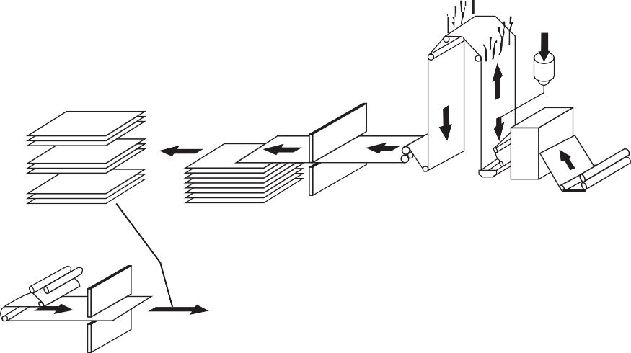

Pre-build

Prepreg cut-to-length

Epoxy resin

Cloth unwind

Copper

Cut-to-length

Prepreg and copper lay-ups

Laminate lot testing

Ship

Trim

Press

Inspect

Cut-to-size

**FIGURE 6.6** The conventional manufacturing process.

cost of manufacturing or to improve material performance, or both. Common to all processes is the need to manufacture a copper clad laminate and the bonding sheets or *prepregs* used to manufacture multilayer circuits.

###### Conventional Manufacturing Processes

The overall conventional manufacturing process is illustrated in Fig 6.6. This process can be subdivided into two processes: prepreg manufacturing and laminate manufacturing. Prepreg is also called *B-stage* or bonding sheets, while laminate is sometimes called *C- stage*. The terms B-stage and C-stage refer to the degree to which the resin system is poly- merized or cured. B-stage refers to a state of partial cure. B-stage is designed to melt and continue polymerizing when it is exposed to sufficient temperatures. C-stage refers to a state of “full” cure (typically we never realize *full* cure, in the sense that not all reactive sites on the resin molecules have cross-linked; however, we use the term *full cure* to mean that the over- whelming majority of such sites have reacted and additional exposure to temperature will do little to advance the state of cure).

###### Prepreg Manufacturing

The first step in most of these processes involves coating a resin system onto the chosen rein- forcement, most commonly a woven fiberglass cloth. Rolls of fiberglass cloth or alternative reinforcement type are run through equipment called *treaters*. Figure 6.7 shows some of the resin system components that are mixed and aged prior to application to the fiberglass cloth. Figure 6.8 illustrates the overall treating process. The fiberglass cloth is drawn through a pan containing the resin system and then precise metering rolls help control thickness and also push resin into the yarns of the glass cloth (see Fig. 6.9).

**6.20** PRINTED CIRCUITS HANDBOOK

Resin

Curing agent

Catalyst

To oven

Solvent

Batch mixing tank



Metering rolls

Resin bath

Holding/aging tank

**FIGURE 6.7** Resin mixing, aging, and treating.

Next the cloth is pulled through a series of heating zones. These heating zones commonly utilize forced air convection, infrared heating, or a combination of the two. In the first set of zones, solvent used to carry the resin system components is evaporated off. Subsequent zones are dedicated to partially curing the resin system, or B-staging the resin. Finally, the prepreg is then rewound into rolls or cut into sheets.

A number of process controls are required in this operation.The concentrations of the resin system components must be controlled and the viscosity of the resin system maintained within acceptable limits. Tension on the cloth as it is pulled through the treater is also important, for among other reasons, it is vital not to distort the weave pattern of the cloth. Control of the

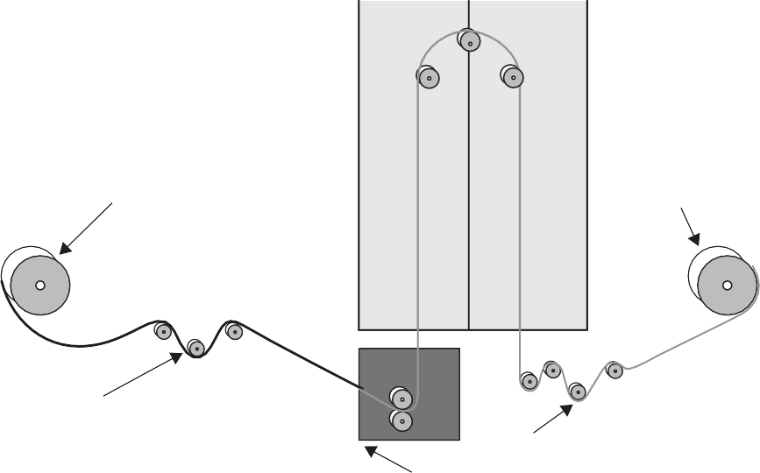Raw glass unwind

Oven

Prepreg windup

Tension controls

Tension controls Resin application/coating

**FIGURE 6.8** “Treating” fiberglass cloth with resin.

INTRODUCTION TO BASE MATERIALS **6.21**

resin-to-glass ratio or resin content, the degree of cure of the resin and cleanliness are also critical.

Because the resin system at this point is only partially cured, prepregs must typically be stored in temperature- and humidity-con- trolled environments. Temperature, for obvi- ous reasons, could affect the degree of cure of the resin and therefore its performance in lam- inate or multilayer circuit pressing. Since mois- ture can affect the performance of many curing agents and accelerators, not to mention the performance of the resin system during lamination or press cycles, humidity is also important to control during prepreg storage. Absorbed moisture that becomes trapped dur- ing lamination cycles can also lead to blisters or delaminations within the laminate or multi- layer circuit.

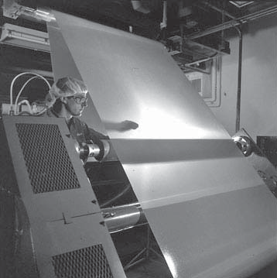

**FIGURE 6.9** Prepreg after treating with resin.

###### Laminate Manufacturing

The process of copper clad laminate manufacturing begins with the prepreg material. Prepregs of certain fiberglass cloth styles and specific resin contents are combined with the desired copper foils to make the finished laminate. First, the prepregs and copper foils are sheeted to the desired size. Figure 6.10 shows an automated copper-sheeting process.

These materials are then laid up in the proper sequence to produce the desired copper clad laminate. Figures 6.11 and 6.12 are examples of an automated build-up process where the prepreg and copper foil materials are combined prior to being pressed together. Several of these individual sandwiches of prepreg and copper foil are stacked on top of each other, typically separated by stainless steel plates, although other separator materials, including aluminum, can also be used. These stacks are then loaded into multi-opening lamination

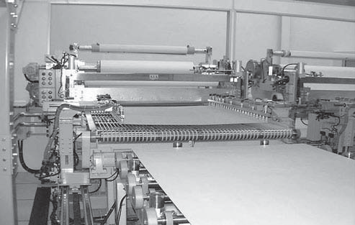

**FIGURE 6.10** Sheeting of rolls of copper foil.

**6.22** PRINTED CIRCUITS HANDBOOK

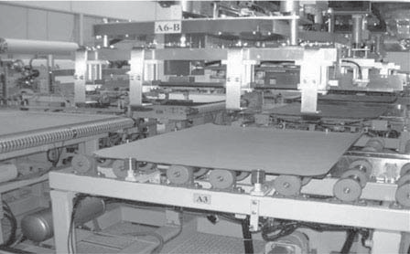

**FIGURE 6.11** Automated build-up of copper and prepreg.

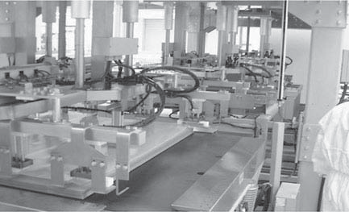

**FIGURE 6.12** Automated build-up of copper and prepreg.

Top plate (optional)

Heated press platen

Laminate book w/copper foil

Carrier plate

Heated press platen

Hydraulic rams

**FIGURE 6.13** Laminate pressing.

Lagging material

Press plate Lagging material

INTRODUCTION TO BASE MATERIALS **6.23**

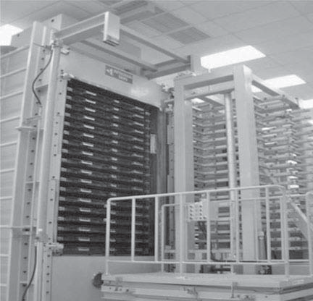

**FIGURE 6.14** Lamination press with multiple openings.

*(Photo Courtesy of Polyclad Laminates, Inc.)*

presses (see Figs. 6.13 and 6.14), where pressure, temperature, and vacuum are applied. The specific press cycle used will vary depending upon the particular resin system, the degree of cure of the prepregs and other factors. The presses themselves have many platens that can be heated by steam or hot oil that flows through the platens, or they can also be heated electrically.

Process controls in the lamination/pressing process are also critical. Cleanliness in the manufacturing environment and cleanliness of the steel separator plates are critical in achieving good surface quality and in avoiding embedded foreign material within the lami- nate. Control of the temperature rise during lamination will provide the desired amount of resin flow, while control of the cooldown rate can impact warp and twist. The length of time that the laminate is above the temperature required to initiate the curing reaction will determine the degree of cure, as will the degree to which the actual temperature exceeds this temperature.

While these descriptions of prepreg and laminate manufacturing give a simple descrip- tion of the processes used, it is important to understand that there are many variables that influence the quality and performance of the finished products. In addition, many of these variables interact with each other, meaning that a change in one may influence others and may require adjustments to these other process variables. In summary, prepreg and laminate manufacturing is much more complex than it appears at first glance.

###### Direct Current or Continuous Foil Manufacturing

Continuous foil or direct current manufacturing is an alternative method used to manufacture copper clad laminates (see Fig. 6.15). Prepregs are still used in this process, however, the lay-up and pressing operations are somewhat different. In this process, the copper foils are not sheeted, but kept in rolls. To start, copper foil with the side to be bonded to the prepreg facing up, is laid

**6.24** PRINTED CIRCUITS HANDBOOK





D.

C.

er ply

pow

1

2 Separator

plates

sup

−

Innerlayer

and prepreg

Cu-foil

**FIGURE 6.15** Laminate pressing with continuous copper foil and direct current heating.

*(Illustration Courtesy of Cedal)*

down, while still part of a continuous roll. The prepregs are laid up in the proper sequence, and then the roll of copper foil is passed over the prepregs so that it is applied to the top of what will become the finished laminate. Typically, two rolls of foil are used to allow dissimilar copper weights or types to be bonded to either side of the laminate. A separator plate, typically anodized aluminum, is then placed on top of this sandwich, and the process is repeated so that several laminates are stacked up.

At this point, the stack of laminates is loaded into a press and subjected to heat, pressure, and vacuum. However, as opposed to the conventional process, this technique involves apply- ing direct current to the copper foil that runs throughout the stack. The current heats the foil and therefore the prepregs are adjacent to the foils. By controlling the amount of current, you control the temperature of the materials in the stack.

###### Continuous Manufacturing Processes

Over the years, continuous lamination processes have also been designed. Rather than cut the prepregs and foils into sheets, lay them up and press them as individual laminates, these processes use rolls of prepreg or bare fiberglass cloth and rolls of copper foil that are continuously unwound and fed together into a continuous horizontal press. One process starts with rolls of prepreg. Another starts with the bare, untreated fiberglass cloth, applies a resin to the cloth and is sandwiched with the copper foil as it is fed continuously into a horizontal press. At the back end of the press, sections of the continuous laminate can be cut into sheets, or with thin lami- nates, rolls of copper clad laminate can be manufactured.

#### **REFERENCES**

* + - 1. IPC-4101, “Specification for Base Materials for Rigid and Multilayer Printed Boards.”
      2. IPC-4562, “Metal Foil for Printed Wiring Applications.”

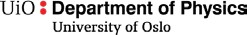

***FYS 4260/FYS 9260 Microsystems and electronic packaging and interconnection technologies***

**8 Ceramic Circuits**

Please see lecture presentation of ceramic circuits on semester page.

Document version: January 2017 (Work in progress) 56

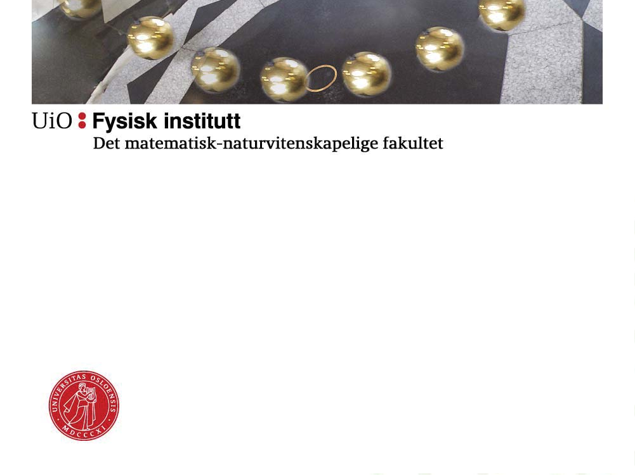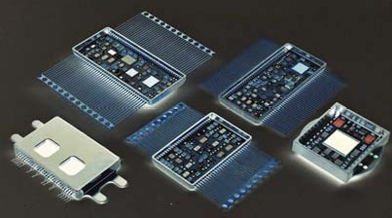

**FYS4260IFYS9260:**

**Microsystems and Electronics Packaging and Interconnect**

**Ceramic Circuit Boards, Multichip Modules, and other Inorganic Circuit Board Technologies**

**Hybrid technology and Multi Chip Modules (MCMs)**

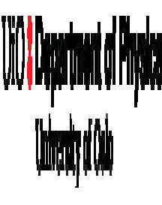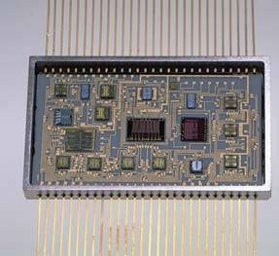

* Hybrid = composite
* Mixture of *integrated components* (resistors, inductors, capacitors et cetera) on the circuit board combined with discrete components mounted on the board (using for example adhesives or soldering)

**Thin film hybrid**

2

1



**Why use inorganic ceramic circuit boards rather than organic PCB?**

* Lower size, volume and weight
* Better high frequency properties
* Sharper line widhts (especially for thin film boards)
* Stable, high reliability

– Hybrid circuits are much used in electronics for harsh environment applications (for example under hood automotive)

3



**Summary of ceramic hybrid properties**

* Good dimensional stability with respect to high temperature processing
* Good adhesion between substrate and materials printed on top
* High thermal conductivity
* Relatively low CTE (6-7 ppm/K)
* High electrical resistance in the substrate
* Moderate to low dielectric constant
* Moderate dielektric losses
* Mashinable
* Price

4

2

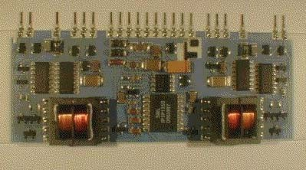

5

**Thick film hybrid (Microcomponent AS)**

Thick film

* Ceramic substrate (usually alumina) alumina)
* Polymer substrate (PTF)

Thin film

* Conventional (one layer)
* Multilayer

Multilayer ceramic (co-fired)

* High Temperature Co-fired Ceramic (HTCC)
* Low Temperature Co-fired Ceramic (LTCC)

•

•

•

**Hybrid technologies**

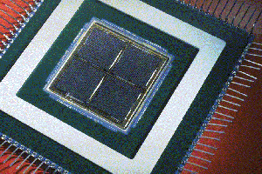

6

**MCM with 4 large GaAs gate-arrays**

* Three main types:
  + Ceramic
    - HTCC,LTCC
  + Deposited
    - Thick film, thin film
  + Laminated
    - PCB, PTF

**Multi Chip Modules (MCMs)**

* MCM: Multiple (naked) integrated circuits connected on a single board or to a package

3

|  |  |  |  |  |  |  |  |
| --- | --- | --- | --- | --- | --- | --- | --- |
|  |  |  |  |  |  |  |  |
|  |  |  |  |  |  |  |  |

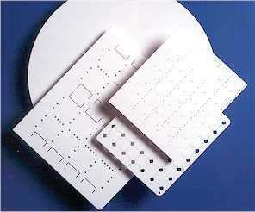

7

**Alumina substrates, CoorsTek**

Aluminia most widely used material

Reasonable stability during fabrication (shrinkage approx 20%)

Good adhesion between substrate and integrated components and components/conductor paths

High thermal conductivity (20 W/m K) Favorable CTE (6.4 ppm/K)

High electrical resistivity Intermediate dielectric constant (9.4) Low price

Somewhat difficult to machine (brittle)

•

•

•

•

•

•

•

•

•

**Thick film substrate technology**

|  |  |  |  |  |  |  |  |
| --- | --- | --- | --- | --- | --- | --- | --- |
| Relative Permittivity | 9.8 | 10 | 15 to  45 | 11.9 | 3.9 | 7.5 | 3-4 |
| Thermal | 10 to | 140 to |  |  |  | 10 to |  |
| Conductivity (W/m °K) | 35 | 170 | 270 | 150 | 1.5 | 40 | 0.4 |
| Thermal Expansion |  |  |  |  | 0.3 to | 2.5 to | 20 to |
| Coefficient (10-6/°K ) | 5.5 | 2.65 | 3.7 | 2.6 | 0.5 | 3 | 70 |
| Breakdown Field |  |  |  |  | 106 to | 106 to |  |
| Strength (V/cm) | 105 | 105 | 700 | 105 107 107 106 | | | |
| Loss Factor (tan  ) | 3x10-4 | 5x10-4  to 10-3 | 5x10-2 | 4x10-3  4x10-2 | 3x10-2 | _ | _ |
| Modulus of Elasticity | 300 to |  |  |  | 70 to | 280 to |  |
| (kN/mm2) | 380 | 300 | 380 | 170 | 72.5 | 320 | 3 |

4



**Substrate propoerties**

**Table** 3.1 c): Properties of ceramics, Si, Si3N 4 and SiO 2 and polyimide.[3.1]

Characteristic Specific Resistance (Ohm•cm)

Al2O 3

AlN SiC

Si 10-4 to

10+4

SiO 2 Si3N 4 Polyimide

>1014 4x1011

1013

106

1012

1016

8



**The significance of the dielectric constant**

* For high frequencies (RF), we wish low  since this gives the lowest capacitive coupling:

Cp Rp

– tan  = (1/R)/C = 1/Q

–  = □ (k´ - jk")

– tan  = k"/k´.

9

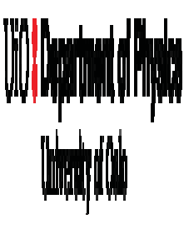

**Inorganic substrate materials with particular properties**

* AlN (aluminim nitride):
  + High heat conductivity (200 W/K)
  + Low CTE (4.5 ppm/K)
* Saffire glas
  + Very hig heat conductivity
  + Very expensive
* Beryllium oxside (beryllia)
  + High heat conductivity
  + Very poisonous

10

5

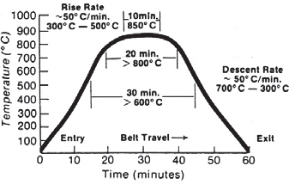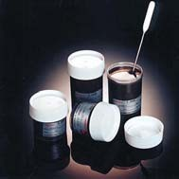

11

**Paste – from box – ready for use**

**(Heraeus AG)**

The pastes consist of

* Active ingredients (metal particles, alloys, oxide or other)
* Binder (glas partikles)
* Organic solvent (temporary binder in paste)

•

**Typical temperature profile for sintering of thick fil paste**

Resistors, dielectrics, conductor tracks in paste form are printed using stencil printing

The different layers are dried at 100-150 ˚C, and are then sintered at high temperature (800 ˚C).

•

•

**Principle for circuit production**



**Stencil printing**

**Stencil printing:**

**a) og b): Printing process**

**c) og d): Details from stencil**

12

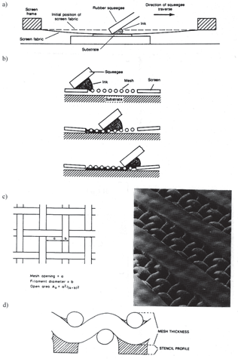6

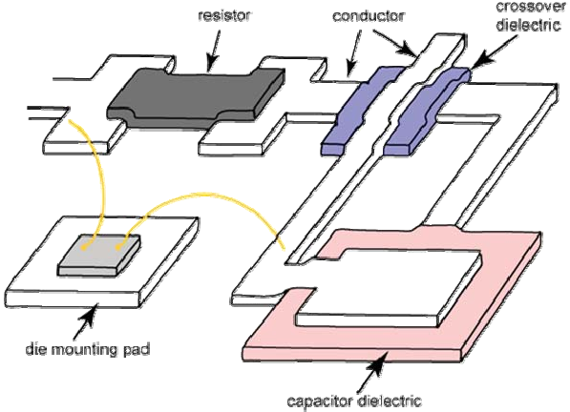

13

Frode Strisland

FYS4260/FYS9260

**Example of realized structures in hybrid thick film**

**Pastes for electrical conductors**

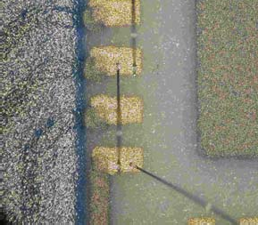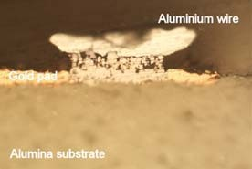

* Properties
  + High electrical conductivity
  + Good adhesion to substrate
  + Solderable
  + Wirebondable
  + Price
* Sintering at high temperatures means that noble metals predominantly are used:
  + Au
  + Cu
  + Ag
  + AgPd
  + Other alloys of Au or Ag with Pd or Pt
  + Why not Sn or Al?

**Detail from thick film test board Al wirebonding on Au**

**Cross-section after heat exposure (below)**

14

### 7

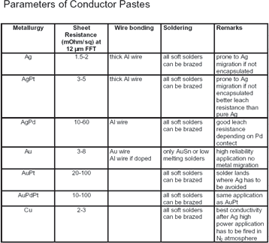



**On the choice of metallization system**

* Solderability
  + Cu and AgPd gives good solderablity
  + Au not possible to solder to (gets dissolved in the solder)
* Bondability (for wire- bonding)
  + Au and Ag-baseed works well
  + Cu (and Ni) more difficult due to oxidation
* Price
  + Au expensive
* Line widhts
  + Cu, Ag 150 µm
  + Au 50 µm

**Source: Heraeus AG**

15

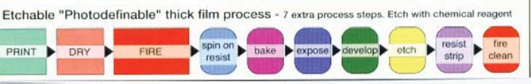

16

Frode Strisland

FYS4260/FYS9260

**Photodefinable thick film process**

* Combination of conventional thick film technology with elements of thin film technology
* Low cost solution to producing high quality microwave circuits.

8

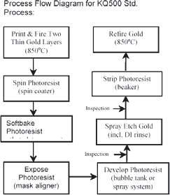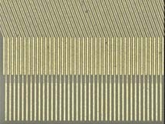



**Thick film combined with photoprocess (2)**

* Thick film combined with photo process can give more narrow line widths/structures
* Heraeus KQ:
  + 25 µm on 96% alumina
  + 10 µm on more planar substrates

**Process flow Heraeus KQ process**

**12 µm line width, 30 µm gap (Microcomponent AS)**

17

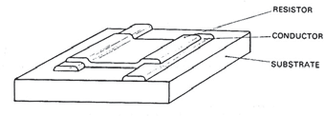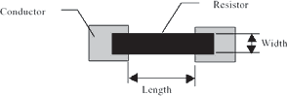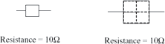

18

* Resistance materials:
  + Ruthenium oxides (RuO2, BaRuO3, Bi2Ru2O7)
  + Oksides of Ir, Rh, Os
* Resistors are stable with respect to temperature drift:
  + Drift < 0.5 % in demanding applications
  + Temperature Coefficient of Resistance TCR 100-700 ppm/K
  + TCR on a given circuit and paste ~15 ppm/K

**Two layouts, same resistance!**

Resistors determined by

* Paste jar (9 decades – up to Gohm values possible)
* Resistance area
* Resistance geometry
* Film thickness

•

**Printing of resistors**

9

• Mulig å fintune komponenter ved lasertrimming

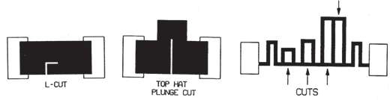

19

* Accuracy < 1% on resistors
* Automatic process - 30 resistors/second common
* Important to design circuits so that trimming is possible.

**Digital trimming, most used for high precision thin film resistors**

**L-cut most common**

**Fine-tuning of resistor values**



**Dielectrics - for isolation, passivation and capacitors**

* Al2O3 and glass are the most common functional materials for isolation and passivation
* Capacitors:
  + I high value capacitors, ferroelectric materials with high dielectric constants are used (r > 1000)
  + Titanium alloys and oxides common for lower capacitor values
* Capacitors cannot be laser trimmed
  + Thick film capacitors are only applied when accuracy requirements are low (such as for decoupling)

20

10



**Surface mounted resistors is based on thick film technology**

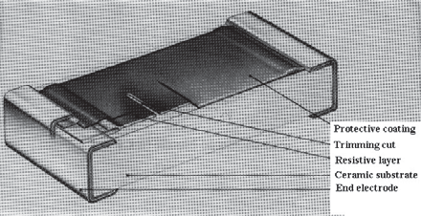

* Fig.4.2.a: Thick film layers on ceramic substrate, rectangular shape

Slide 21



**Production process – ceramic thick film**

* Preparatory work:
  + Board layout (CAD)
  + Photo process - stencils
  + Order substrates (with laser drilled holes (?))
  + Order paste jars

22

11

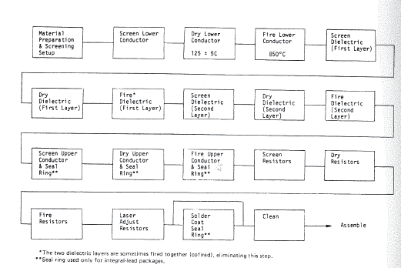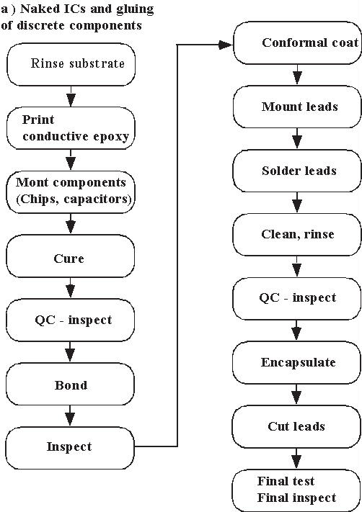



**Example process flow – thick film hybrid circuit board**

23



**Component mounting**

**Conductive adhesives**

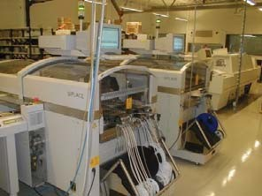

**Pick-and-place machine Microcomponent AS**

**Process flow – based on the use of naked chips and adhesive assembly of discrete components**

24

12

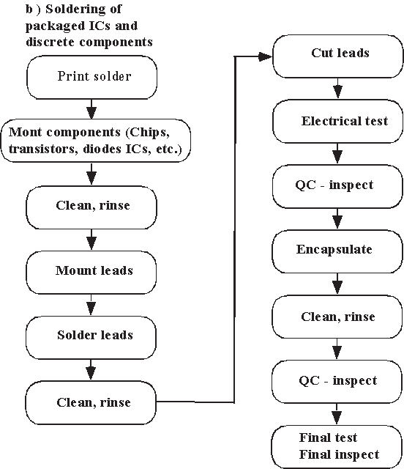



**Component mouting**

**Soldering**

**Process flow when components are soldered**

25

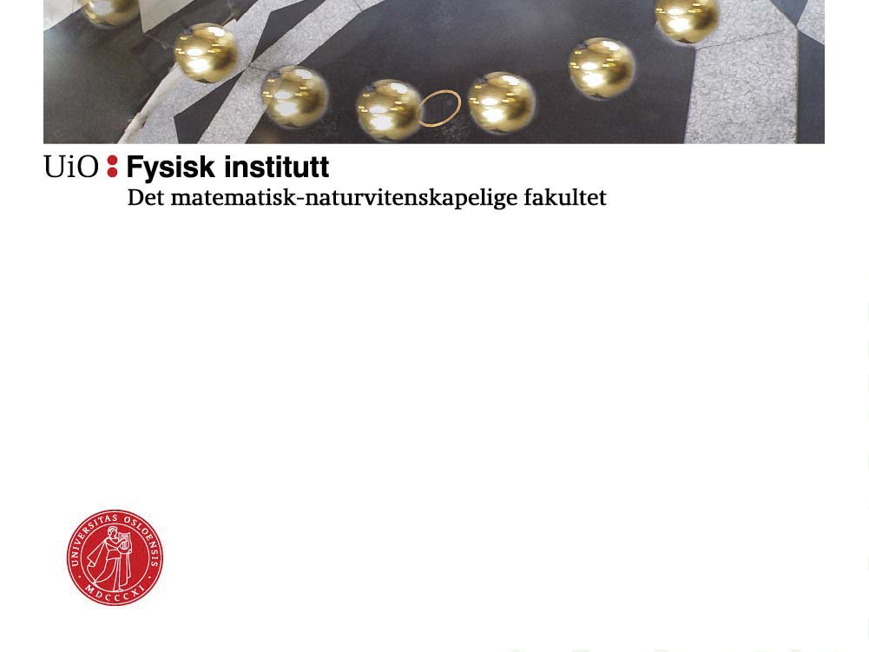

**One small de-tour:**

**On SINTEF's interest in ceramic hybrids**

26

13

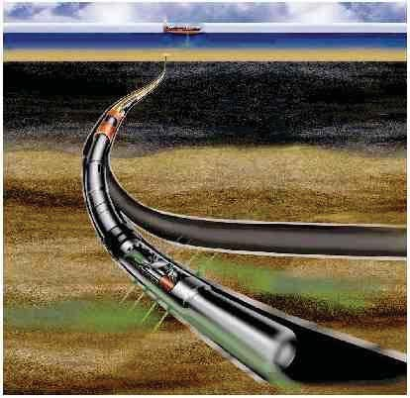

27

27

* SINTEF develops instrumentation systems intended for harsh environment applications
* Example: Oil well logging
  + high temperatures (-10 - 200˚C)
  + high pressure
  + vibrations
  + corrosive and abrasive properties of the oil fluid
  + High reliability is important!

- Typical c*ost of failure: $40- 100 000 pr. hour*

FYS4260/FYS9260 Frode Strisland

**SINTEF’s high temperature activity**

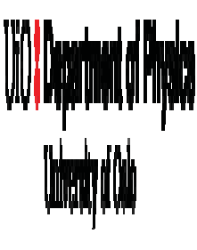

**SINTEF’s HT packaging project**

* GOAL: Develop processes and components that enables us to build a microelectronic system for 10 years reliable operation at 200˚C.

Processes:

* Die-attach
* Wire-bonding and inter-connects
* Encapsulation Components:
* Passive components
* Standard IC and HTASIC

28

14

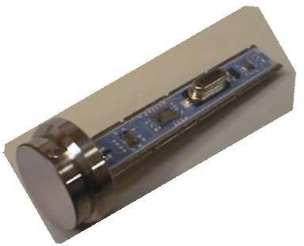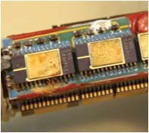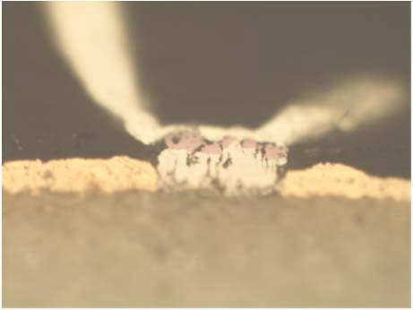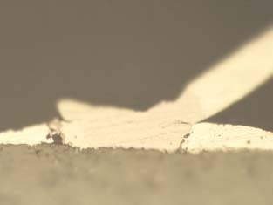

29

29

Frode Strisland

FYS4260/FYS9260

Alumina

Purple, intermetallic layer. Voids and cracking.

Alumina

No voids at the interface. Cracking along the edge.

**Cross-section images after 9 months thermal ageing at 250˚C**

**Aluminium - SilverPlatinum Aluminium - Gold**

Al-wire Al-wire

Au

AgPt



30

30

Frode Strisland

FYS4260/FYS9260

Developed by Kitron for power applications

Test bonding with 25 m Al wire

**Test with AgICuINiIAu**

0.03 m Au 1 - 3 m Ni 150 m Cu Ag thick film

15

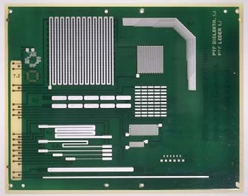

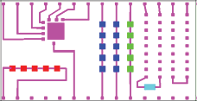

31

56-pins kovar package, Au on pins.

Nitrogen, air, open

**Package**:

**Atmosphere**:

substrate to package

25 m Al from chip to substrate, 25 m Au from

**Wire-bond**:

**Chip:**

HTMOS 1204 fra Honeywell, switch

p1

P28

**Resistors:**

DuPont 2000 serien, 100 , 1 k

s1

s14

**Die-attach:**

Epotek 3084

**Preform:**

Staystik 415

s28

s15

**Conductors and pads**: Ag/Cu/Ni/Au

**ap**p**p**29 **lications** p56

**MCM test circuit for high temperature**



**Polymer based thick film (PTF)**

* In polymer thick film, the glass binders of hybrid technology are exchanged with polymers as binders for conductors, resistors and isolating layers.
* The substrate can be ordinary FR4

32

16



33

33

Frode Strisland

FYS4260/FYS9260

Disadvantages

* Does not withstand demanding environments
* Only moderate complexity
* High resistance in electrical conductors
* Difficult to solder to
* Durability (shelf life) is a problem
* Advantages: •
  + Lower price
  + Easy processing
  + Fast production of prototypes
  + PTF technology possible to modify and repair (not straight forward on ceramic boards)

**PTF – pros and contras**



**Thin film technology**

* Circuit boards seems similar to thick fim, but individual layers are much thinner (< 1µm) than for thick film (~10 µm).
* “Silicon related” processing technology:
  + Photo litography
  + etching
  + Evaporation
  + Plating
* Smaller line widths than conventional thick film
* Conventional thin film:
  + 1 conductor layer
  + 1 resitor layer
  + 1 dielectricum layer
* Also multilayer thin film is possible

34

17



**Thin film materials**

* Substrates
  + Glass
  + 99.6% alumina
  + Silicon
* Metals
  + Conductor paths: Au and Al (plating or evaporation/sputtering)
  + Adhesion material: NiCr (evapration/sputtering + photo process)
  + Diffusion barrier: Ni
* Resistor material
  + NiCr or TaN2 (10 - 1000 ohm/sq)
* Dielectrica
  + Passivation SiN3, SiO2 (CVD process)
  + Condensators SiO, SiO2, Al2O3, Ta2O5 (various deposition techniques)

35



**Conventional thin film process**

* **Photo litography and etching**
* **Vacuum deposition (evaporation)**
* **Sputtering**
* **Plating**
* **Oxidation**

**Process for manufacturing of thin film hybrid circuits**

36

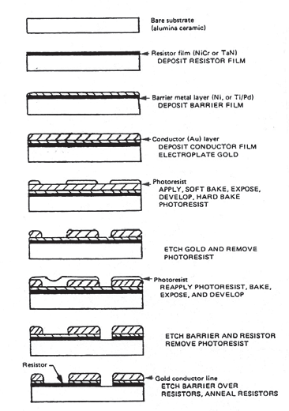18



**Thin film resistors**

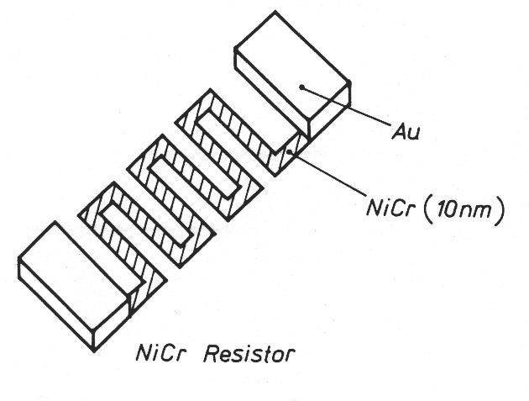

**Structure for thin film resistor in 10 nm thick NiCr with Au termination**

37



**Circuit example thin film**

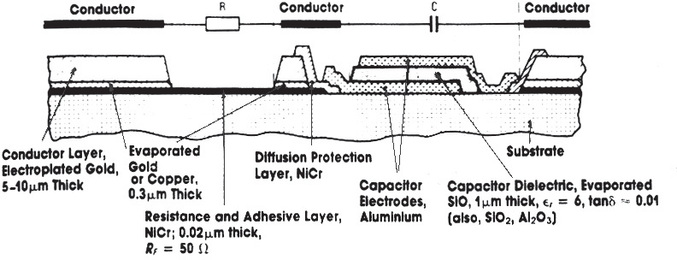

**Thin film circuit for micro wave applications**

38

19

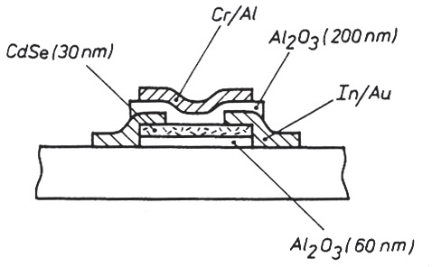



**Integrated semiconductor components in thin film hybrids**

* It is possible to include semiconductive materials in thin film circuits so that diode and transistor structures can be realized.

39



**Multilayer thin film**

* Expansion of conventional thin film to multiple layers
* Important for MCM and other applications with strict demands for miniaturization/integration

**Cross-section through a circuit based on the High Density Interconnect (HDI) process of Raychem**

40

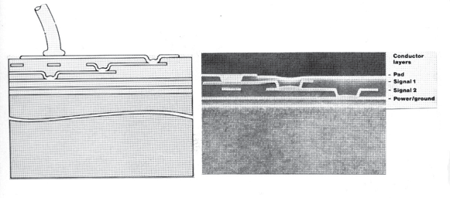20

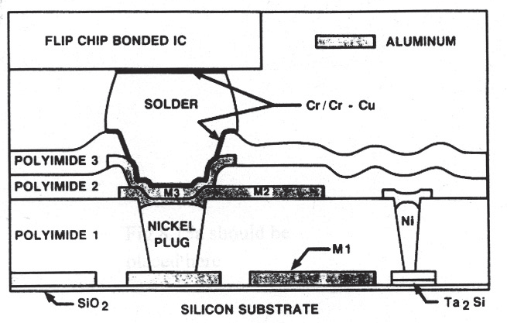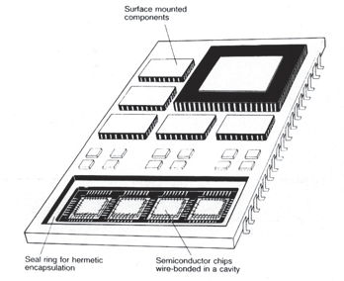



**Multilayer thin film (2)**

**AT&T's structure for multilayer thin film**

41



**Ceramic MCM**

* Extremely condensed circuits possible
* A large number of layers
* 3-dimentional packaging
* Buried components
* Shrinks 20% during high temperature processing

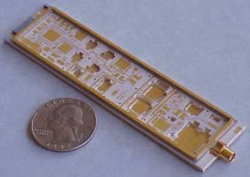

***Example of 3D packaging, Scrantom Engineering, Inc.***

42

21

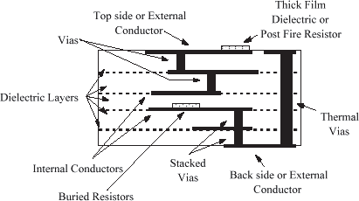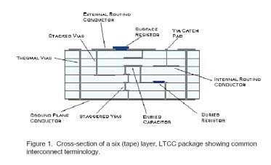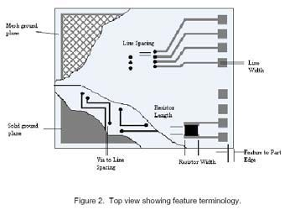

**Ceramic MCM (2)**

* High temperature process (High Temperature Co-fired Ceramic HTCC)
  + Ceramic based
  + 1500-1700 ˚C prosessing temperature
  + Molybdenum/tungsten conductors
* Low temperature process (Low Temperature Co-fired Ceramic LTCC)
  + Glass/ceramic based
  + 850 ˚C process temperature
  + Compatible with ordinary thick film metals
  + Wide usage

43



**Circuit elements - Co-fired Ceramic**

**From Hereaus LTCC design guide**

44

22

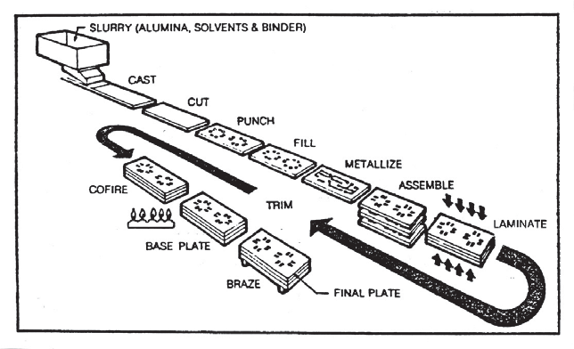



45

45

Frode Strisland

FYS4260/FYS9260

**Low-temperature co-fired ceramic LTCC**

* Advantages • Disadvantages
  + Low processing temperature – Poor thermal conductivity
  + Processes can share – Brittle materials manufacturing equipment used

for thick film

* + Has the same flexibility as thick film when it comes to ranges of conductor materials with low resistance
  + Plating not required prior to bonding
  + Resistors can be stencil printed
  + Low r dielectric materials



**Multilayer ceramic circuit boards Green Tape prosess**

**Process diagram for the manufacturing of multilayer ceramic LTCC circuits**

46

23



**Multilayer processes in ceramics:**

**Tape LTCC prosess**

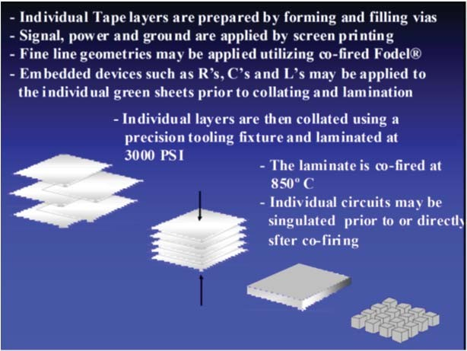 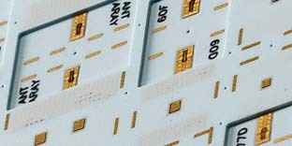

<http://www.dupont.com/content/dam/assets/products-and-services/electronic-electrical-> materials/assets/datasheets/prodlib/GreenTape_Design_Layout_Guidelines.pdf

47



**LTCC very suitable for 3-dimensional packaging**

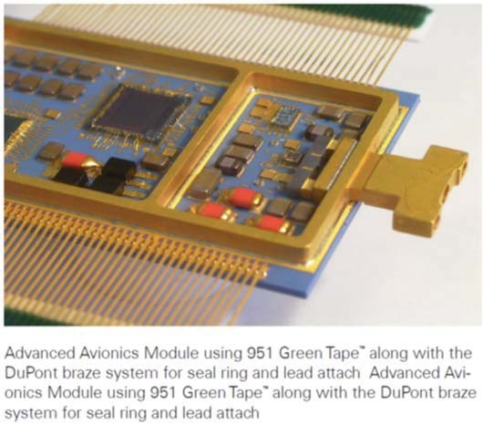 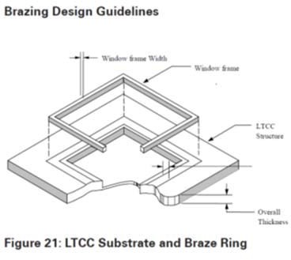

48

24

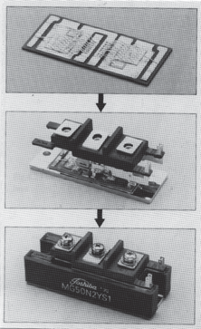



**Power electronics Design challenges**

* Must deal with large currents (~ 100 A)
* Heat development € excellent heat conductivity
* Thermal stress due to CTE differences between joined materials
* Electrical high voltage isolation (2.5 kV or more)
* Integration of power components and control components on the same chip or substrate
* Design to avoid inductans-driven giant currents when circuits switch on and off

49



**Power electronics:**

**Direct Copper Bonding DCB**

**Cu**

**Al2O3 or AlN Cu**

**Power module (Toshiba). DCB conductors on AlN. Wire bonding with a thick Al wedge-wedge bonding. This is soldered to a rigid Cu plate, and is covered by silicon gel. Each of the transistors and diodes can deal with 50 A currents**

50

25



51

Frode Strisland

FYS4260/FYS9260

**Special purpose inorganic substrate technologies**

* AlN, Beryllia, Sapphire glass: Applied in various applications where
* Glass
  + Glasses with sputter-depositied metal can be used as circuit boards. For example the borosilicate glass Pyrex® has very good match to the thermal expansion coefficient of silicon
* Silicon wafers
  + For high performance applications, silicon wafer can act as an excellent substrate in terms of thermal conductivity, IC- level fine line width, and perfect thermal expansion coefficient match to silicon chips.



52

Frode Strisland

FYS4260/FYS9260

**Brief introduction to design concerns when the electronics speeds up**

**High frequency electronics**

26

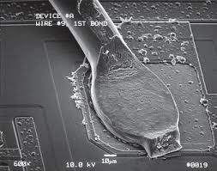

**FYS4260IFYS9260: Microsystems and Electronics Packaging and Interconnect**

**Metallization and Interconnects**



**Learning objectives**

* Metal heros
* Significance of selecting right metallization systems and examples of failure modes
* Flip-chip bonding
* Stud bumping
* Die attach
* Conductive adhesives

1



3

Frode Strisland

FYS4260/FYS9260

… Tin (11.0 µfi–cm)

Silver is widely used in electronics, but still does not make the heroes' list because…

**The electronics metallisation super-heros**

We want low resistivity!

The best conductors in nature are

1. Silver (1.60 µfi–cm)
2. Copper (1.67 µfi–cm)
3. Gold (2.3 µfi–cm)
4. Aluminum (2.69 µfi–cm)

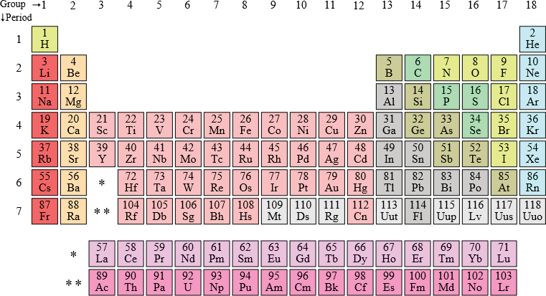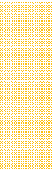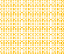

4

Frode Strisland

FYS4260/FYS9260

**Locations in the periodic system:**

**It is not a coincidence that Cu, Ag and Au share properties!**

2



5

Frode Strisland

FYS4260/FYS9260

**Silver in metallisation**

Excellent electrical conductivity (the best you can buy). Frequently used in glass and adhesive mixtures as conductive ingredient.

Ag is a VERY fast diffuser in dielectrics, especially when driven by an electric field. The rapid diffusion is because diffusion happens as an Ag+ ion which is much smaller in size than the neutral Ag atom, and thus moves easily. Susceptible for electromigration.

Pure Ag also quickly forms oxides.

Ag is quite rare and relatively expensive.



**The metallization heros:**

**Aluminium (Al)**

The final metal layer of most IC bond pads is sputter deposited aluminum, providing a satisfactory surface for conventional wire bonding. Al can be shaped into fine wires applied for wedge- wedge Al bonding. Al immediately forms oxides in air. Aluminum is not a readily solderable surface, neither wettable nor bondable by most solders.

Aluminum may corrode over time when not protected from the environment.

Low melting temperature (660˚C), limiting its use in ceramic hybrids.

FYS4260/FYS9260 Frode Strisland 6

3



7

Frode Strisland

FYS4260/FYS9260

**The metallization heros:**

**Gold (Au)**

Gold is the metallization superhero; highly conductive and ductile. It does not corrode and is frequently used as a protective layer. Diffuses easily, for example into tin, as well as into unprotected silicon in which it can destroy semiconducting band-gaps. Gold is therefore strictly forbidden in several IC and microsystems processing facilities.



8

Frode Strisland

FYS4260/FYS9260

**The metallization heros:**

**Tin (Sn)**

Tin is a soft, ductile, low melting point metal that wets and blends in whereever it can! The electrical conductivity of Sn is not comparable to Al,Au, and Cu, but the material is still valuable in solder applications in particular. Sn is responsible for the reduced soldering temperature in most (bi-/multi- metal) soldering compositions. Tin has a reasonable resistance towards the environment, making it an acceptable surface finish for printed circuit boards.

Can create whiskers that causes reliability concerns.

4



9

Frode Strisland

FYS4260/FYS9260

**The metallization heros:**

**Copper (Cu)**

Copper is the PCB metallization workhorse. Conductivity comparable to silver. Cu can be electro- and electroless plated on many surfaces. Excellent electrical and thermal conductivity and ductile. Oxidises in air so flux treatment is needed prior to soldering. Cu is also increasingly applied as IC metallization.

**Wire bonding**

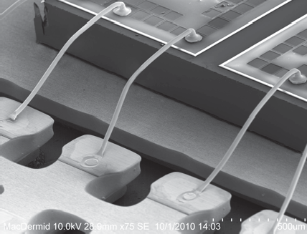

Wires:

* Gold (ball-wedge)
* Copper (ball- wedge)
* Aluminium (wedge- wedge)
* Alloyed aluminum wires

Ball-wedge bonding SEM illustration

Aluminium wires often alloyed with 1% Si or 0.5% Magnesium for greater drawing ease to fine sizes and higher pull-test strengths in finished devices

FYS4260/FYS9260 Frode Strisland 10

5

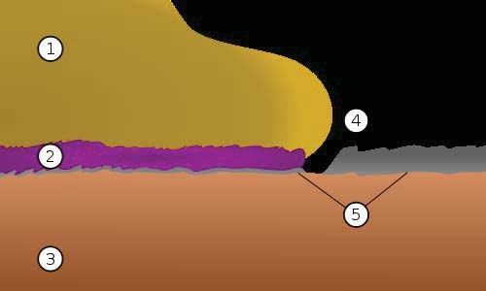

11

Frode Strisland

wire-bond of gold wire on an aluminium pad. (1) Gold wire (2) Purple plague (3) Copper substrate

(4) Gap eroded by wire-bond (5) Aluminum contact

"Gold-aluminium intermetallic" by Bondkontakt_Gold-Aluminium.svg: Cepheidenderivative work: Shoecream (talk) - Bondkontakt_Gold-Aluminium.svg. Licensed under Public Domain via Wikimedia Commons - http://commons.wikimedia.org/wiki/File:Gold-aluminium_intermetallic.svg#mediaviewer/File:Gold-aluminium_intermetallic.svg

FYS4260/FYS9260

AuAl2 consume the slower-growing ones. This process, known as Kirkendall voiding, leads to both increased electrical resistance and mechanical weakening of the wire bond.

All problems caused by gold-aluminium intermetallics can be prevented either by using bonding processes that avoid high temperatures (e.g. ultrasonic welding), or by designing circuitry in such a way as to avoid aluminium-to-gold contact using aluminium-to- aluminium or gold-to-gold junctions.

**Failures due to intermetallics growth**

**Example: Purple plague in Ag-Al interfaces**

A gold-aluminium intermetallic is an intermetallic compound of gold and aluminium that occurs at contacts between the two metals.

These intermetallics have different properties than the individual metals which can cause problems in wire bonding in microelectronics. The main compounds formed are Au5Al2 (white plague) and AuAl2 (purple plague), which both form at high temperatures. Long exposure of of a circuit to > 100 ˚C is sufficient to develop purple plague

Cavities form as the denser, faster-growing layers of

A schematic cross-section of a purple plague in a



12

Frode Strisland

FYS4260/FYS9260

Kirkendall voids in the interface

•

Material A Material B

Diffusion time

**Kirkendall voiding**

The Kirkendall effect is the motion of the boundary layer between two metals that occurs as a consequence of the difference in diffusion rates of the metal atoms

In general, diffusion coefficients are not the same for material A into material B as B into A.

In effect, voids are formed in the interface, causing mechanical weakening and increased interface resistance

•

•

6

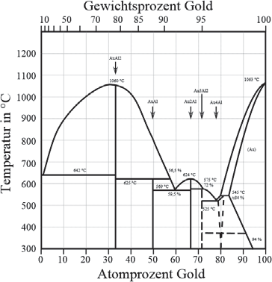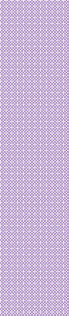

13

Frode Strisland

FYS4260/FYS9260

**Purple plague in the phase diagram**

Specific alloy compositions can give changes in material electrical and mechanical properties, such as

* Au5Al2 (white plague) has very low conductivity
* AuAl2 (purple plague) primarily is very brittle

Purple plague

White plague

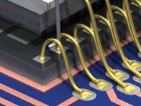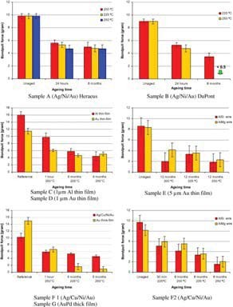

14

Frode Strisland

FYS4260/FYS9260

SINTEF wirebonding pull testing on samples aged in high temperature

**Wirebond testing**

Devices measuring the pull strength is frequenctly used to measure wire bonding quality.

Fresh wire bonds typically should have bond strengths of the order 10 grams force

7

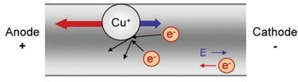

15

Frode Strisland

FYS4260/FYS9260

**Failure modes in metals:**

**Electromigration**

Electromigration is the transport of material caused by the gradual movement of the ions in a conductor due to the momentum transfer between conducting electrons and diffusing metal atoms.

Effects increase with increasing current densities

Aluminium is for example prone to electromigration. Addition of 2-4% Cu lowers the tendency to 1/50th due to changes in the microstructure.

Main source: <http://en.wikipedia.org/wiki/Electromigration>

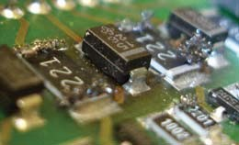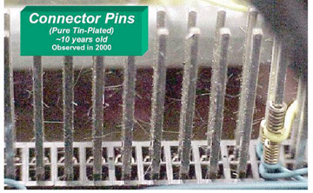

16

Frode Strisland

FYS4260/FYS9260

Silver whiskers

**Failure modes in metals:**

**Whiskers**

Metal whiskering is a crystalline metallurgical phenomenon involving the spontaneous growth of tiny, filiform hairs from a metallic surface.

The mechanism behind metal whisker growth is not fully understood, but seems to be encouraged by compressive mechanical stresses.

Whisker formation is common in tin where the growth can cause short circuits

8

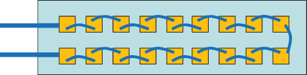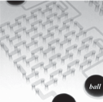

17

Frode Strisland

* Maximise risk of electromigration between parallel conductors

FYS4260/FYS9260

Daisy chain for testing through-silicon vias Chung et al.

**Common test structures for failure analysis**

* Daisy chain: Increase likelihood of and effect of systematic failure

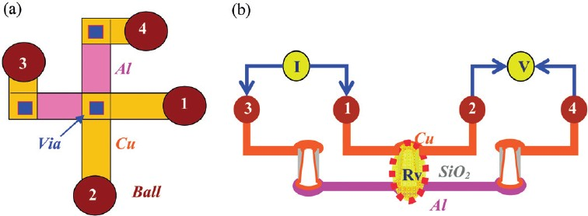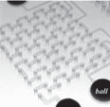

From: Chung et al, A complete resistance extraction methodology and circuit models for typical TSV structures, Int. J. of Electronics, 2012

18

other wire pair

FYS4260/FYS9260 Frode Strisland

Four point measurement where current is driven in one wire pair, and resulting impedance in measured in the

**Kelvin structure for testing of via (or bond padIwire bondIflip chip) resistance**

9



19

Frode Strisland

FYS4260/FYS9260

Die or circuit board

* Protective layer
* Conductor layer
* Diffusion barrier
* Adhesive layer
* Conductor integrated

layer-by-layer approach.

Depending on the application and materials used, a number of functions must be impelemented on a electrical pad. This is usually implemented in a

**Pad metallization**



20

Frode Strisland

FYS4260/FYS9260

**Diffusion barrier**: Shall ensure that low resistivity conduction. Example: Ta or W based nitrids or more complex oxides/nitrides for Cu diffusion in ICs, Cr in PCB

**Adhesion layer**: Shall ensure that metallization sticks on the surface. Example: Nickel Chrome (NiChrome) is often used as a adhesion layer towards gold.

Die or circuit board

**IC or PCB conductor layer**: Usually aluminum or Cu (can in some cases be doped silicon) on ICs.

**Protective layer**: Protect pad from the environment and ensure bondability – even after storage.

Example: 1 µm Sn or 10 nm Au

**Conductor layer**: Shall ensure low resistivity conduction. Example: Cu on PCBs, Au, Ag or Pt glass matrix on ceramic substrates, Cu or Al on ICs

**Pad metallization**

10

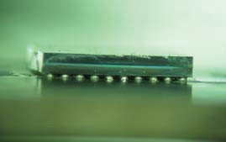

21

Frode Strisland

FYS4260/FYS9260

Flip chip is used for interconnecting semiconductor devices, such as IC chips and microelectromechanical systems (MEMS), to external circuitry with solder bumps that have been deposited onto the chip pads.

**Controlled collapse chip connection (C4)**

**Flip Chip Bonding**



**Under-Bump Metallization in FlipChip bonding1)**

It is not possible to solder directly to Al (oxide) pads. An under-bump metallization (UBM) is therefore needed:

* It must provide a strong, stable, low resistance electrical connection to the aluminum.
* It must adhere well both to the underlying aluminum and to the surrounding IC passivation layer, hermetically sealing the aluminum from the environment.
* The UBM must provide a strong barrier to prevent the diffusion of other bump metals into the IC.
* The UBM must be readily wettable by the bump metals, for solder reflow

1) This and subsequent UBM slide are based on material from <http://flipchips.com/tutorial/process/under-bump-metallization-ubm/>

FYS4260/FYS9260 Frode Strisland 22

11

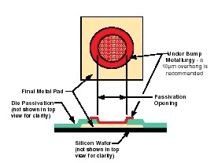

23

Frode Strisland

FYS4260/FYS9260

5.

A typical design layout for UBM relative to the original pad.

Sputter etch the native oxide to remove oxide and expose fresh aluminum surface.

Deposit 100 nm Ti / Cr / Al as the adhesion layer.

Deposit 80 nm Cr:CU as the diffusion barrier layer.

Deposit 300 nm Cu / Ni:V as the solder- wettable layer.

Deposit 50 nm Au as the oxidation barrier layer (optional).

1.

2.

3.

4.

**Example UBM process**

About 75% of UBM currently produced consists of multi-metal layers evaporated or sputtered in a vacuum system. A typical process sequence would be:

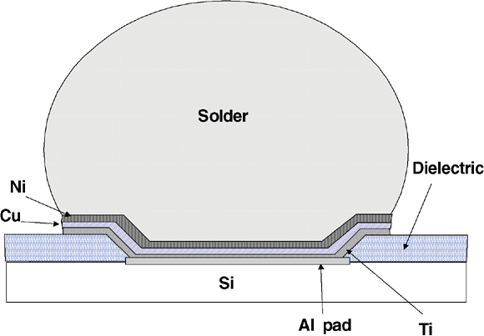

24

Frode Strisland

FYS4260/FYS9260

**Another example of UBM structure**

12

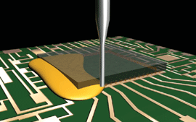

25

Frode Strisland

FYS4260/FYS9260

Following flip chip reflow, it is common to apply an adhesive that flows between the solder balls and solidify to form a strong chip attachment

**Underfill:**

**Mechanical strengthening of flip chip bonds**

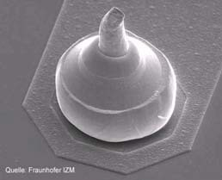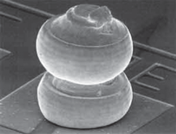

In cases with significant thermal stress, higher bumps are made from additional gold balls

26

Frode Strisland

FYS4260/FYS9260

Single stud bump

Gold ball bonding is first performed on wafer or chip level, but the wire is cutted right above the ball forming flip- chip like balls

The chip is flipped and placed in position.

Underfill is deposited and cured

In the underfill curing process, the adhesive shrinks, thereby strenghtening the mechanical bond between the stud bumps and the interfacing substrate

•

•

•

•

**Stud bump bonding**

Stud bump bonding is a cross-breed of wire bonding and flip chip bonding:

13

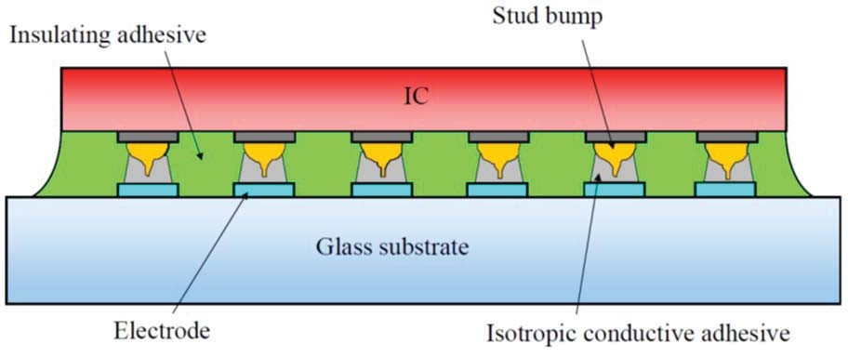

27

Frode Strisland

FYS4260/FYS9260

**Stud bump bonding combined with Isotropic Conductive Adhesive**

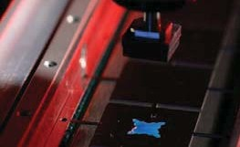

Die attach is the process of making the electrical connection between the semiconductor device die and its package.

Requirements on die attach process and material

* Conductive (usually) to ground the chip
* Thermally conductive
* Compatible with a soldering hierarchy; must be stable at normal soldering temperatures
* Mechanical strength (must withstand high shear stresses)

FYS4260/FYS9260 Frode Strisland 28

Die about to be placed onto a

substrate

**Die Attach**

14



29

Frode Strisland

FYS4260/FYS9260

**Die Attach**

**Common approaches**

* High temperature soldering (hard solders, good thermal conductivity)
  + AuSi (420˚C) and AuSn (350˚C)
  + High lead, e.g. Pb90Sn10 (300˚C)
* Adhesives (high tensile stresses from curing, moderate thermal conductivity)
  + Silver filled adhesives: Epoxy resin that has been highly loaded with silver metal flakes

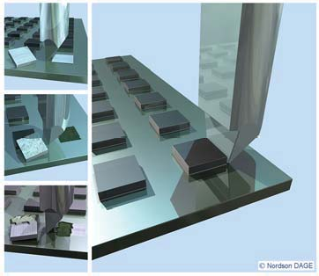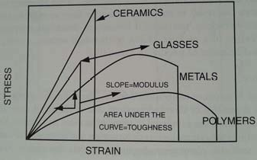

30

Frode Strisland

FYS4260/FYS9260

<http://www.sinerji-grup.com/bond-tester-> systems/dage-4000plus-bond-tester

**Die Attach**

**Testing of die attach quality by shear testing**

15



31

Frode Strisland

FYS4260/FYS9260

**Adhesives in Electronics**

* Adhesives categorized into
  + Non-conductive adhesives
  + Isotropic Conductive Adhesives
  + Anisotropic Conductive Adhesives

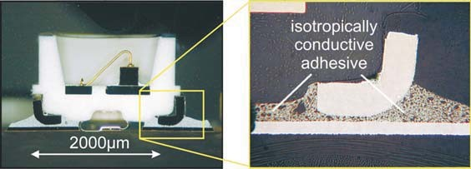

32

Frode Strisland

FYS4260/FYS9260

Cross section of an ICA bonded LED (Light Emitting Diode).

From: <http://www2.isas.tuwien.ac.at/aem/Homepage-AEM-e/research/contact-form.htm>

**Isotropic conductive adhesives**

Isotropic conductive adhesives are filled with conductive particles (usually silver) with sufficient density to ensure high conductivity in all directions (isotropic) upon solidification.

The shrinking during curing contributes to ensuring electrical contact between the conductive particles.

16

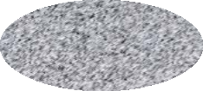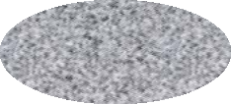

FYS4260/FYS9260 Frode Strisland 33

Current only flowing between designated pads

Must avoid short circuits between pads that should be isolated from each other

**Anisotropic Conductive Adhesives**

In contrast to isotropic conductive adhesives, anisotropic adhesives applies strategies to ensure that electrical conduction only takes place in a single (anisotropic) direction

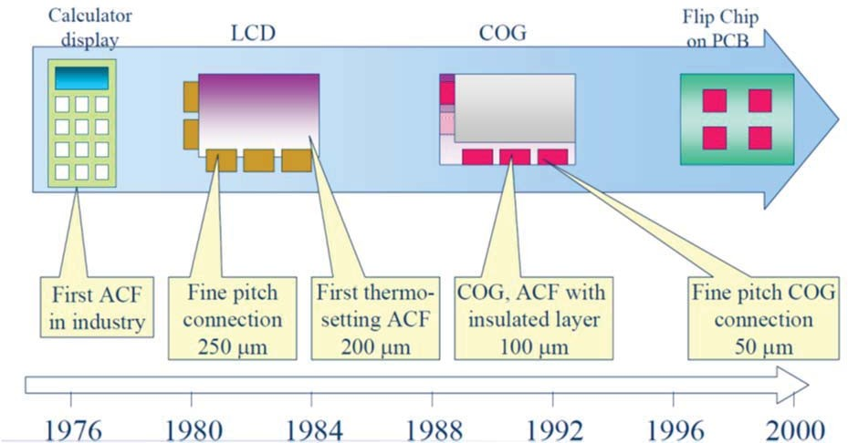

34

Frode Strisland

FYS4260/FYS9260

**ACF history**

17

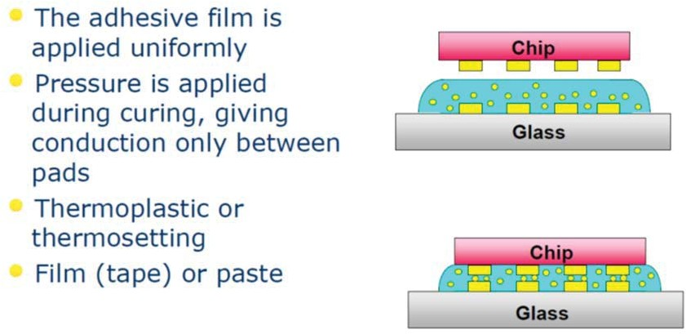

35

Frode Strisland

FYS4260/FYS9260

**Anisotropic Conductive Adhesive**

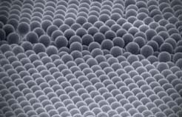

36

Frode Strisland

FYS4260/FYS9260

**Conpart monodisperse sphere approach to anisotropic conductive adhesives**

Conpart’s first business area was conductive particles in anisotropic conductive adhesives (ACA) used in interconnect of liquid crystal displays (LCD). Conductive particles are the most critical component in such adhesives, requiring specific mechanical properties, a very narrow size distribution and an intolerance of large offsize particles for optimal reliability of the ACA assembly.

18

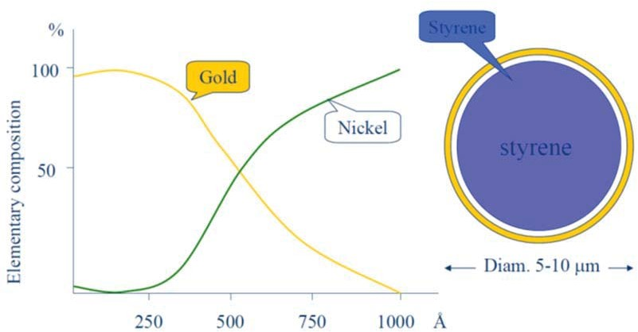

37

Frode Strisland

FYS4260/FYS9260

**Conpart conductive particle**



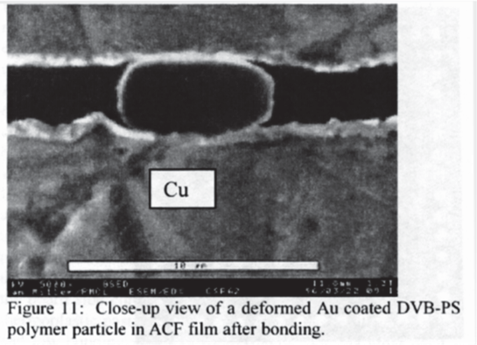

FYS4260/FYS9260 Frode Strisland 38

19

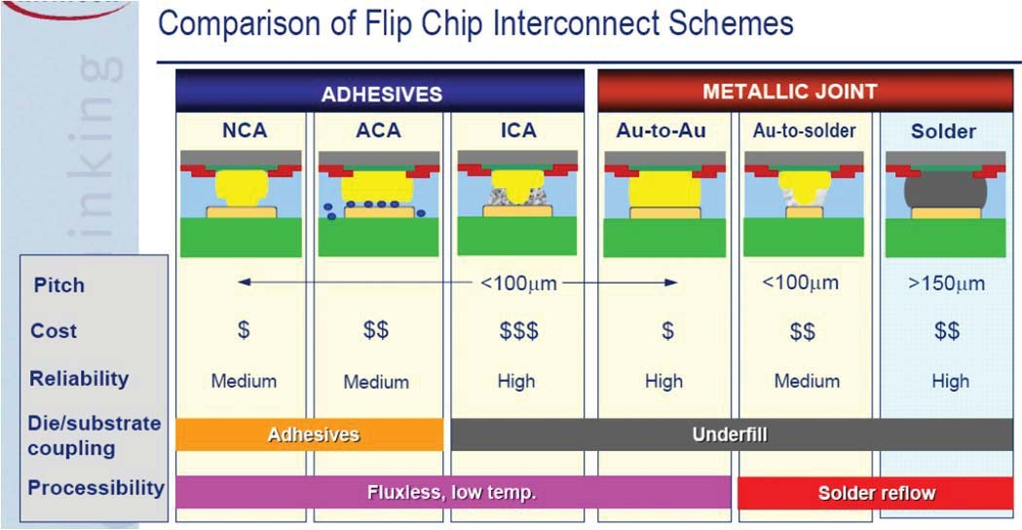



**Final take home message on Flip Chip Montage:** Several different Flip Chip technologies are used – Flip Chis is not a single, standardized process!

From C. Lee, ESTC 2006, Dresden



**End of lecture:**

**Metallization and Interconnections**

* Important issues:
  + Metals are different, and a lot of things takes place on the atomic scale
  + You should be able to explain the various ways to electrically connect a die to a circuit board or package

20

